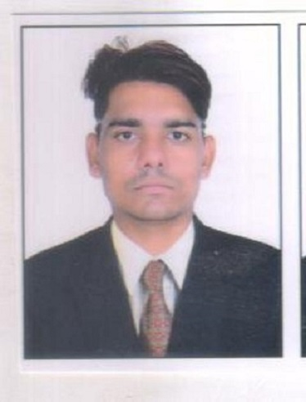  RAJESH B SHARMA.  E-MAIL  Rajeshbs35@gmail.com  ADDRESS FOR  COMMUNICATION  Rajesh B Sharma.  71.HIRA BHAI MARKET  B/H CLOTH MARKET  KANKARIYA Road  AHMEDABAD.  PERMANENT ADDRESS.  Rajesh B Sharama  76/100 Kalapinagar Road  Asrwa Ahmedabad.  Mo:9998108407  PERSONAL DATA  Date of Birth: 10/July/1988  Sex: Male  Nationality: Indian  Passport No: J9188150  Marital Status: Unmarried  Father's Name: Biharilal Sharma  Religion: Hindu  (God Brahmin)  HOBBIES: Playing Cricket.  Watching Criket.  LANGUAGES KNOWN  Hindi, English & Gujrati.  English, Hindi, & Gujrati.  (Speak, Read & Write) | RAJESH B SHARMA.  OBJECTIVE  To work in a dynamic and challenging atmosphere where I can prove my mettle and make my work place the most happening one. I can work with a team of highly committed and dedicated people so that I can realize my full potential and become a successful team leader.  ACADEMIC CREDENTIALS  10th Class Gujrat Secondary Education Board 2003  12th Gujrat Senior Secondary Education Board 2005  TY. BCOM From Bulandkhand University Jhansi 2010  OTHER QUALIFICTION  M.S. Office (M.S-Work, Excel, PowerPoint, Access,  Internet (E-mail)  Operating System (Windows 98, Windows XP, Server 2003, Window Vista, Windows 7 Etc.  Accounting Tally 9 ERP.  &  I Have passed National Certified Financial Market (NCFM) EXAM for Equity Desk.
WORK EXPERIENCE.
  - Now I am working with Vijay Trading co. As a Tally Accountant last 4 year and its Continue.
  - I want bright Futcher so I am also join LIC of India from last 3 year
  - I have also Work Exp as Investment Advisor in Angel Broking 1 Year.
  - I have also Work as Surveillance Admin Department at ECS House 3 Year.
  - I Have Also 3 years work Experience as CSR in VODAFONE.

JOB RESPONSIBILITIES.
  - Carrying out the day to day office activities.
  - Trouble shooter of task force.
  - Update always debtors list and creditor list day to day
  - Handel office rutting work account and and sales also.
  - Vibrant personality of Client meetings.
  - Attending calls of Customer Regarding for his/her Enq, Request & complain.

DECLARATION
I here declare that all the above-furnished details are correct to the best of my knowledge.

CARRIER GOL

I want to Archive many Things in This Life. Like a success person at goods stage.
And I try to my best with my honesty, sincerity and to my smart work.

Place: Ahmadabad
Date: 18/09/2018 RAJESH B SHARMA.
9998108407

