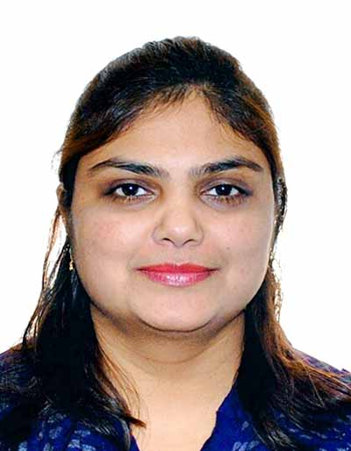

Jinal P Patel
Mobile: +91 8156081983
E-mail: jinalppatel12283@gmail.com

Account Executive – Account Assistant – Admin/HR Executive
Customer Service – Customer Relationship Management – Office Management

Objective
To contribute to the growth of an organization to provide a wide scope of creativity and productivity to any role that I endeavour. To attain job satisfaction and move towards professional excellence.

Education & Training
Advance Diploma in International Hospitality and Tourism Management
United Asia School of Management, 2009, Singapore.

Bachelor’s Degree with Economics

Gujarat University, 2003, Ahmadabad, India.

Professional Experience
Simran Security (S) Pte Ltd, Singapore
Assistant accountant 15th Oct 2009 - 18th Oct 2013

Responsibilities:

- Income Tax (I.R.A) related work including completion and submission of various forms
- Managing Accounts payable
- Managing Accounts receivable
- Cash Management-Handling day to day cash transactions
- Book keeping
- Day to day banking related work
- Preparation of client Invoices and managing client communications
- Routine H R and Admin responsibilities

Vodafone Essar Ltd., Ahmedabad, India June-2007-June 2008
Customer Service Associate
The company is a leading telecom operator in India.

Responsibilities:
• Effectively handling customers, enquiries, complaints and requests
- Providing advice, information and assistance to callers
- Making sure that all telephone calls are answered promptly
- Following up customers by calling them back
- Research required information for callers using available resources
- Essentially receiving up to 50 incoming calls from customers daily
- Accurately recording details of calls and issues on logging in CRM software
- Having a professional and courteous manner at all times.
- Identifying and escalating priority issues or customer complaints.
- Satisfying the customer by providing the best solution.

Achievements:
• Rewarded as best Customer Service Associate for providing quality service on every call
- Handled grooming and training of new team members on the Corporate P&Ps

Tarika exclusive, Ahmedabad, India April 2004-March 2007
Account Assistant
The firm is in a Sari and Dress material retailer in Ahmedabad – a city which earned its name as Manchester of the East for its booming textile industry.

Responsibilities:
- Book Keeping
- Cash Management-Handling day to day cash transactions
- Inventory Management
- Maintaining Ledgers
- Managing Account Receivable
- Managing Account Payable

Diwan Ballubhai High School, Ahmedabad, India June 2001 - May 2003
Computer Instructor

Responsibilities:
- Coaching primary and undergraduate students on basic computer functions and applications
- Training students on C, C++ and MS Office
- Coaching students on standard X course curriculum (Equivalent to ‘O’ level)
- Coaching students on standard XII course curriculum (Equivalent to ‘A level)

Technical skills
- Microsoft Office – Word, Excel, Power Point and Access
- Tally 6.0
- CRM Software
- DOS

Strengths:
- Undying courage and positive attitude
- Team player with mixing nature and excellent inter personal skills
- Able to work under pressure and to tight deadlines

Personal Information
Languages Known : English, Hindi and Gujarati
Date of Birth : Feb 12, 1983
Nationality : Indian
Gender : Female
Marital Status : Married
Hobbies : Music & traveling
Address : T61, Satellite Complex,
Opp: Manasi Tower,
Satellite Ahmedabad 380015

