BABARIYA SANJAY KUMAR DEVJI BHAI

Mobile(+91):9824804615 E-Mail:sanjayvidhi93@gmail.com

Seeking assignment in the field of production|Fabrication

Personal Snippetsp

Date of Birth :23/11/1996 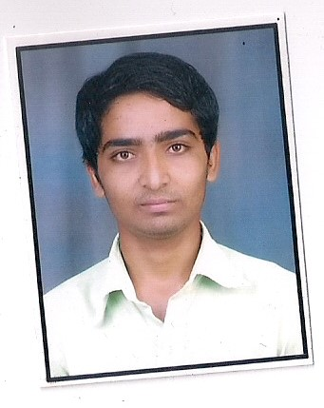
Marital Status :Unmarried
Religion :Hindu
Nationality :Indian
Language :Hindi Gujarati English

EDUCATION
SSC-Board 10th

Gujarat Secondry Board Gandhinagar

Month of Exam  March-2012 | Seat No.  C947275 | Percentile Rank  59.49

HSC-Board 12th

Gujarat Secondry Board Gandhinagar

Month of Exam | Seat No | Percentile Rank
March-2014 | G327784 | 49.14

BCA(Running)

University : Saurastra University Rajkot
Collage : A.R Bhatt Collage Com.Science Collage Una
Sem1 | 60.16
Sem2 | 62.83
Sem3 | 69.1

