SYNTHESIS OF QUINOLINE
BASED HETROCYCLES


A
DISSERTATION REPORT
SUBMITTED TO THE
GUJARAT UNIVERSITY
IN THE FACULTY OF SCIENCE
FOR THE DEGREE OF

MASTER OF SCIENCE
IN ORGANIC CHEMISTRY

SUBMITTED BY
BALDANIYA BHAGVATI NAJUBHAI
(Enrolment Number-202002300279)

UNDER THE GUIDANCE OF

Dr. S.B. TERAIYA

DEPARTMENT OF CHEMISTRY
BHAVAN’S SHETH R.A. COLLEGE OF SCIENCE
AHMEDABAD- 380001
GUJARAT, INDIA
APRIL- 2022

DECLARATION

I, hereby declare that the CHE-510(O) Dissertation was completed at department of chemistry Bhavan’s Sheth R. A. College of Science, Ahmedabad from 15-02-2022 to 06-04-2022 (50 days) under the guidance of Dr. S. B. Teraiya.
I also hereby declare that this CHE-510(O) dissertation report is originally written by me and submitted to Gujarat University for the part of fulfillment of the award of Master of Science.

BALDANIYA BHAGVATI N.

Uni. Exam Number:1225
(M.Sc.-SEM-IV Roll No. 102 HPP)
Chemistry Department
Bhavan’s Sheth R. A. College of science, Khanpur, Ahmedabad-01
Place: Ahmedabad
Date: 13-04-2022

CERTIFICATE

This is to certify that the CHE-510(O) Dissertation report is a bonafide record of independent training work done by Miss. BALDANIYA BHAGVATI N. (UNi. Exam No.: 1225 M.Sc.-IV) under my supervision and submitted to the Gujarat University in partial fulfillment for the award of the Degree of Master of Science (M.Sc.).

Dr. S. B. Teraiya
Assi.Professor Head of Department
Chemistry Department
Bhavan’s Sheth R. A. College of science,
Khanpur, Ahmedabad-01

Place: Ahmedabad
Date: 13-04-2022

ACKNOWLEDGEMENT

This dissertation work cannot be accomplished without help and views of these noble figures. I convey my deepest regards to all involved in this dissertation.
This is the perfect moment for me to express my gratification for Dr. H. M. Patel (principle) Bhavan’s Sheth R. A. College of Science, Ahmedabad for granting me necessary permission to carried out this work in the college. for his suggestion and wholehearted support during the entire tenure of my study.
I am deeply indebted to my guide Dr. S. B. Teraiya for his immense concern and encouragement. During these years I have known him as an insightful and principle-centered person. Without his help, this work would not be possible. It is his positive analysis, determination and patience to my idiosyncrasies that has led my research work to this stage.
I am also very grateful to all teaching and non-teaching staff members of Chemistry Department, Bhavan’s Sheth R. A. College of Science for inspirational support and Valuable suggestions during the entire tenure of my study.
I express my gratitude to my friends for their valuable suggestions and support. I am heartily thankful to all my colleagues specially, who helped me at various stages of this work. I am also thankful to Inflibnet, which provided a great source of help for accessing the e- journals.

-BALDANIYA BHAGVATI N.

INDEX

Chapter | Title |  | Page
1 | Introduction
 | 1.1 | Quinoline | 1
 | 1.2 | Synthetic route of Quinolines | 2
 | 1.3 | Synthesis and reactions of 2-chloro-3formyl Quinolines | 4
 | 1.4 | Quinolone derivatives as therapeutic agent | 12
2 |  | Present Work | 15
 | 2.1 | Experimental | 15
 | 2.2 | Reaction Scheme | 17
3 |  | Results and Discussions | 19
4 |  | Conclusion | 25
5 |  | References | 26

Chapter-1 Introduction

1.1 QUINOLINE
Quinoline (1-azanaphthalene or benzo[b] pyridine) is a colorless, hygroscopic basic liquid darkens in color on exposure to light. It is a high-boiling liquid with a sweetish odour. Quinoline is a stable base and places between aniline and pyridine in basic strength. Quinoline is important class of heterocyclic compound known for long time. Quinoline was first isolated in an impure state in 1834 by Runge from coal-tar distillate [1]. The substance isolated by Runge was named leukol. Shortly after the isolation of quinoline from coal tar it was also recognized as a pyrolytic degradation product of cinchonamine, an alkaloid closely related to quinine. Gerhardt obtained quinoline, probably contaminated by lepidine by distillation of cinchonine and quinine with caustic alkali, and named it quinoleine [2]. This name was subsequently changed to quinolines by Berzelius.
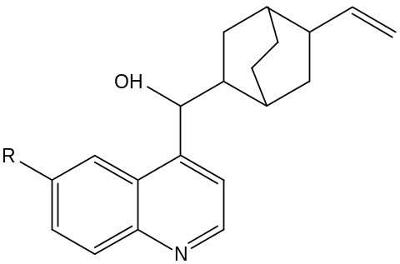

Where R= -H (Cinchonine)
R= -OCH₃ (Quinine)

Quinoline family compounds are widely used as a parent compound to make drugs (especially anti-malarial medicines), fungicides, biocides, alkaloids, dyes, rubber chemicals and flavoring agents. They also have antiseptic, antipyretic and antiperiodic properties. They are also used as catalyst, corrosion inhibitor, preservative and as solvent for resins and terpenes and in the production of paints. Since the preparation of quinoline must proceed from available materials, the different methods have been described below.
1.2 Synthetic route for Quinolines
a. The Skraup synthesis
The Skraup synthesis is probably the most important synthetic route to quinoline derivatives. quinoline is produced when aniline, concentrated sulphuric acid, glycerol and oxidizing agent are heated together. The reaction has been shown to proceed by dehydration of glycerol to acrolein; to which aniline then adds in conjugate fashion. Acid-catalysed cyclization produces a 1,2-dihydroquinoline finally dehydrogenated by oxidizing agent to give the quinoline. The skraup synthesis is the best for the ring synthesis of quinoline unsubstituted on the hetero-ring [3].

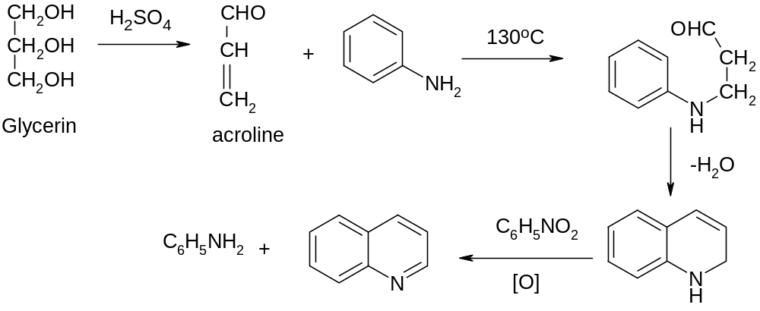

b. The Doebner V. Miller Synthesis
In 1881 Doebner and V. Miller reported that when aniline is heated with paraldehyde and sulfuric acid, quinaldine results. [4] It was also noted that HCl was preferable to sulfuric acid. It has been found that addition of little Zinc chloride to the reaction mixture results in increased yield. [5]

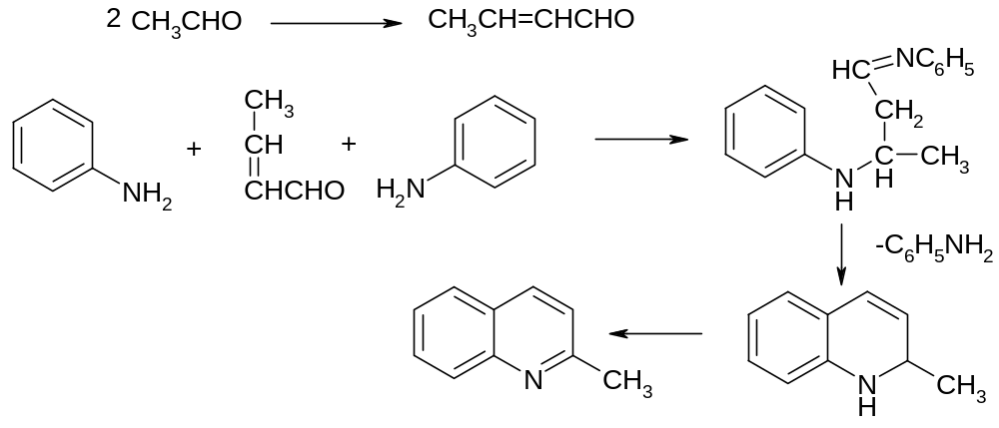
c. Beyer’s Modification of the Dobner-V. Miller synthesis
Substitution of a methyl ketone for the second molecule of aldehyde in the Dobner-V. Miller synthesis [6] results in the formation of a 2,4-disubstituted quinoline.

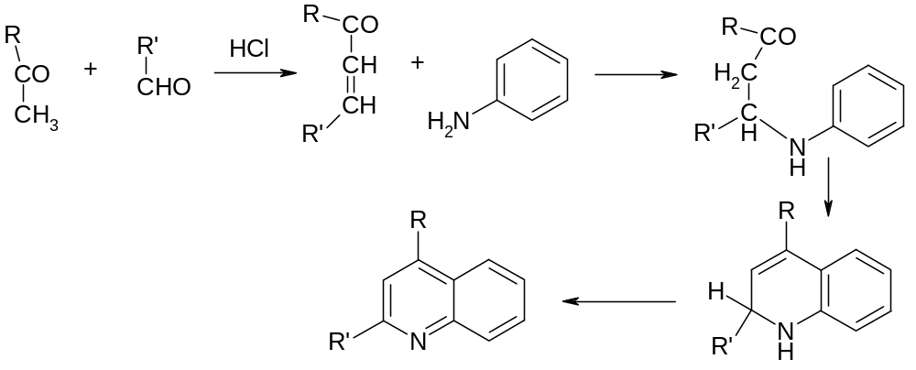

Other methods for the synthesis of quinoline and its various derivatives has been reported in literature. [7-10]

1.3 Synthesis and reactions of 2-chloro-3-formyl quinoline
As the quinoline compounds reported in this thesis are derived from 2-chloro-3-formyl quinoline, details regarding its synthesis and reactions are also reviewed here.
1.3a Synthesis of 2-chloro-3-formyl quinoline
In the broad field of quinoline, 2-chloro-3-formyl quinoline possesses a prominent position in the intermediate category as it can be utilized for the synthesis of many heterocyclic compounds. There has been relentless interest towards the use of Vilsmeier-Haack reagent in organic synthesis of several nitrogen and oxygen heterocycles. The Vilsmeier-Haack reagent (Halomethyleneiminium salt) formed from the interaction of dialkyl formamides such as DMF with POCl₃ has attracted the attention of synthetic organic chemists since its discovery in 1927.[11] It is one of the most commonly used reagents for the introduction of an aldehydic(-CHO) group in to aromatic and heteroaromatic compounds. It is proved to be a mild and efficient method for the formylation. [12-17]. The utility of this reagent also explores the powerful route for the synthesis of substituted 2-chloro-3-formyl quinoline.
Meth-Cohn and co-worker s [18] have shown that reaction of acetanilide with the Vilsmeier-Haack reagent using POCl₃ as solvent resulted in to a quinoline derivative called 2-chloro-3-formyl quinoline (1).

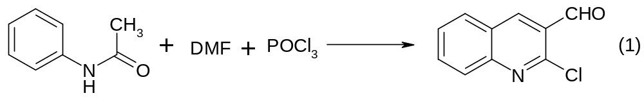

MECHANISM
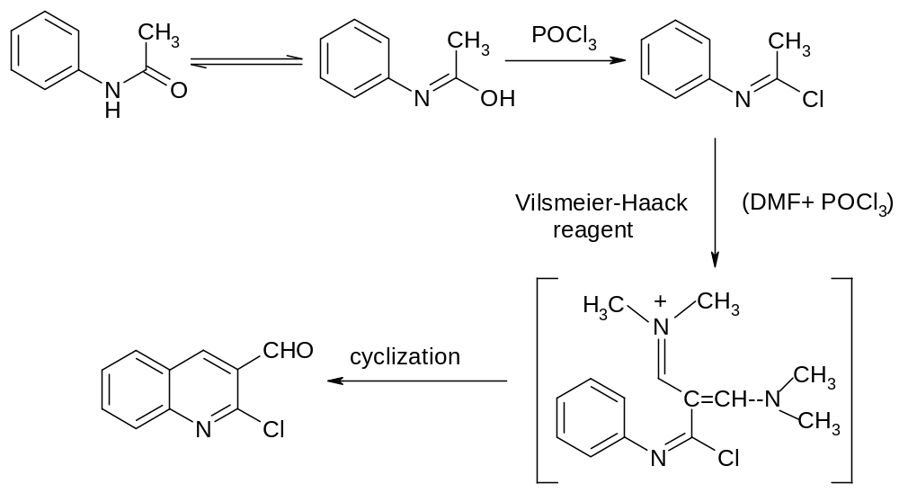
P. T. Perumal and R. R. Amaresh have reported synthesis of 4-chloro-3-quinolinecarboxaldehyde (2) from o-aminoacetophenone using Vilsmeier reagent.[19]

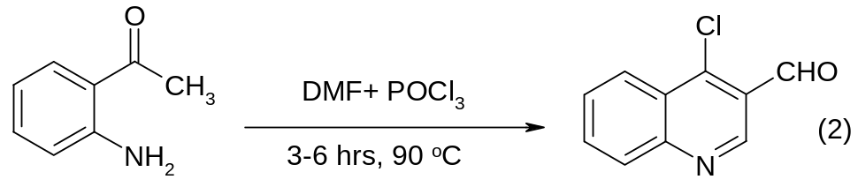

Mazahir Kidwai and Shelly Jindal have described the method for the preparation of substituted 2-chloro-3-formyl quinoline (3) starting from acetoacetanilide [20].

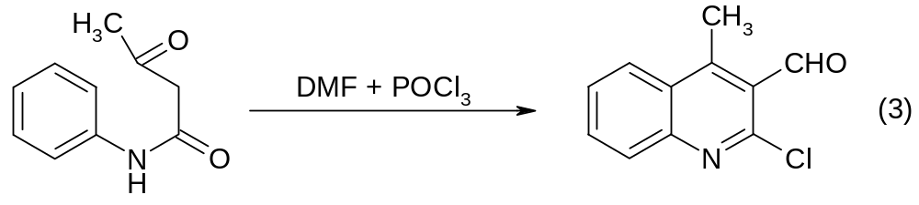
P. A. Pawar, P. B. Bajare and coworkers have also reported synthesis of 2-chloro-3-formyl-4-methyl quinoline (4) from acetophenone oxime under the Vilsmeier cyclization conditions [21].
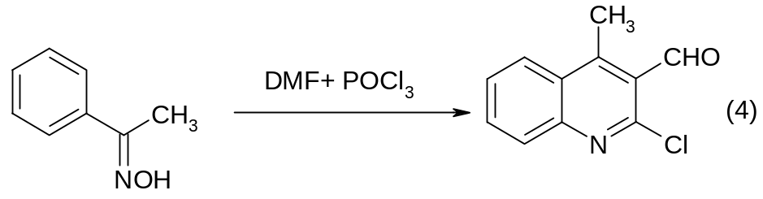
Rajjana and coworkers have reported that acetanilids undergo Vilsmeier-Haack cyclization in micellar media to afford the corresponding 2-chloro-3-formyl quinoline derivatives in good yields.[22] As the current trend of green chemistry they have also synthesized the 2-chloro-3-formyl quinolines using ultrasound in the presence of micelles like CTAB (cetyltrimethylammonium bromide). Under ultrasonic irradiation the reaction time were reduced with dramatic enhancement in the yield of reaction products.[23]

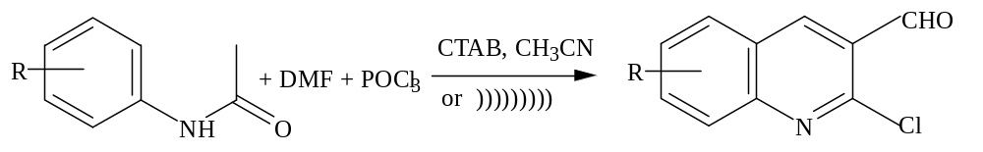

1.3B Reactions of 2-chloro-3-formyl quinoline
The substituted 2-chloro-3-formyl quinolines are the unique intermediates as they can be utilized for various functional group interconversions. [24-25]
The presence of electron rich nitrogen at 1-position and electron withdrawing formyl group at 3-position activates the chlorine towards various displacement reactions. Some examples of the displacement reactions at 2-position are cited below.

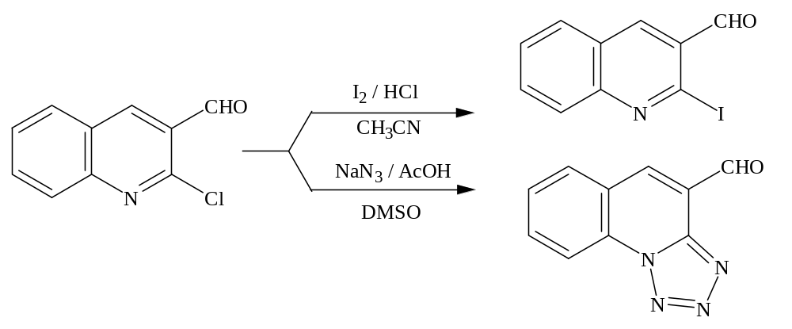
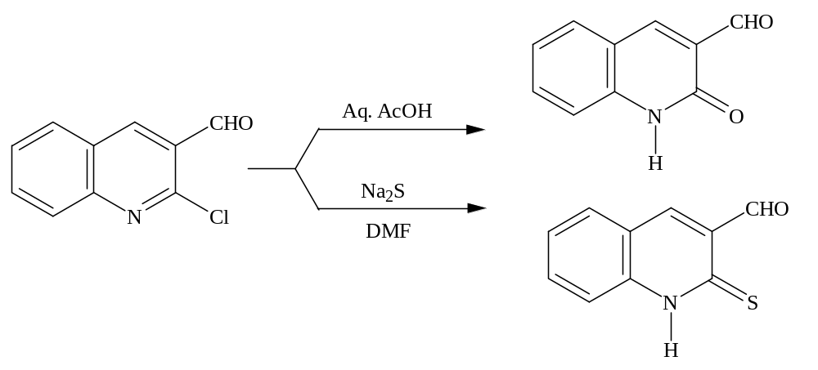
Formyl group of the 2-chloro-3-formyl quinoline also undergoes various addition and condensation reactions to give different compounds. Formyl group at 3-position is highly reactive towards hydrazine hydrate, phenyl hydrazine and hydroxylamine.

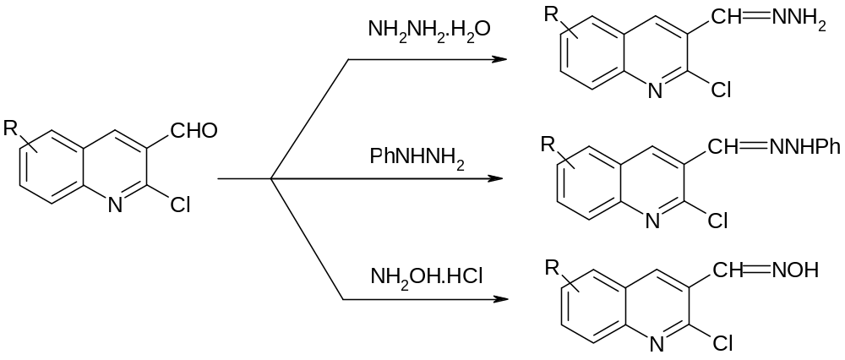It also undergoes oxidation, reduction and Grignard reactions.
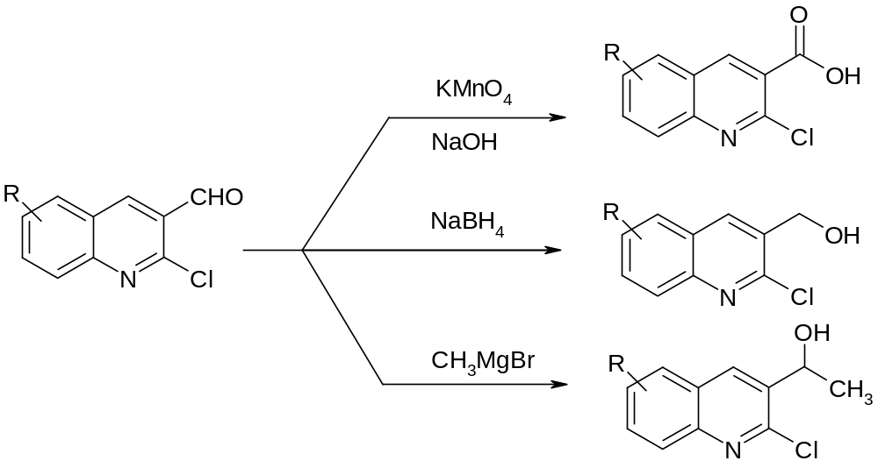
It undergoes various electrophilic and nucleophilic substitution reactions. Some examples are shown below.
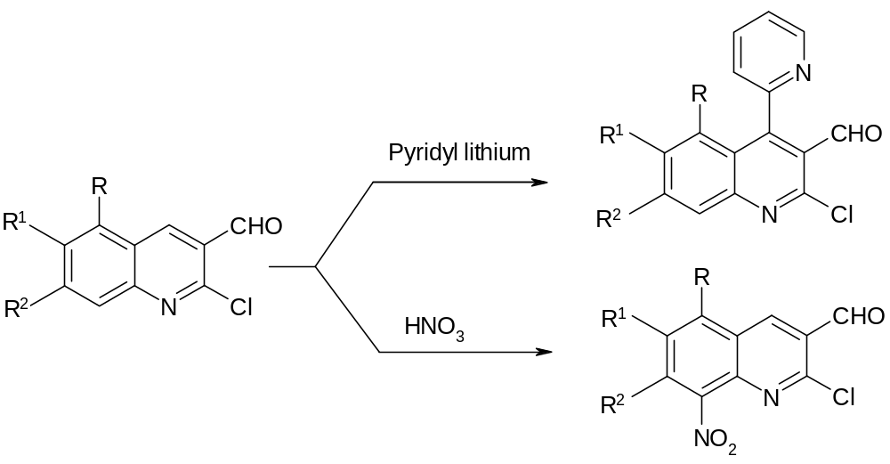

Among quinolines, 2-chloro-3-formyl quinolines are versatile intermediate for further [b] and [c] annellation [26] for various heterocyclic ring systems. Some examples of [b] annellation are shown here.
Tricyclic condensed quinoline system can be obtained from 2-chloro-3-formyl quinoline; an example for the preparation of theine quinoline derivatives (5) is described as follows.[27]

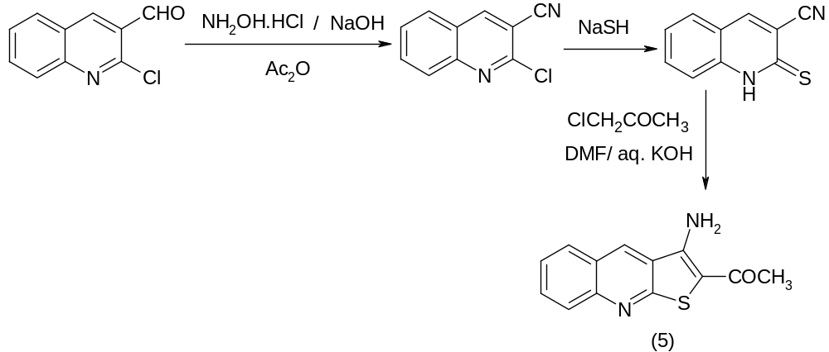

2-Chloro-3-formyl quinoline upon condensation with ethyl mercaptoacetate in ethanol, generates a five membered thiophene ring (6)[28] and upon condensation with guanidine nitrate in alcoholic sodium hydroxide it cyclizes to give 3-aminopyrimido[4,5-b] quinolines (7).[29]

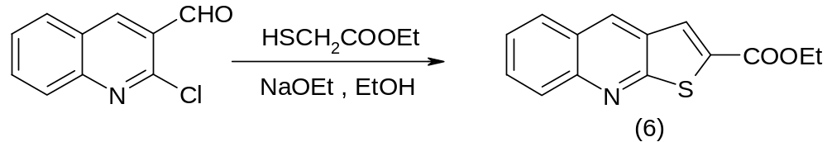

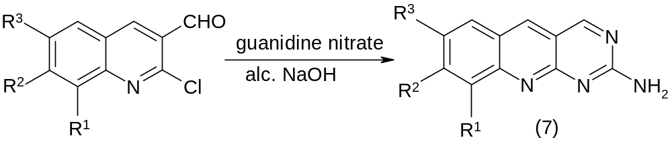

The fused tetracyclic derivatives, 3-aryl/alkyl-9-substituted-1,2,4-triazolo[3,4-b] [1,3,4] quinoline thiadiazepines (8) have been reported by B. Kalluraya and others by reaction of 6-substituted-2-chloro-3-formyl quinolines and 3-subtituted-4-amino-5-mercapto-1,2,4-triazole.[30]
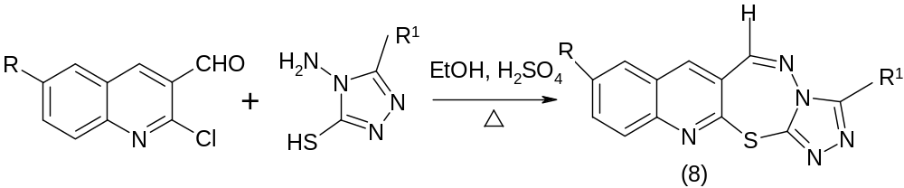Where, R= H, CH₃, OCH_{3,} R¹ = Me, n-C₃H₇, Ph, p-ClC₆H₄.

R. Nandha Kumar and co-worker [31] have prepared 2,3-heteroannelated quinoline derivatives (9) like quino [3,2-f] benzoxazepines by reaction of substituted 2-chloro-3-formyl quinoline and 2-aminophenol in methanol.
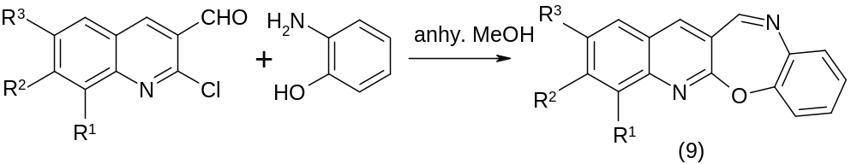
Where, R¹ ⁼ H, CH₃, OCH₃
R² ⁼ H, CH₃
R³ ⁼ H, OCH₃

2-chloro-3-formyl quinoline on treatment with benzil in the presence of ammonium acetate and acetic acid gives 2-amino-3-[(4’5’-diphenyl)-imidazol-2’-yl] quinoline (11) while with ethyl aminocrotonate gives 2-amino-3-[4’-(2’,6’-dimethyl-3’,5’-dicarbethoxy-1’,4’-dihydropyridyl)] quinolines (12).[32]
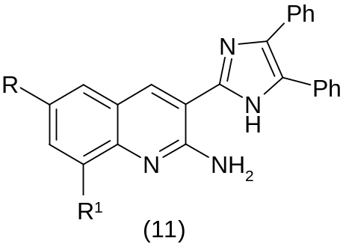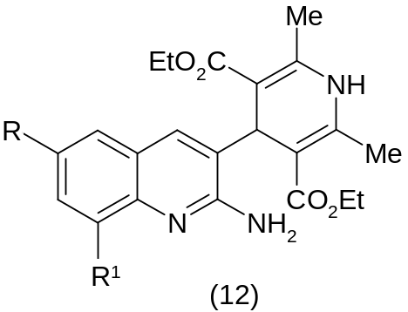
R= H, Me, OMe R= H, Me, OMe
R¹=H, Me R¹=H, Me

Judith Toth and coworkers have reported the synthesis of new 2-chloro3-formyl quinoline derivatives.[33]
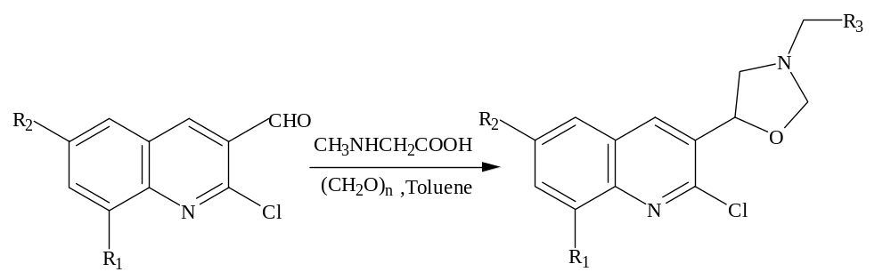
Where: R₁=H, Cl, Me; R₂=H, Me, OMe; R₃=H, Ph

1.3C Some reactions as per current green chemistry trend
a. An efficient microwave –assisted synthesis of thienoquinolines under solvent free conditions from 2-chloro-3-formyl quinolines using K₂CO₃ as catalyst.[34]

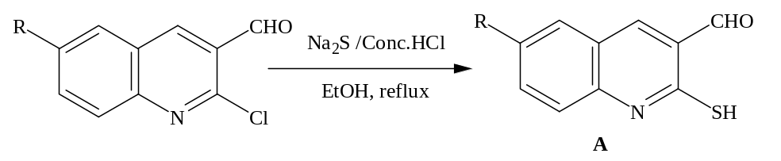

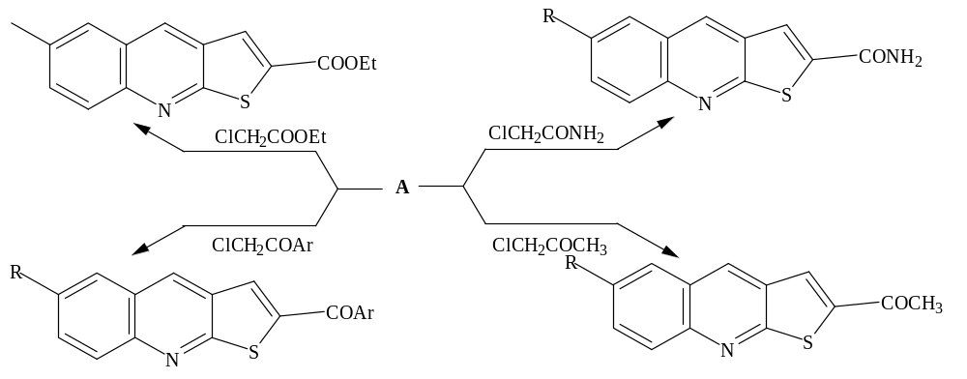

b. One pot synthesis of some new quinoline derivative under microwave irradiation conditions.[35]
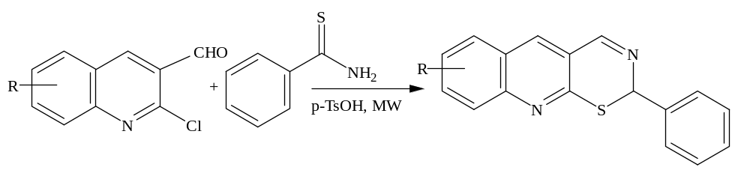
M. Ragvendra and coworkers have reported some new thiazapino quinoline derivatives under microwave irradiation.[36]
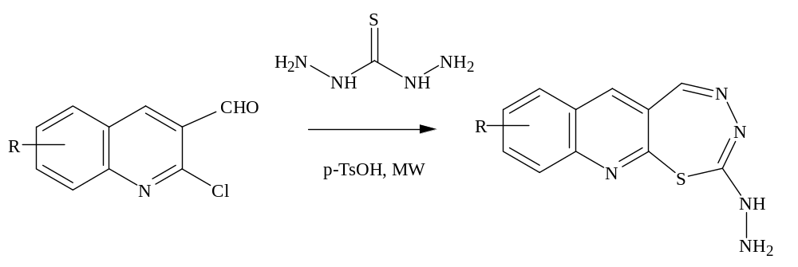
1.4 Quinoline derivatives as therapeutic agents
A number of derivatives of quinoline serve as valuable therapeutic agents. Some hundred years ago cinchona bark was introduced for the treatment of malaria, and until very recently quinine has remained the standard remedy for this disease. Several other synthetic antimalarial drugs are based on quinoline nucleus e.g., chloroquine. Ciprofloxacin is effective antibacterial agent in the market.
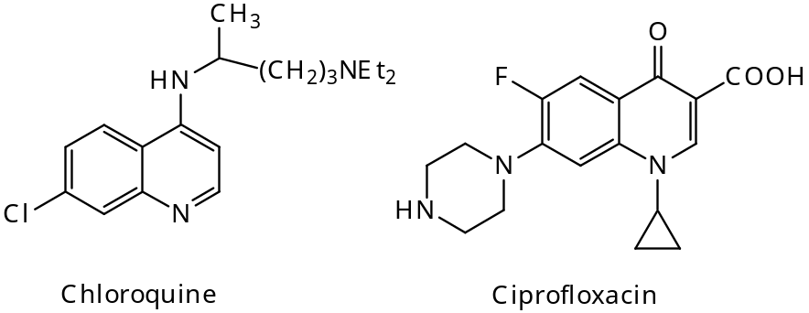
Considerable interest has been created in the chemistry of quinoline due to their wide spectrum of therapeutic activities like bactericidal [37-39], antihypertensive[40],antimalarial[41],antidepressant[42],analgesi[43],antiulcer[44],antiviral[45],anthelmintic[46],antitumor[47]antiallergic[48],anticonvulsant[4,anti-inflammatory[50] etc.
Some of the therapeutically active compounds derived from 2-chloro-3-formyl quinoline derivatives are reviewed here.
T. Suresh and co-workers [51] have reported the synthesis of various 4-phenyl-3-thiopyrimido[4,5-b] quinoline derivatives (13) which shows antibacterial and antifungal activities.
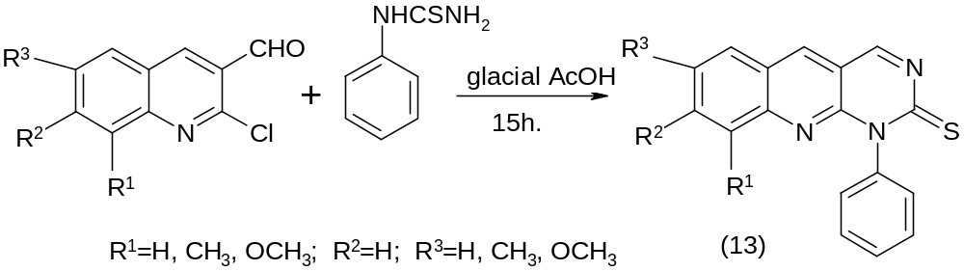
Rajiv Gupta et al [52] have reported anti-inflammatory, antibacterial and antifungal activities of quinoline derivatives, 2-chloro-6/8-subtistuted-3-(3-alkyl/aryl-5,6-dihydro-5-triazolo-[3,4-b][1,3,4]thiadiazol-6-yl)-quinoline(14). 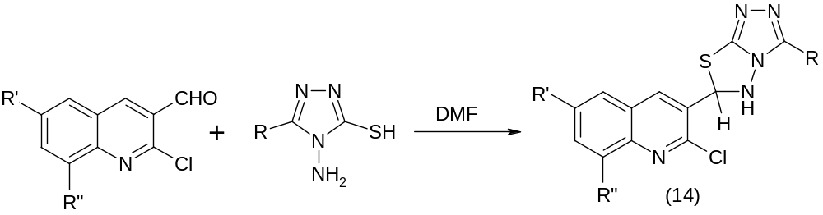
Parikh and co-workers [53]¹⁴⁹ have reported antimicrobial activity of some formazan derivatives of the type (15).

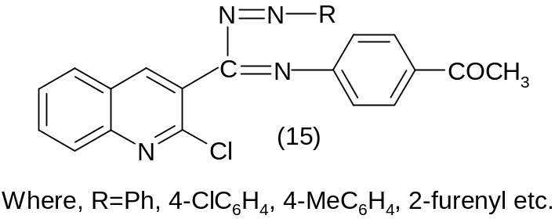
Fathy N. M. and Aly A. S. have reported azomethine derivatives of 2-chloro-3-formyl quinoline of the type (16), which shows bactericidal and fungicidal activity.[54]

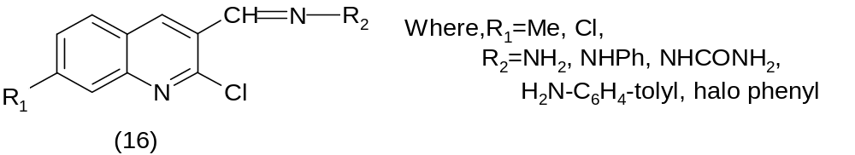
Parikh et al [55] have reported antifungal and antibacterial activities of some Schiff bases (18) and their 2-azetidinones derivatives (19) of 2-chloro-3-formyl quinoline.

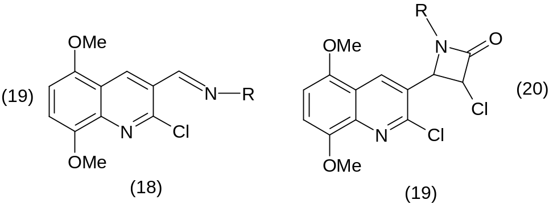
Pyranoquinoline alkaloids have gained considerable importance due to their pharmacological activities like anticonvulsant, coronary constricting, optically brightening, antifungal activities and as optically brightening. N. Venkatesh Kumar and co-workers [56-57] have reported pyranoquinoline derivatives of types (20) from 2-chloro-3-formyl quinoline.
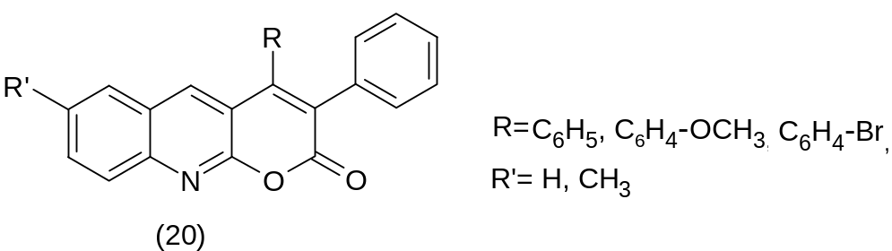

Antimicrobial activity of quinoline derivatives of type (21, 22) are reported by Khunt et al. [58]
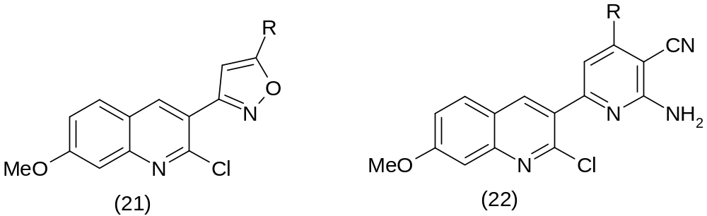

Chapter-2 PRESENT WORK
PRESENT WORK

Literature survey reveals that quinoline derivatives having a vast variety of biological activities. Hence, it has been thought worth to combine these two moieties in a single framework in order to enhance the biological profile many folds than its parent nuclei.
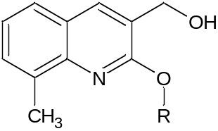 | R = CH_{3.}  CH₂CH₃

2.1 EXPERIMENTAL
This part of the chapter explores the synthesis, characterization and biological profile of the synthesized compounds.
The purity of the synthesized compounds including intermediates were checked by thin layer chromatography (TLC) using silica gel G, and chromatography was developed using a mixture of Toluene: Ethylaceate (7:3).
2.1 A Synthesis of (2-Alkoxy-8-methylquinolin-3-yl) methanol
The title compounds were synthesized in following steps:
- Synthesis of 2-chloro-8-methylquinoline-3-carbaldehyde.[1]
- Synthesis of 2-Alkoxy-8-methylquinolin-3-yl) methanol [2 and 3]

(a) Synthesis of 2-chloro-3-formyl quinoline.[1]
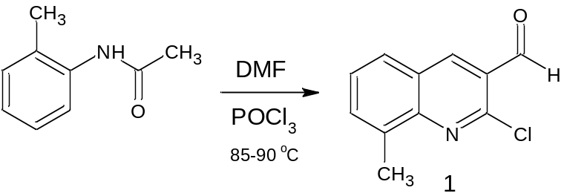
Scheme 2.1 Synthesis of 2-chloro-8-methylquinoline-3-carbaldehyde (1)

Dimethylformamide (19.2 ml, 0.250 moles) was charged in a three-necked round-bottomed flask equipped with a thermometer, a drying tube and mechanical stirrer and cooled to 0ºC. To it phosphorous oxychloride (64.4ml, 0.70 moles) was added drop wise with stirring at 0-10ºC. To the solution, N-(2-methylphenyl) acetamide (0.10 moles) was added and the mixture was heated under reflux for 22 hours at 80-90ºC. The reaction mass then cooled to room temperature and poured in crushed ice (300gm) with mechanical stirring. The product isolated was filtered and washed with water till neutral. The solid was crystallized from ethyl acetate to give light yellow compound.
Table-1: Physical data for compound I
Compd. | M.P. (ºC) | Mol.Wt. (gm) | % Yield
1 | 136-140 | 205 | 44.77%

TLC of the Reaction:
The reaction was monitored by using thin layer chromatography (TLC). After 6 hrs reflux of reaction, the TLC of the above reaction-I was carried out in n-hexane: Ehyal acetate (3:1).

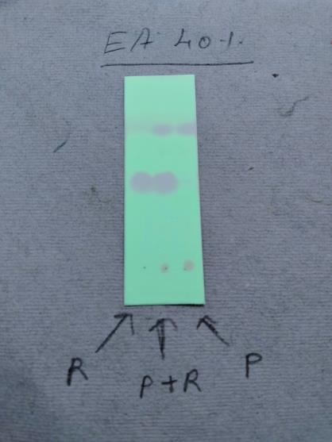

TLC of 2-Chloroquinoline 3-carbaldehyde

(b) Synthesis of (2-Methoxy-8-methylquinolin-3-yl) methanol [2].

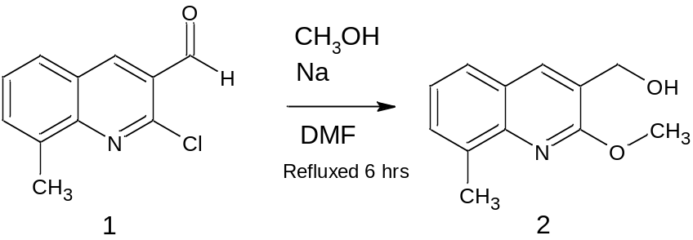
Scheme 2.2: Synthesis of (2-Methoxy-8-methylquinolin-3-yl) methanol (2)

Experimental Procedure: 0.98 gram of sodium (0.043 mol) was dissolved in 10 mL methanol, and 2-chloro-8-methylquinoline-3- carbaldehyde (0.5 g, 0.0024 mol) and 10 mL of N, N-dimethylformamide were added to it. A reaction mixture was refluxed for 6 hours, at which TLC analysis showed complete disappearance of the aldehyde. After removal of methanol using distillation, the remaining content was cooled to room temperature and added to 100 mL ice-cold water. A precipitate was collected by fractional distillation

TLC of the Reaction:
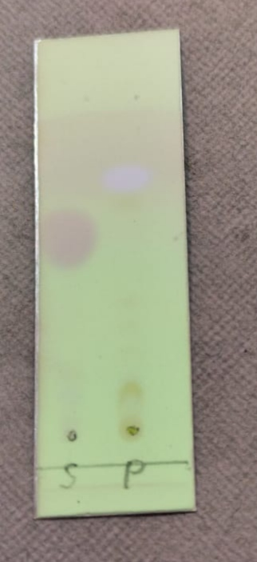
The reaction was monitored by using thin layer chromatography (TLC). After 6 hrs reflux of reaction, the TLC of the above reaction-I was carried out in n-hexane: Ethyl acetate (3:1).

TLC of (2-Methoxy-8-methylquinolin-3-yl) methanol

(C) Synthesis of (2-Ethoxy-8-methylquinolin-3-yl) methanol [3].

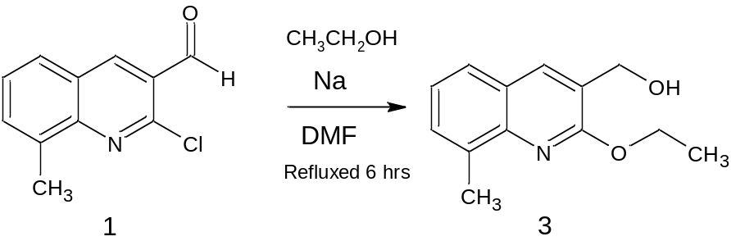
Scheme 2.3: Synthesis of (2-Ethoxy-8-methylquinolin-3-yl) methanol [3].
Experimental Procedure:

Sodium (1 g, 0.043 mol) was dissolved in ethanol (10 mL), and 0.5 g (0.0024 mol) of 2-chloroquinoline-3-carbaldehyde and 10 mL of N, N-dimethylformamide were added to it. A reaction mixture was refluxed for 5 hours, at which TLC analysis showed complete disappearance of the aldehyde. ethanol was removed by distillation, and the remaining content was cooled to room temperature and added to 100 ml cold water. +e precipitate was collected by fractional distillation
TLC of the Reaction:
The reaction was monitored by using thin layer chromatography (TLC). After 6 hrs reflux of reaction, the TLC of the above reaction-I was carried out in n-hexane: Ethyl acetate (3:1).
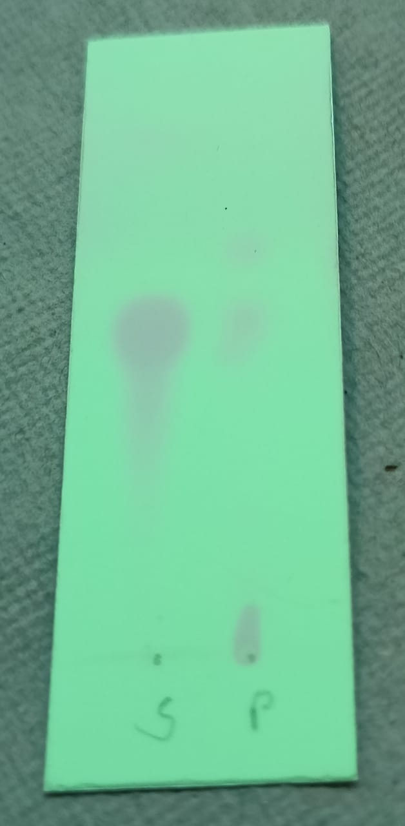

TLC of (2-Ethoxy-8-methylquinolin-3-yl) methanol.
Chapter-3 RESULTS AND DISCUSSION

Reaction Scheme 2.1 outlines the synthesis of 2-chloro-3-formyl quinoline (1). Reaction Scheme 2.2 and Scheme 2.3 outlines 2-alkoxy3-formyl quinolines 2 and 3. Acetanilide, Dimethylformamide, POCl₃, Alcohols etc. are commercial products and were used without further purification. All the solvents were distilled before use. The purity of the synthesized compounds including intermediate was checked by thin layer chromatography (TLC) using silica gel G, and chromatography was developed using a mixture of n Hexane: Ethyl acetate. All the melting points are uncorrected and expressed in ºC. Elemental analysis (% C, H, N) were carried out by Perkin Elmer 2400 CHN analyzer. IR spectra of all the compounds have been recorded on Nicolet Impact 400D FT-IR spectrophotometer using KBr. The ¹H-NMR spectra and ¹³C-NMR Spectra have been recorded on a Bruker Advance (300/400MHz) spectrophotometer using solvent as internal standard in CDCl₃ and DMSO-d₆. Some selected FT-IR, ¹H-NMR and ¹³C-NMR spectra are furnished at the end of this part of the chapter.

3.1 CHARACTERISATION

Table-2: Physical data for new quinoline derivatives [2 and 3]

Comp. | M.P. (ºC) | Mol.  Wt. | Yield % | Elemental Analysis  Calculated  (Found)
 |  |  |  | C% | H% | N%
2 | 98-99 | 203 | 53% | 70.93  (70.35) | 6.4  (6.2) | 6.89  (6.70)
3 | 85-87 | 217 | 82.7% | 71.88  (71.75) | 6.9  (6.3) | 6.4  (6.1)

Spectral Analysis of new quinoline derivatives
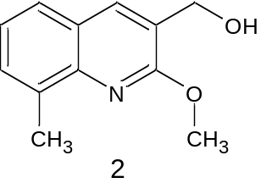
2-Methoxy-8-methylquinolin-3-yl) methanol [2]. C₁₂H₁₃NO₂
IR cm⁻¹ | 3470 (br-alcohol CHO-H str.), 3013 (aromatic C-H str.), 2930.9 (aliphatic C-H str.), 1625 (quinoline C=N str.), 1589.6 and 1475.5 (aromatic C=C str.
¹H NMR δ_{H} ppm | (400 MHz; CDCl₃) δH 2.80 (3H, s, H-10), 4.11 (3H, s, H-9), 4.79 (2H, s, H-1), 7.28 (1H, t, J 7.58 Hz, H-6), 7.42 (1H, d, J7.0 Hz, H-7), 7.58 (2H, d, J 8.34. Hz, H-5), 7.86 (1H, s, H-4);
¹³C NMR δ ppm | (100 MHz, CDCl3) δC 18.1 (C-10), 51.3 (C-9), 61.9 (C-1),  123.8 (C-3), 124.1 (C-6), 124.2 (C-4a), 125.0 C-5), 129.4 (C-7), 135.1 (C-8), 135.9 (C-4), 144.7 (C-8a), 160.2 (C-2).
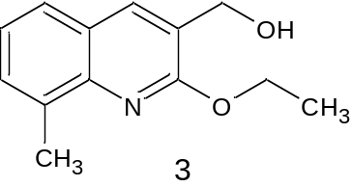
2-Ethoxy-8-methylquinolin-3-yl) methanol [3].C₁₃H₁₅NO₂
IR cm⁻¹ | 3502–3148 (OH str.), 3025 (aro-  matic C-H str.), 2930.9 (aliphatic C-H str.), 1625 (quinoline  C N str.), 1582 (aromatic C C str.);  �
¹H NMR δ_{H} ppm | (400 MHz; CDCl3) δH 1.5 (3H, t, J 7.01 Hz, H-10), 2.74 (3H, s, H-11) 4.63 (2H, q, J 7.01 Hz, H-9), 4.48 (2H, s, H-1), 7.26 (1H, t, J 7.04 Hz, H-6), 7.47 (1H, d, J 6.89 Hz, H-7), 7.56 (1H, d, J=7.80 Hz, H5) 7.93 (1H, s, H-4).  �  � �
¹³CNMR δ ppm | (100 MHz, CDCl3) δC 13.7 (C-10), 19.3 (C-11), 61.5 (C-1), 61.8 (C-9), 123.0 (C-9), 124.2 (C-6), 124.90 (C-4a),  125.0(C-5), 130.3 (C-7), 135.0 (C-8), 135.8 (C-4), 144.7 (C-8a), 158.3 (C-2).

Results of spectral studies
Examination of the IR-spectra of these compounds reveal the expected frequencies. Some of the important frequencies are indicated as: band around 3470 cm⁻¹ for (br-alcohol CH-OH stretching.), band around 1582 cm⁻¹for (-C=C- stretching of aromatic ring), band around 3025 cm⁻¹ (aromatic C-H str.) and 2930.9 cm⁻¹(aliphatic C-H str.) confirms the quinoline derivatives as a result of reduction between substituted quinolines and heterocycles. ¹H-NMR studies reveal that peak around 7.93(1H-s, H-4) indicated the olefin –CH=C- proton and the peak around 8.c indicated the –OH proton. The peak around 125δ (C-5) and 144.7 δ (C-8a) just before aromatic region in ¹³C-NMR indicated the carbon.
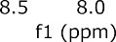
¹H-NMR Spectra of Compound-1

¹³C-NMR Spectra of Compound 1

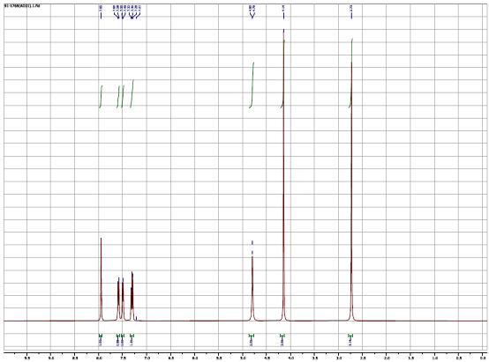

¹H-NMR Spectra of Compound-2

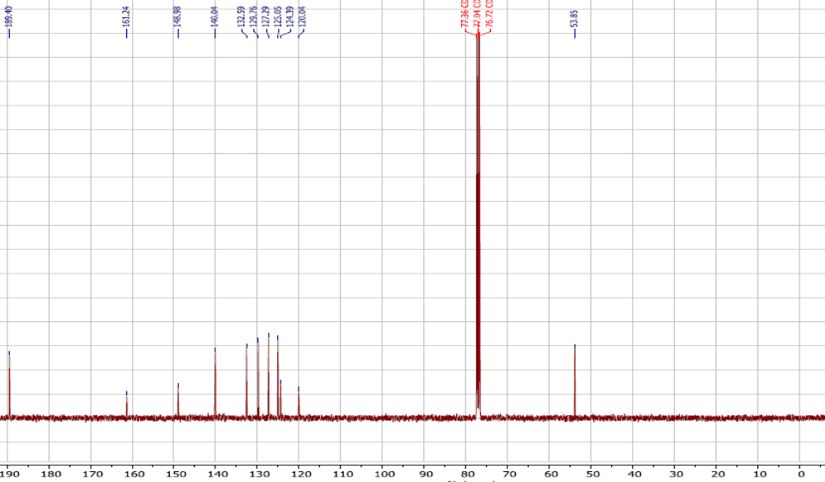

¹³C-NMR Spectra of Compound 2
1H-NMR spectra of Compound 3

¹³C-NMR spectra of Compound 3

Chapter-4 CONCLUSION

In recent years, much attention has been focused on the synthesis of quinoline based heterocycles due to their significant biological activity. The quinoline heterocycles is useful scaffold to develop biological molecules. In view of above observation and knowing the importance of heterocycles quinoline derivative, the biological important derivatives 2-3 have been synthesized from 2-chloro-3-formyle quinoline [1]. The synthesized compound is characterized by TLC, melting point, various spectroscopic method like IR, ¹H NMR,¹³C NMR. Notable feature of this method are readily available starting materials, mild reaction conditions, and broad substrate scope. Further extension of this study can be possible by screening all synthesized compounds of their biological activity and can be further optimized to serve as lead compound.

Chapter-5 REFERENCES
- Runge., Ann. Physik and Chem., 1834, 31(2), 65.
- Gerhardt., Ann. Chim. et Phys., 1842, 7(3), 251.
- Skraup., Ber., 1880, 13, 2086.
4. Dobner and V. Miller., Ber., 1881, 14, 2812.
5. Mills, Harris and Lambourne., J. Chem. Soc., 1922, 119, 1294.
6. Beyer., J. Parkt. Chem., 1886, 33(2), 393.
7. Beyer, J. Prakt. Chem., Vol.33, p.393, 1886.
8. Jones and Evans., J. Chem. Soc., 1911, 99, 334
- Hausher and Reynolds., J. Am. Chem. Soc., 1948, 70, 2402.
- Engler and Riem, Ber., 1885, 18, 2245.
- A. Vilsmeier and A. Haack., Berichte, 1927, 60, 119.
- C. M. Marson., Tetrahedron., 1992, 48, 3659.
- C. Jutz., Advance in organic chemistry, Ed by Taylor, 1976, 225.
- S. S. Eshadri., J. Sci. Ind. Res., 1973, 32, 128.
- O. Meth Cohn and B. Tarnowski., Adv Heterocycle chem., 1982, 31, 128.
- O. Meth Cohn., Heterocycles., 1993, 35, 539.
- O. Meth Cohn and D. L. Taylor., J. Chem. Soc. Chem. Commun., 1995,1463.
- O. Meth Cohn, B. Narine and others, J. Chem. Soc., Perkin Trans I, 1981, 1520.
- R. R. Amaresh and P. T. Perumal., Indian J. Chem., 1997, 36B, 541.
- M. Kidwai, S. Jindal and S. Kohli, Indian J. Chem., 2002, 39B, 462.
- P. A. Pawar, P. B. Bajare and S. B. Munande, J. Ind. Chem. Soc., 1990, 87, 685.
- M. M. Ali, Tasneem, K. C. Rajjana, P. K. Saiprakash., Synlett., 2001, 251.
- M. M. Ali, Tasneem, K. C. Rajjana, P. K. Saiprakash., Synth. Commun., 2002, 32, 1351.
- S. P. Rajendran, M. Manonmani and S. Vijaylakshmi., Org. Prep. Proced Int, 1994, 26, 383.
- A. Srivastava and R. M. Singh, Indian J. Chem., 2005, 44B, 1868.
- M. Kidwai and M. Negi., Monatosh. Chem., 1997, 128, 85.
- S. K. Nandeeshaih and Y. Sarvottam Ambekar, Indian J. Chem., 1994, 33B, 688.
- Ligaian Nagarapu and Narendar Ravirala., Indian J. Chem., 1998, 37B, 39.
- R. N. Kumar,T. Suresh and P. S. Mohan., Indian J. Chem., 2003, 42B, 688.
- B. Kalluraya, R. Gururaja, G. Rai., Indian J. Chem., 2003, 42B, 211.
- R. N. Kumar, T. Suresh and P. S. Mohan., J. Indian Chem. Soc., 2002, 79, 774.
- V. H. S. Krishnan, P. K. Dubey, S. S. Rao and V. Arapna, Indian J. Heter. Chem., 2003, 13(1), 11.
- Judith Toth, G. Blasko, A. Danso, L. Toke and M. Nyerges. Synth. Commun., 2006, 36, 3581.
- B. P. Nandeshwarappa, D. B. Arunakumar, H. S. Bhojyanaik and Kittappa M. Mahadevan., J. Sul. Chem., 2005, 26(4), 373.
- M. Ragvendra, H. S. Bhojyanaik, T. R. Rajkumarnaik and B. S. Sherigara., J. Sul. Chem., 2007, 28(2), 165.
- M. Raghvendra, H. S. Bhojyanaik and B. S. Sherigara., Arkivok, 2006, 15, 153.
- Kyorin Pharmaceutical Co Ltd., Belg. Be 890, 223 (Cl C07 D); Chem. Abstr., 1982, 96, 181311e.
- Kuo, Hsien-Shou Tung, I-Chin, Hui-min Pharmaceutical Co. Ltd., Jpn. Kokai, Tokkyo Koho JP 58, 67, 672(Cl C07 D 215/38); Chem. Abstr., 1981, 99, 880699.
- S. Vurbanova and S. Chervenkov, Chem. Abstr.,1987, 107, 77601g
- Mohrhayer, Rolf Noigt, Dietrich, Voiget, D. Hiltru., Chem. Abstr., 1982, 96, 217722d.
- Zheng, Xianyu., Chen Cheng, Guo Huizhu, Feng Zhihui., Yaoxue Xuebao, 16(7), 1981, 502; Chem. Abstr., 1982, 97, 5566a.
- Archibald, John Leheup, Ward, Terence James; Brit UK Pat. Appl. GB 2, 182, 935; Chem. Abstr.,1987, 107, 198110e.
- S. Mehrotra, J. P. Barthwal, and T. K. Gupta., Indian J. Physiol, Pharmacol., 1982, 26(3), 253.
- Uchida Minoru, Komatsu Makoto, Morita Seiji; Chem. Abstr., 1986, 104, 88454a.
- Radi, Stanislav, F. Roubinek, V. Zikan, and F. Smejkal, Chem. Abstr., 1987, 106, 18429p.
- R. J. Alamino, C. F. Spencer, J. B. Sheffer, R. J. Storrin, C. J. Hatton and R. E. Kohis., J. Med. Chem., 1978, 21(3), 298.
- J. Atwal Graham, D. Bw Claudia, C. Baguley Bruce and A. Denny William., J. Med. Chem., 1988, 31(5), 1048.
- Ozeki, Kohji Ishizuka, Yashiro., Sawada, Mashiro., Yaginuma, Hideya., Chem. Abstr., 1987, 107, 217458t.
- Simiande, Jacaues, Boigegrain, Robert Keane, Peter, Eugene, Vernieres, Jean Claude; Chem. Abstr., 1988, 108, 94413k.
- Kreft, Anthony Frank, Kees Kenneth Lewis, Musser John Henry, Bicksler James Jacob; Brit UK Pat. Appl. GB 2,181,135; Chem. Abstr., 1987, 107, 96605c.
- T. Suresh, R. N. Kumar, S. Magesh and P. S. Mohan., Indian J. Chem., 2003, 42B, 2133.
- R. Gupta, A. K. Gupta, S. Paul and P. L. Kachroo., Indian J. Chem., 1998, 37B, 1211.
- R. C. Khunt, N. J. Datta and A. R. Parikh., Journal of the Institution of Chemists, 2002, 74(1), 18.
- N. M.Fathy, A. S. Aly, Abd. El. Motti, Egypt J. Chem., Vol. 29(5), p.609, 1986; Chem. Abstr., 1989, 110(25-26), 231409w.
- B. P. Kansagro, H. H. Bhatt, A. R. Parikh, J. Inst. Chem., 2000, 72(2), 68.
- N. Venkatesh Kumar, B. Subramani and S. P. Rajendran, J. Indian Chem. Soc., 2003, 80, 918.
- N. Venkatesh Kumar, B. Subramani and S. P. Rajendran., Asian J. Chem., 2004, 16(2), 848.
- R. C. Khunt, N. J. Datta., Bharmal, M. Fatima, G. P. Manjad, A. R. Parikh; Indian J. Heterocyclic Chem., 2000, 10(2), 97.

