RESUME
Drashti Gohil T/2 Divya Appartment,
Pratapkunj Society,
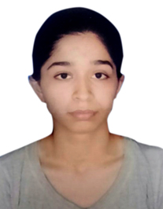
Nr, G.B.Shah College,
Vasna, Ahmedabad, 380007.
(+91) 8980695272
Drashti.gohil@gmail.com

Career Objective:
To work with an organization that can give me ample opportunities to grow so that I will be able to help in the growth of that organization as well as enhance my skills and my capabilities.

Academic Qualifications:
Exam. | Board/University/Institute | Year of Passing | Grade/Percentages
P.G.D.M | Som-Lalit Institute | 2018 | Pursuing
B.Com | Gujarat University | 2016 | 68%
H.S.C. | Gujarat Board | 2013 | 76%
S.S.C. | Gujarat Board | 2011 | 85%
Extra Qualifications:
Certified course on computer concepts (CCC)

Personal Details:

Full Name : Drashti Jayendra Gohil
Date of Birth : 22nd Feb, 1995
Gender : Female
Matiral Status : Single
Nationality : Indian
Religion : Hindu
Languages Known : English, Hindi, and Gujarati

Skills:
- Knowledge of windows applications (Word, Excel, Office, PowerPoint) – Advanced.

Hobbies:
- Reading, Music, Drawing
Place : Ahmedabad
Date : 23rd March, 2017 (Drashti Gohil)

