
VIREN MEHTA
: +91-9898691622
: viren08mehta@gmail.com
: I/501, Safal Parivesh, Prahaladnagar, S G Road, Ahmedabad, India
Date of Birth: 5th June 1976

Senior Management Professional
Head of Administration ● Profit Centre Operations ● Real Estate & Banking Operations
Effective and efficient day-to-day operations of the company, Enterprising leader & planner with a strong record of contributions in streamlining operations, invigorating businesses, heightening productivity, systems & procedures

Ability to establish new business, lead operations and work in multi-cultural environment and deliver sustained profitability and growth in dynamic conditions. Duties for the Director of Administration will include managing administrative staff, guiding operating methods, disbursing funds to departments, monitoring budgets, improving information systems, overseeing human resources requirements, updating senior executives, analyzing financial data, and developing operating

SUMMARY

- Dynamic Professional with 21 years of experience in Real Estate and Banking with focus on top-line & bottom-line performance; expertise in determining company’s mission & strategic direction as conveyed through policies & objectives
- Hands-on experience in handling transactions including implementing risks management policies & controlling mechanisms, procedures and systems to detect transactions outside established parameters
- Distinction of working overseas at Equitorial Trust Bank Plc, Lagos, Nigeria in Retail Banking and Wealth Management
- Served as a core team member of Trade Finance, CMS, Audit and Risk & Compliance
- Proficiency in monitoring various banking operations and maintaining long-term relationships by providing high quality service
- Conversant with various products including Trade Finance, Cash Management, Treasury and General Banking Product
- Demonstrated excellence in formulating corporate goals, short & long term budgets, developing business plans for accomplishment of target and goal for all the branches of the organisation
- Proficient in conceptualising and implementing the competent strategies with a view to penetrate new accounts and expand existing ones for a wide range of products and services
- Expertise in penetration, churn and enhancing revenue by adding new channels and enhancing market coverage
- Leading, training & monitoring performance of team members to ensure efficiency in the operations; successfully led a team of more than 2500
- Possesses excellent interpersonal, communication and organisational skills with proven abilities in training & development, customer relationship management and planning

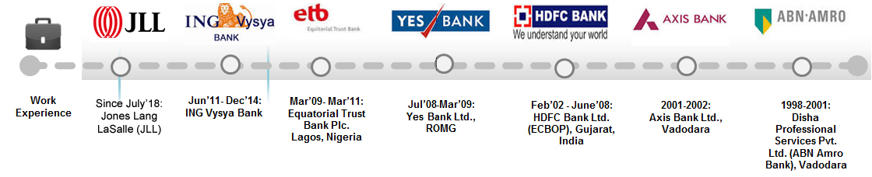

SKILL SET

- Strategic Business Planning - Retail Credit & Banking Operations - Setting-up Business Operations
- Wealth Management - Best Practices Implementation - Business Transformation
- Client & Product Management - Delivery Process Management - Fund Management
- Trade Finance / FOREX Operations - Risk Management/ Budgetary Control - Variance Analysis
- MIS Reporting - Audit and Inspection - Statutory Compliance
- Relationship Management - Team Management - Stakeholder Management

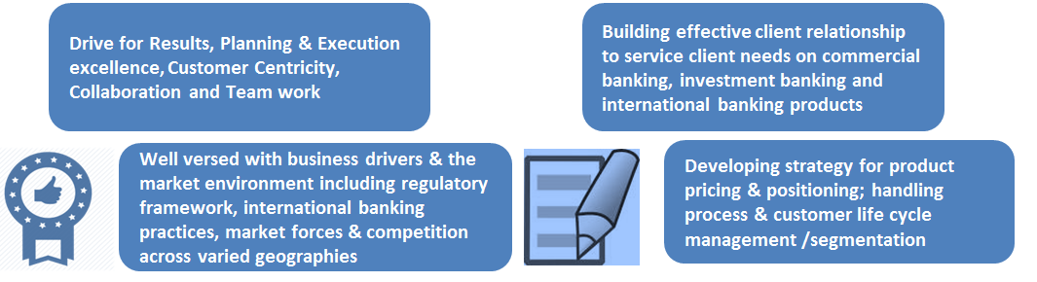

CAREER MILESTONES

At ING Vysya Bank
- Delivered highest performance PAN India in all lines in 2013-14
- Planning and coordinating administrative procedures and systems and devising ways to streamline processes. Recruiting and training personnel and allocate responsibilities and office space. Assessing staff performance and provide coaching and guidance to ensure maximum efficiency.
- Got Best Performance Rating by delivering superlative in CASA, Quality Assets (Retail and BB), Highest Fee Income (including Trade Forex and Wealth revenue), Surged 75%Primary Customer base, All business unites got satisfactory Audit / Operation ratings and Maintained highest Service Quality
- Recipient of Best Performer Awards PAN India & Qualified for 3 Conventions & Regional contests. Achieved numerous other employee recognitions in ING Vysya Bank & HDFC Bank in 2011-2012
- Recognised for consistently delivering high sales & growth no’s QoQ (Interest income up by 25 % & FEE income by 120 %) across retail banking products such as Liabilities, Investment, Insurance, Mortgages, Remittances & CASA
- Successfully managed portfolio profitability of INR 20 million on balance sheet & INR 40 million off balance sheet, channel assets consisting Gold, Cards & Fee products / GL size 7.50 Billion
- Established 10 new branches and ensured penetration of new verticals & customer segments in potential Tier II sectors
- Ensured that all business units are risk free (best rated in audit) and in customer service
- Pivotal in generating profitability by upping 35 % of FEE Income & bagged increase in Interest income by 27 %

At Equatorial Trust Bank Plc. Lagos, Nigeria
- Actualized concept of LC & Trade Finance by fostering tie-ups & international deals which enhanced revenue by 200 % in ETB, Nigeria in 2010
- Championed all aspects of Branch banking & managed multi state businesses generating $ 1 million in revenue in 2009
- Established 20 new high-end flagship branches & profitably managed branch distribution network of over 110 branches across Tier I & II cities as National Head
- Directly interfaced & influenced revenue in 130+ retail banking branches as well as private client areas
- Revamped & managed indirect lending, floor planning & servicing areas to appropriate risk return & profitability.

At Yes Bank
- Increased revenue from business units & portfolio managed over 70 % & successfully created 30% efficiency in business expenses, resulting in profitability despite market downturn in 2008 -09

At HDFC Bank
- Established new branch & new break-even benchmark record of 9 months
- Got rated 5A-best rating for an individual at HDFC Bank (CBOP)
- Successfully shaped the branch banking business, contributing 42% to regional revenue, making Gujarat, the #2 in the country in terms of net income from a loss making territory in span of less than a year

ORGANIZATIONAL EXPERIENCE

Since July’18: JLL India as Sr Director and Head Transactions

Key Result Areas

JLL is an NYSE listed company having presence in 80 countries across the globe with gross revenue of $7.9 bn. We are the biggest international property consultants (IPC) in Asia Pacific with over 32,000 employees operating in 83 offices in 16 countries across the region. The firm was named ‘Best Property Consultancy’ in seven Asia Pacific countries at the International Property Awards Asia Pacific 2014, and won nine Asia Pacific awards in the Euro Money Real Estate Awards 2013. Its investment management business, LaSalle Investment Management, has $58.1 billion of real estate assets under management. JLL is the brand name, and a registered trademark, of Jones Lang LaSalle Incorporated. We provide boutique of services to meet your real estate requirement as follow.

Providing end to end solution on Real Estate

Key Result Areas
Rresponsible for revenue administration and general administration in the area under West Zone. Functions of Sr Director broadly include, Collection of revenue and function as per JLL Ethical practice, Function as Executive Magistrate, To travel to places to oversee for implementation of JLL policies, Supervision of expenditure of funds as per norms of financial propriety, Recruiting and training personnel and allocate responsibilities and monitor productivity.
- Consulting and Advisory
- Office, Retail and Residential Service
- Capital Market (Equity / Debt, Structure Funding)
- Industrial Services (Warehouse, Land, BTS - BUY/SALE/LEASE)
- Land Services (Commercial, Residential, Agri, Industrial etc)
- Project & Development Services
- Cross Selling IFM (Integrated Facilities Management)
- Property & Asset Management
- Real Estate Intelligence Services
- Alternate Asset Class - Hotel, Hospital, School

Jun’11- Dec’14: ING Vysya Bank as Head - Central & North Gujarat

Key Result Areas
- Accountable for:
  - Document checking against letter of credit as part of trade operation team at Mumbai/Bangaluru Trade Centre, to meet agreed customer service level agreements and review outstanding transactions
  - Retail Banking, Corporate Banking, Co-operative Banking, Digital Banking & Transformation, Payments and Compliances
  - Ensuring compliance (KOP, Ops manual, etc.) with internal policies and audit and regulatory requirements
  - Controlling OPEX (operational expenditures), cost optimisation, branch profitability by increasing GL/CASA
  - Channel Migration by driving customers to alternate/ multiple delivery channels i.e. Mobile Banking/Internet Banking / Phone Banking / ATM/QCD
  - Implementing accounting system, financial controls and decision oriented Management Information Systems.
  - Revenue Analysis of subscribers through in depth MIS tools like Zero usage analysis, recharging trends, tertiary transactions, customer segmentation based on revenue earning customers trend

Mar’09- Mar’11: Equatorial Trust Bank Plc. Lagos, Nigeria as Country Head – Retail Banking and Wealth Management

Key Result Areas
- Established 80 New High End flagship branches
- Led branch distribution network of existing 210 branches across Tier I & II cities
- Acquired approvals from Central Bank of Nigeria and executed gamut of tasks like projections, relocations and refurbishments, recruiting human assets, space strategy and client acquisition
- Introduced verticals of wealth management and all fee based products which grew casa book & low cost deposit by 35% ensuring profitability; wherein tier I branches turned profitable in 10-12 months & tier ii branches in 15- 18 months of set-up
- Conceptualized and implemented overall governance models for the distribution nationally, encompassing strategy, planning, and execution of key metrics & business drivers

Jul’08-Mar’09: Yes Bank Ltd., ROMG, India as Vice President (Head – Retail Banking and Wealth Management)

Key Result Areas
- Mentored a team of AVPs, Senior Relationship Managers and Relationship Managers
- Adhered to Banking Rules, FEMA, ISBP, UCPDC, URR, URC, Regulations & Procedures
- Imparted training to operational staff in branch and other business groups for to ensure operational efficiency in Trade Finance
- Ensured error free transactions and entries in system
- Scrutinized Foreign Documentary Letter of Credits (Foreign/ Inland)
- Monitored and resolved complaints on system and ensured timely and quality CCMS and QMS for closure
- Collaborated with Process & Risk Control Team Manager to implement relevant controls across key business processes
- Designed controls for various problems in personal banking and identified reasons for any breaches through investigations, thereby recommending solutions to prevent recurrence

Feb’02 - June’08: HDFC Bank Ltd. (ECBOP), Gujarat, India
Joined as Branch Manager & rose to the position of State Head – Retail Banking
Key Result Areas
As State Head – Retail Banking
- Headed the entire branch operations in the region covering 17 branches across Gujarat
- Successfully revamped the entire team across the region
- Augmented the business for the region from 1.90 Billion in liabilities to 4.50 Billion
- Recorded multifold increase in the third party product income over the period

As Branch Manager
- Mentored a team of 18 highly motivated people across officers and staff with varied vintage
- Created strong market awareness of product offerings across banks and contributed towards product development enhancement and implementation of new product offerings
- Implemented robust self-assessment process and strong control systems, thus ensuring minimal financial, regulatory and franchise risk for the business
- Assessed & resolved process gaps either through 6 Sigma or Turbo Projects
- Headed the branches in managing the cash holdings in branch vault and ATMs (both offsite and Branch); patch application; discrepancies in submission of AODs and customer complaints & logging in next step

PREVIOUS EXPERIENCE

2001-2002: Axis Bank Ltd., Vadodara as Relationship Manager

1998-2001: Disha Professional Services Pvt Ltd. (ABN Amro Bank), Vadodara as Direst Sales Manager

EDUCATION

1998 M.Com. Final Only (Marketing & Management) from M.S. University, Vadodara 1
1996 B.Com. from MS University (Account & Audit)
1997 Diploma in Computer Science (Private Coaching)

Others: Cleared NSE’s Certification of Financial Market with Distinctions

TRAININGS ATTENDED: Train the Trainer; Bank on Me; Motivation and Leadership Management;
Implementing 5S Management; Leadership, Portfolio Management & Project Management

