resume

VYAS HARSHIL SHAILESHKUMAR
2/A,NAVNIRMAN AGAM NIGAM SOC
BEHIND ANAND WADI BUS STOP
ISANPUR ROAD
AHMEDABAD-382443
+91-9904904365
EMAIL ID : harshilvyas47@gmail.com

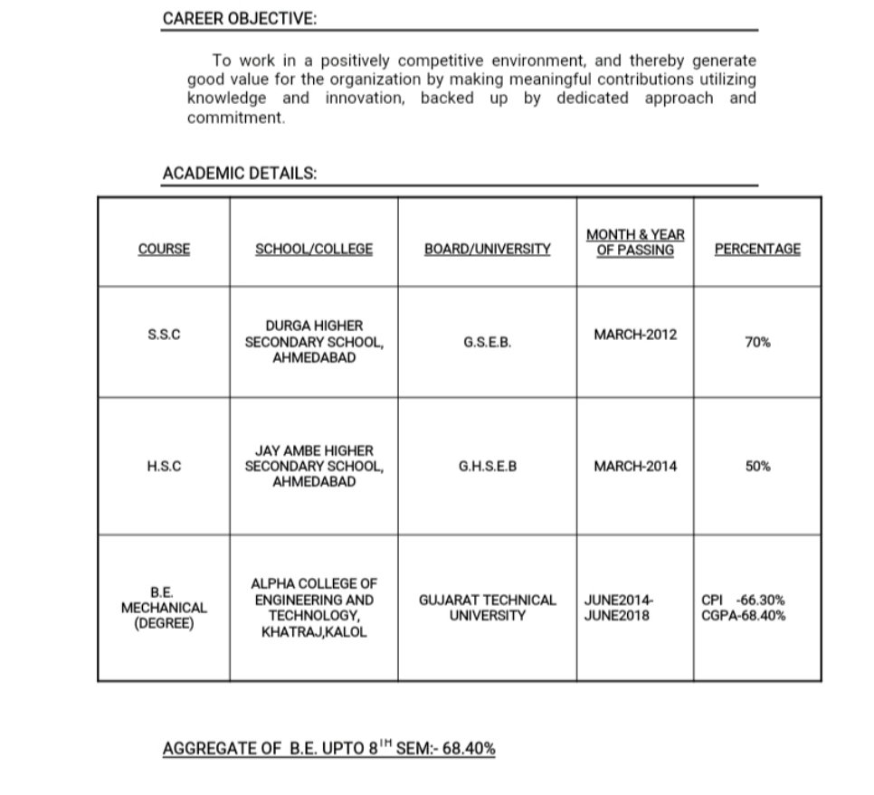

QUALIFICATION

- Degree Engg. (Mechanical)

PERSONAL DETAILS
- Date of Birth :- 06/10/1996
- Language known : - Gujarati , English & Hindi
- Gender : - Male
- Nationality : - Indian
- Marital Status :- Unmarried
- Computer Skill : - Basic
- Hobbies :- Music

WORK EXPERIENCE
- I have 2.5 year work experience in Parnil Industries as a production incharge.
- Recently, I have joined a new company as a production incharge in Jupiter comtex pvt. Ltd.

DECLARATION
I do here by declare that the above information is true to the best of my knowledge.

Place: -Ahmedabad

Yours faithfully,
VYAS HARSHIL

