Curriculum Viate of Mr.Nehal B Shah 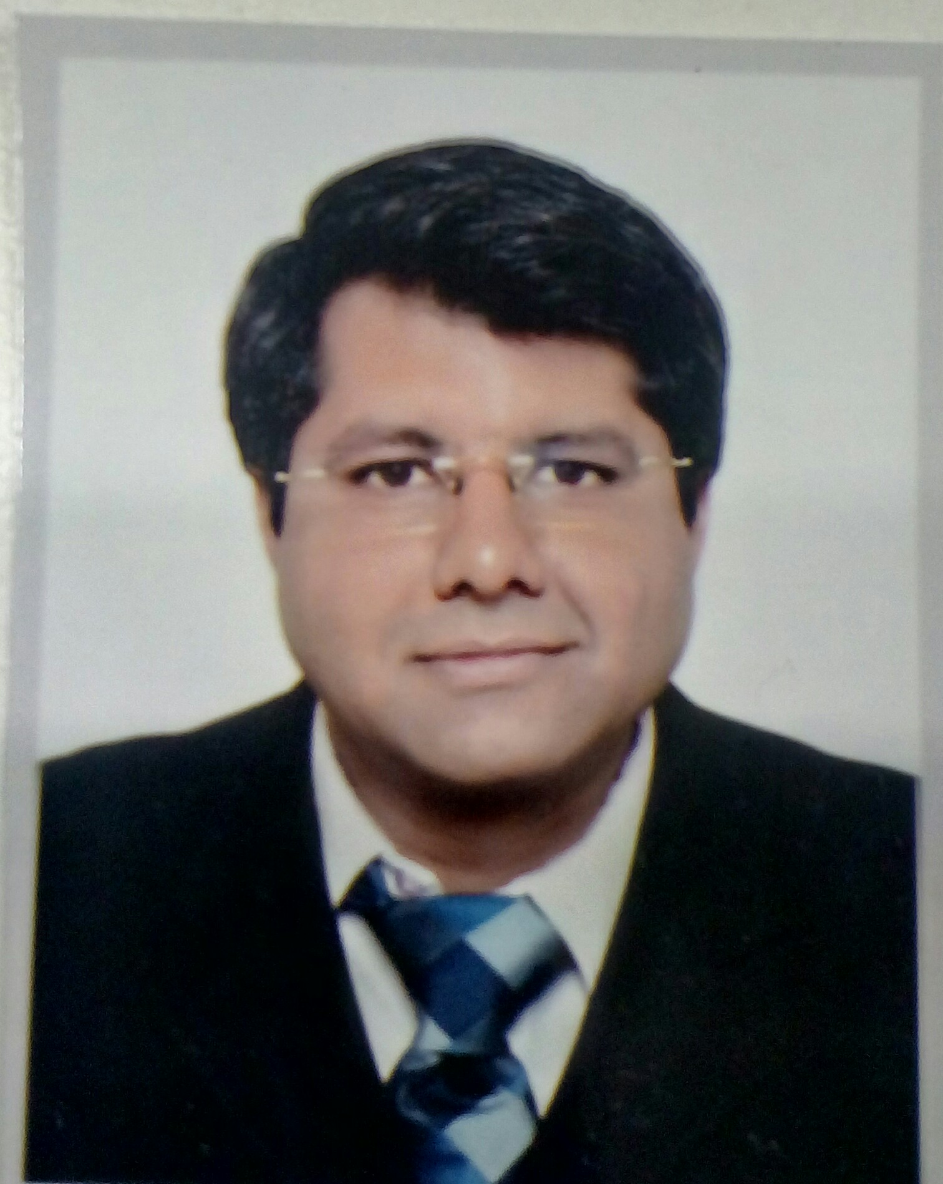
Contact - 11/11,3rd Floor, Mangalvilla Appartment
Vadnagar Patidar Society, Opposite Rambag Police station,
Maninagar, Ahmedabad – 380008.India
Ph (R) 91-79-25460655 (M) 9824611379 Email – nickshah9@gmail.com

OBJECTIVE:

To work for growing & innovative Company with full of challenges, independent / team responsibility with free working environment in the field of Collection as well as Customer Service.

Work Experience:
More than 12 years in the field of Credit Management / Customer Service / Collection with Time-Share, Non-Banking Financial Services and Gems & Jewelry Companies.

Summary of Work experience:
- More than 11 years of experience in Credit management, customer service and collection
- Excellent ability to deal with high profile clients
- Ability to interact professionally and courteously with clients
- Ability to demonstrate good judgment in problem – solving
- Possess a good knowledge of MS-Word and MS-Excel with advance functionality of V-Lookup and Pivot Tables.

Deputy Manager – Account And Finance - (From April 17 to Till Now at IndusInd Media and Communication Ltd)
- Responsible for All Account and Finance including Billing collections of Gujarat Region.
- Handle team of 3 Account Executive.
- Coordinating in Receivable Accounting / (Dr / Cr) note issue in the organization.
- Credit monitoring & follow-up with due payment of customers.
- Executing reconciliation of LCO - Distributor accounts, follow-up of accounts receivable collection as per policy.
- Tracking credit period of customers / sending letters / making collection call / visit to LCO - Distributor.
- Preparation of various management reports: Daily cash flow statement / outstanding account receivable.
- Actively involved in maintaining accounts records & Resolving queries of LCO - Distributor.
- Deal with all sorts of inward and outward documentary collections.
- Negotiation of arrangements to pay outstanding amounts.
- Reconciliation of accounts as required and updates customer data.
- Allocation of payments received to the correct account.
- Collect any sums due in accordance with company policies and procedures.

Assistant Manager –Collections (From Nov 12 to March 17 at Magic Holidays)
- Responsible for collections of Gujarat Region.
- Handle team of 3 Collection Executives and 1 Collection Pick-up boy.
- Coordinating in Receivable Accounting / (Dr / Cr) note issue in the organization.
- Credit monitoring & follow-up with due payment of customers.
- Executing reconciliation of customer accounts, follow-up of accounts receivable collection as per policy.
- Tracking credit period of customers / sending letters / making collection call / visit to customer.
- Preparation of various management reports: Daily cash flow statement / outstanding account receivable.
- Actively involved in maintaining accounts records & Resolving queries of customers.
- Control of an account of around 300 customers.
- Outbound & inbound calls to customers regarding outstanding amounts.
- Deal with all sorts of inward and outward documentary collections.
- Negotiation of arrangements to pay outstanding amounts.
- Reconciliation of accounts as required and updates customer data.
- Allocation of payments received to the correct account.
- Collect any sums due in accordance with company policies and procedures.

Achievements:

- Reduced around more than 50% of Ledger in 7 month of period.
- Exceeded KPI’s on average each quarter

Recovery Manager (From May 12 to Oct 12 at Suvarnakala Pvt. Ltd.)

- Tracking credit period of customers / making collection call / visit to customer.
- Preparation of various management reports: Daily cash flow statement / outstanding account receivable.
- Actively involved in maintaining accounts records & solving queries of customers.
- Control of an account of around 150 customers
- Discuss problematic accounts with the Managing Director and recommend the appropriate action

Achievements:

- Collected 80% of overdue payment from customers within month.

Team Leader (From July 09 to April 12 with a CitiFinancial Consumer Finance India Ltd)

- Tracking credit period of customers / making collection call / visit to customer.
- Proven skills in dealing with collection agency and properly monitoring of customers accounts
- Preparation of various management reports: Daily cash flow statement / outstanding account receivable.
- Actively involved in maintaining accounts records & solving queries of customers.
- Handling several collection agencies along with 7 collection executives and supervisor of each collection agency.
- Control of an account of around 200 customers
- Outbound & inbound calls to customers regarding outstanding amounts
- Negotiation of arrangements to pay outstanding amounts
- Update customer data if necessary
- Discuss problematic accounts with the Credit Manager and recommend the appropriate action

Achievements:

- Reduced delinquency up to 5% of ledger
- Have been Achieving target more than 90% almost every month
- Exceeded KPI’s on average each quarter
- Achieve personal and company objectives at the productivity and quality levels

Collection Officer 7 month (From Dec 08 to June 09 with Fullerton India Credit Company Ltd)

- Executing reconciliation of customer accounts, follow-up of accounts receivable / collection as per policy.
- Tracking credit period of customers / making collection call / visit to customer
- Actively involved in maintaining accounts records & solving queries of customers.
- Control of an account of around 120 customers.
- Negotiation of arrangements to pay outstanding amounts.
- Reconciliation of accounts as required and updates customer data.
- Collect any sums due in accordance with company policies and procedures
- Discuss problematic accounts with the Credit Manager and recommend the appropriate action

Achievements:
- Reduced outstanding to 15% of ledger
- Exceeded KPI’s on average each quarter

Collection Executive 3 years & 4 Month (From Aug 05 to Nov 08 with Club Mahindra Holidays)

- Coordinating in Receivable Accounting / (Dr / Cr) note issue in the organization.
- Credit monitoring & follow-up with due payment of customers.
- Executing reconciliation of customer accounts, follow-up of accounts receivable collection as per policy.
- Tracking credit period of customers / sending letters / making collection call / visit to customer.
- Preparation of various management reports: Daily cash flow statement / outstanding account receivable.
- Actively involved in maintaining accounts records & Resolving queries of customers.
- Control of an account of around 300 customers.
- Outbound & inbound calls to customers regarding outstanding amounts.
- Deal with all sorts of inward and outward documentary collections.
- Negotiation of arrangements to pay outstanding amounts.
- Reconciliation of accounts as required and updates customer data.
- Allocation of payments received to the correct account.
- Collect any sums due in accordance with company policies and procedures.

Achievements:

- Reduced around 50% of Ledger.
- Exceeded KPI’s on average each quarter.
- Achieve personal, team and company objectives at the productivity and quality levels

EDUCATIONAL QUALIFICATION:

B.Com Passed from Sunrise University

PERSONAL
Date of Birth : 11th March 1977 (40 Years)
Marital Status : Married
Health : Good
Languages known : English, Hindi and Gujarati (Mother Tongue)
Activities : Public relations, traveling
Reference : Can be furnished upon request
My Self : Ability to work hard
Good communication & interpersonal skill
Positive attitude & high learning aptitude,
Aiming higher goals

