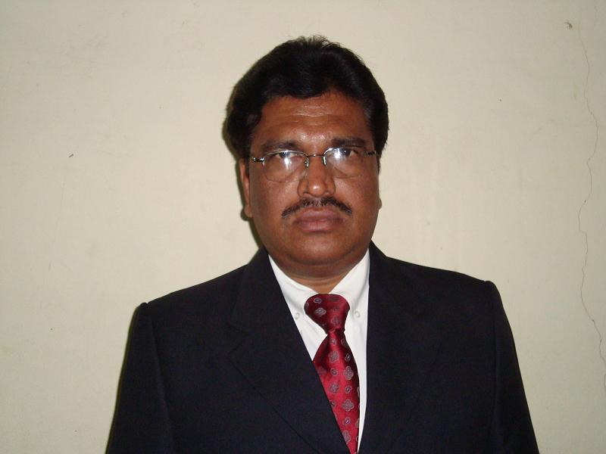
A Sudhakara Rao M.Com., AICWA.
G-3, Sri Sai Sudha Enclave, Kolan Narayan Reddy Colony, Nizampet village, Qudbullapur Mandal, Hyderabad-500090,
Tel: 040-40174664(R), Mobile: +918008885216, Email: annamsudhakar@yahoo.co.in

Career accomplishments:
- Heading the Department of Finance & Accounts for a Group of Companies in Leather processing industry in Kenya – Introduced systems and procedures, budgetary controls, MIS.
- I have been a core team member in arranging a CDR package for a Company, which contributed about Rs. 600 crores to the bottom line during the tenure of the package.
Work Experience:
NAGARJUNA FERTILIZERS & CHEMICALS LIMITED – HYDERABAD (AP. INDIA) (May 2010 to till date):
General Manager (Finance): Heading Corporate Accts Management Group, in-charge of MIS, Finalisation of Accts. Audits, Budgets, and Financial Concurrence, IFRS convergence. Cash-flows, projections, Credit Rating, servicing FIs and Working Capital Banks. Tax planning and Direct Taxation. Corporate Restructuring and convergence to IFRS from Indian Accounting Standards, Enterprise valuation & accounting Mergers. Further, additional responsibility to be a CFO of another listed demerged group company.
ALPHARAMA LIMITED – NAIROBI (KENYA)
July2006 – April 2010 (Salary USD 54000/ p.a.)
Role as Finance Manager, responsible for Accounts (under IFRS), Costing, Finance, Budgeting, Tax planning, MIS, Auditing, statutory compliance, Systems design and implementation, training and team building for a fast growing leather manufacturing MNC.
NAGARJUNA GROUP – HYDERABAD (AP. INDIA) (Jan 1994 to Jul 2006):
Sr. Manager (Finance): Heading Corporate Accts Management Group, in-charge of MIS, Finalisation of Accts. Audits, Budgets, and Financial Concurrence. Cash-flows, projections, Credit Rating, servicing FIs and Working Capital Banks,

Special assignment: Core team member in Debt restructuring packages and Revaluation of Assets.

Executive Assistant to MD, of NFL (1997-2000) and to VP (F) (94-96) the following assignments were handled during the tenure.

a) Finance:
in-charge of Working Capital Management, Cash-flow statements, Renewal of Working Capital Limits (CMA) from Banks, Credit Rating for CP, Debentures, Securitization of NPAs.

b) Accounts:
Finalisation of Accounts, Coordination of Audits (Internal, Statutory, Tax, Concurrent, Special, RBI Audit etc), In-charge of FD Bank accounts & Data Management, Controlling Divisional and Branch accounts, Lease Accounting.

c) Compliance and Reporting:
Compliance of Statutory reporting (Public Deposit Return, Half-yearly return, Prudential Norms, RBI Returns etc.,)

d) MIS & Planning:
Preparation of Budgets, Monthly MIS reports - Financial Statements, Variance analysis, Depreciation and tax planning

e) Controlling:
Costing of financial products cost of funds, monitoring capital expenditure budgets, analysis of funding proposals.

Job Accomplishments:

1) Introduced Zero Base Budgetary system. 2) Streamlined Lease accounting 3) Reconciled Public Deposit account 4) Reconciled at par accounting facility and recovered Rs. 1.50 Cr. from the Banking System. 5) Introduced MIS for Branches.

M/s SRI VISHNU CEMENT LTD (Nov. 91 to Dec. 93):
Accounts Officer (Regional Accounts)

M/s KERA SINTER LTD (Feb. 86 to Oct. 91):
Accounts Officer (Complete Corporate Accounts & Finance)

M/s UNIVERSAL TILES LTD (Jun. 84 to Jan. 86):
Cost Accountant (Deferment of Loan repayment, capitalization of assets and initialization of Budgeting process, Project accounting)

Core Skills / Strengths
- Managing Accounts, MIS in complex and highly computerized environment.
- High degree of familiarity with packages (SAP FICO, Tally 9, MS Office, )
- Financial Modeling in Excel,
- Perseverance, commitment to the Job
- Continuous learning and adaptability.

DOB: 08.01.1959
Marital Status: Married
Children: Daughter (1) married and
Son (1) B Tech (Mech.) looking for placement as a fresher

Qualifications: ACMA (formerly AICWA)
M.Com. (I Division) (University College First)
B.Com, (I Division)

Present CTC: INR 29.00 lakhs and Medical, gratuity, Annual Leave pay.
Joining Time: 3 months
Expected CTC: Negotiable
* * * * * * *

