Curriculum Vitae
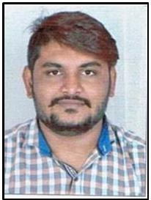

DEVAL BHAVSAR

422,Vishal Nagar, Ishanpur,

Ahmedabad 382443

Contact No . : +91 8690391929

To secure a challenging position where I can effectively contribute my skills as a Sales and Marketing Professional and to enhance my core Skills

PERSONAL INFORMATION

Full Name | : | Deval Shaileshkumar Bhavsar
Date of Birth | : | 1St October 1993
Nationality | : | Indian
Gender | : | Male
Marital Status | : | Single
Languages Known | : | Gujarati, Hindi, & English
Hobbies | : | Listening Music, travelling, driving Playing Sports Kabbadi

EXPERIENCE

Working as marketing – Collection person at “Madhuri Dandiya Ghar” – Family Business.

Worked as Active partner at “Chirag Milk Product”. Handled Marketing and collection part.

Worked with Loyola Research center as an examination supervisor – Examiner from 2013 to 2016.

Area Sales Manager At “Pepsico” from December 2016 to February 2019.

Work at own business in “Riddhi Handicraft” form February 2019 to October 2019

EDUCATIONAL QUALIFICATION:
 | Degree | Board/ University |  | Percentage
 | H.S.C |  | G.H.S.E.B | 59.65%
 | B.COM | Gujarat University |  | 45 %

OTHER SKILL

M.S Office

Internet

STRENGHTS

Honest and punctual person

Effective communication skills, Active team member,

Quick learner, Confident and Responsive

Place : Ahmedabad DEVAL BHAVSAR

