RESUME
Kevin Bheda  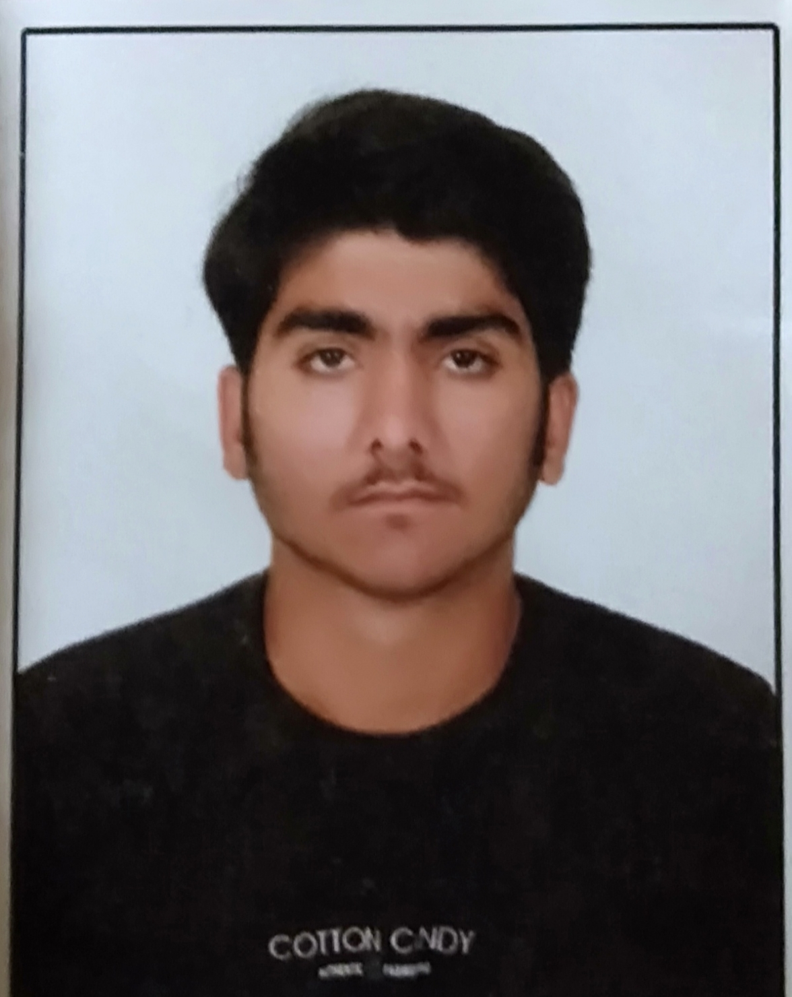  Permanent Address:-  At: Ambaliya (ghed),  Ta: Manavadar,  Dist: Junagadh,  Pin code: 362625,  Contact No.  +91-8347803236  E-mail  Kevinahir62@gmail.com  Date of Birth  12-07-2000  Soul Status  Unmarried  Communicability  English, Hindi, Gujarati.  Nationality  Indian  Assets/Competencies  - Work efficiently with people of diverse cultures.  - Fast learner, adapt well to changes and pressures in work place.  - Sound communication and presentation skills.  - Committed to deadlines and schedules.  Strength  - Self Confidence.  - Positive attitude.  - Good Communication Skills. | Kevin Sarmanbhai Bheda  - Computer Basic  - M.S. Office  - M.S. Excel
  Objective
  Intend to seek position with leading corporate to utilize my skills and abilities in the field of Compuer.
  Personal Skills
  Comprehensive problem solving abilities, Excellent verbal and written communication skills, Attitude to understand and mould as per competitive global environment, deal with people and willingness to learn, face challenges and act as a team facilitator.
  Computer Skills
  Professional Qualification
  EXAM | SCHOOL/COLLAGE | UNIVERSITY | YEAR | PERCENTAGE
  SSC | Alpha Vidhya Sankul-Vadal | G.S.E.B. Gandhinagar | 2015 | 70.05%
  HSC | Parimal School Rajkot | G.S.E.B. Gandhinagar | 2017 | 55.06%
  B.Com | Arjun College-Supasi | Bhakta Kavi Narsinh Mehta University | 2020 | 64.22%
  Hobby
  - Reading Books
  - Travelling
  - Playing Cricket
  Surfing on internet:
  - According to my opinion Internet is the best teacher and the worst teacher. It can help you study in different ways. Using Google, one can learn about anything. By surfing of internet, we can know everything which is going on in the world.
  - We can know about latest technology & latest gadgets.
  Declaration
  I hereby declare that above written particulars are true to the best of my knowledge and belief.
  Your Faithfully
  Kevin Bheda

