CURRICULM VIVATE
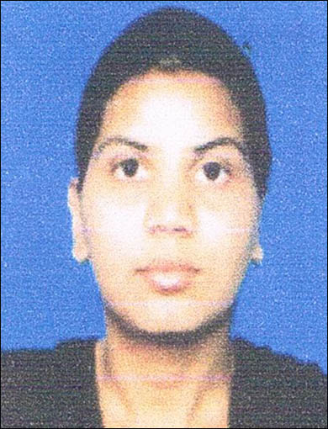
SONIA
Kahnuwan Road, New Colony,
Bhattha Inderjit,
Batala, Distt. Gurdaspur
Punjab. (India)
Mob. No. : +91 8968170047
Email : soniawillson38@gmail.com

OBJECTIVES
To be proficient performer in the field of nursing to active for the highest level of competency professionally & personally. To work in team towards the betterment of organization.
PERSONAL DETAIL
Name : SONIA
Father's Name : Willson
Mother's Name : Rajinder
Date of Birth : 08-10-1989
Sex : Female
Nationality : Indian
Marital Status : Unmarried
Languages Known : English, Punjabi & Hindi

EDUCATIONAL QUALIFICATION

COURSE | BOARD/UNIVERSITY | YEAR OF PASSING
10th | Punjab School Education Board | 2006
10+2 | Punjab School Education Board | 2008
PROFESSIONAL QUALIFICATION

COURSE | NAME OF INSTITUTION | BOARD | YEAR OF PASSING
Diploma in General Nursing & Midwifery | Prayavi School of Nursing, Bidar | Karnataka State Diploma in Nursing & Midwifery | August 2012

STATUS OF GENERAL NURSING AND MIDWIFERY (REGISTRATION FORM)

1 | Name of the Nursing Council | Karnataka State Diploma in Nursing Midwifery
2 | Registration Number (Punjab) | As a Nurse is 68590 and Midwifery is 68607
3 | Date of Registration | 24 Dec 2013

WORK EXPERIENCE
- Mahajan Hospital, Batala. (Punjab)

PROFESSIONAL EXPERIENCE DETAILS

Name of Hospital : Mahajan Hospital Batala
Designation : Staff Nurse
Period : Sep 2012 to Still Work.
Department : ICU

BRIEF WORKING EXPERIENCE
DUTIES & RESPONSIBILITIES :
- Holistic assessment, Planning and implementation care.
- Management and Administration of care includes intravenous therapy, fluid management, blood and blood product transfusion, administration of medication.
- Co-ordination with health personnel
- Obtaining and ECG
- Performing intubations, ventilator and emergency care
- Resuscitation of clients
- Following standing orders in emergencies
- Providing ventilator care
- Tracheostomy care
- Assisting in diagnostic procedures
- Administration of medication
- Assessment of vital signs.
- Collecting blood for ABG analysis.
- Pre-operative and Post-operative care of surgical patient.
- Insertion of Nasogastric tube as well as administration of feeds.
- Maintaining patient hygiene (oral care, bed bath)
- Maintaining records and reports.
- Supervision nursing personnel, junior staff-nurses, student nurses, hospital aides and nursing oderlies during the performance of their duty.

EQUIPMENTS USED :
- Ventilator
- Defibrillator
- Cardiac Monitor
- Suction Apparatus
- Pulse Oxymete
- Nebulizer
- ECG Machine
- Infusion Pump
- Syringe Pump
- Sterilizer
- Steam Inhaler
- Glucometer
- BP Apparatus

DECLARTION
I hereby declare that above said information are true and correct to the best of my Knowledge and belief.

Date : 19-10-2015
Place: BATALA (SONIA)

