CURRICULUM-VITAE
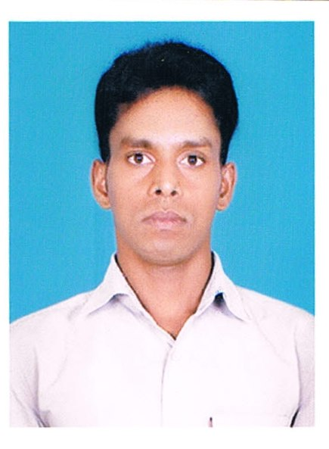
ABHIMANYU BEHERA
At/Po:- Betarsing,
Ps:- Buguda
Dist:- Ganjam
Odisha, Pin :- 761118
Contact No-+91 7787938817 / 8984171058
Email ID : beheraabhimanyu086@gmail.com

Dear Sir/Madam
Please find here with my curriculum vitae for your kind personal information, and I shall be pleased to give you more information in person when called for interview.

CAREER OBJECTIVE :

- To identify a career position where my interests, attitude and proficiency will allow me the opportunity for growth and development of the organization.
ACADEMIC QUALIFICATION:-

Year | Institute | Board | Qualification | % of Mark
2008 | People’s High School, Buguda | B.S.E, Odisha | Metric/10th | 46.50%
2010 | People’s College, Buguda | C.H.S.E Board | +2 (Arts) | 48.66%
2013 | People’s College, Buguda | Berhampur University | B.A (History) | 62.77%

EXTRA KNOWLEDGE:-
- Completed 1 year in P.G.D.C.A. from BIT Computer Education, Buguda.
- Also Operate Windows XP, Vista, 7 & 8, Internet surfing, Web Browsing.

PRESONAL PROFILE:-
Name : Abhimanyu Behera
Father’s Name : Gandu Behera
Date of Birth : 04/01/1992
Sex : Male
Category : SC
Marital Status : Unmarried
Nationality : Indian
Religion : Hinduism
Blood Group : O’+ (Positive)
Language Known: Odia, English, Hindi & Bengoli
HOBBIES:-
- Watching News Updates & Making Friends, Surfing Internet.

DECLARATION:

I do hereby declare that above statement given by me is true to the best of my knowledge and Belief.

Date:
Place: (Abhimanyu Behera)

