ANURAG PATEL  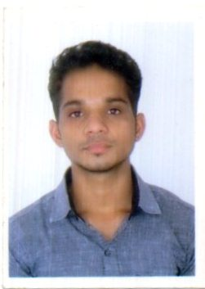  Permanent Address  KAMAL PRASAD PATEL  VILL+PO+PS:-NARAINI,  DIST:-BANDA,UTTAR PRADESH:-210129  Phone:  +91 7376430510  +91 8542026220  E-Mail:  anuragpatel.shiats@gmail.com  Personal Data  Father’s Name: Mr.KAMAL PRASAD PATEL  DOB : 28-07-1996  Sex : Male  Language : English, Hindi  Nationality : Indian  Marital Status: Unmarried  Hobbies  - Listing music  - Playing and Watching cricket  Plus Points: -  - Keenness to explore and learn new things  - Sense of responsibility  - Good Team Player | Objective  To get a position in the worthy organization in the terms of long career objective which values innovation and gives responsibilities and opportunities for growth and development to create a carrier path for myself.  Strengths  Good and quick learner, Can work under stress, Confidence, determination, friendly attitude and Self motivated.  Education/Qualification  INTERNSHIP  - Diesel locomotive works, Varanasi ,Uttar Pradesh, for 15 days from 02 june 2015 to 15 June 2015  - Field Marshal Pvt Ltd, Rajkot, Gujrat for 1 month from 11th June 2016 to 10th July 2016  TECHANICAL SKILLS  - Proficient in MS Office.  - Good Knowledge of Window XP, 7, 8.  - Completed The Training course on ”MATLAB ”.  EXTRA CRICULLAR ACTIVITIES  - Participated in University Cricket Tournament.  - Participated in National Seminar on ”Recent Trends in Finish Machining “ organised by IIT Roorkee.  - Worked as a member of Technical Society of Mechanical Engineering.  ACADEMIC PROJECT:-PERFORMANCE ANALYSIS OF GAS TURBINE
  Course | Board / University | Passing Year | Percentage / OGPA
  10th | RAJ KUMAR INTER COLLEGE | 2011 | 72.14%
  INTERMEDIATE | RAJ KUMAR INTER COLLEGE | 2013 | 78.00%
  B.TECH MECHANICAL ENGINEERING | SAM  HIGGINBOTTOM UNIVERSITY OF AGRICULTURE,TECHNOLOGY AND SCIENCES | 2017 | 7.15

DECLARATION

I do hereby confirm that the given information is true and correct to the best of my knowledge and belief.

Date: 30 /07/2017

Place :-AHMEDABAD (ANURAG PATEL)

