Jitendra Singh Bundela
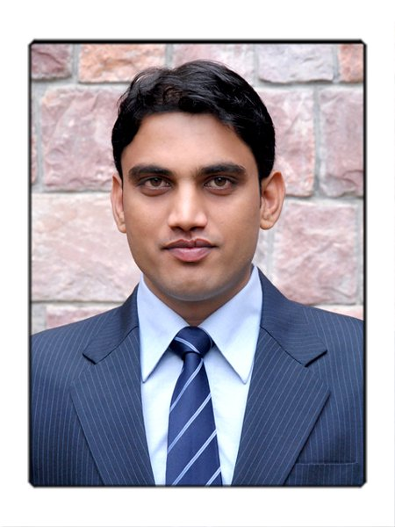
238, Premchand Nagar SOC, Jodhpur Tekra,
Ahmedabad (Guj.) 380015
Mobile no.: +9193275-35663;
Email: jbundela@gmail.com

Career Objective:
To join an organization that offers me a constructive workplace for communicating and interacting with customers and people.
Experience:

- Working with Intas Pharmaceuticals Ltd since July,2012 as Management Trainee (Brand Management Team), handling Nepal Operation of Aquila-CNS Division.
- Worked with MSD Pharmaceuticals Pvt. Ltd for 1.5 Years as Territory Business Manager in Chronic Care (CV Specialty) based at Indore M.P.
Education:
Course Year Institute/University %
P.G.D.M. (Pharma Management) 2011 I.H.M.R., Jaipur cgpa 3.17
B.Pharmacy 2009 R.G.P.V. Bhopal (M.P.) 70%
Higher Secondary 2003 Saraswati H.S. School, Mandla (M.P.) 70%

Computer Proficiency:
M.S. Office, Internet, Basic knowledge of SPSS .
Capabilities:
- Good Co-ordination skills.
- Work well under pressure to meet deadlines.
- Receive and carry out complicated instructions and tasks.

Trainings:
- Dissertation with MSD Pharmaceuticals Pvt. Ltd. on "Study of Market Trends of Statins and analyzing need for Comprehensive Lipid Management".
- Summer internship with Raptakos Brett & Co. Ltd., Mumbai on
  - “Sales, availability and prescription trends of Haematinic brands”.
  - Small project on "Study of Niche Marketing Strategy of Mankind Pharma.
Achievements:
- Got recognition from company at national level in patient care initiative by company called "SPARSH"
- Successfully launched "TREDAPTIVE" in the assigned territory.
- Presented paper on "OTC Drug marketing in India" at National Conference "Pradanya",2010 at IHMR,Jaipur
- Presented review paper on “IPR issues in India” at “National Pharma Summit 2010” organized by Jamia Hamdard University, New Delhi.
- Presented poster on “Contract Research and Manufacturing Services” at National Conference “Pradanya” 2009 at IHMR, Jaipur.
Others:

- Successfully organized National Conference Pradanya, 2010 at IHMR, Jaipur, as a member of Conference Committee.
- Attended workshop on "Pharmaco-economics" by Pfizer & ISPOR at Jaipur.
- Running a blog on latest issues and news updates in pharma industry.

Date of Birth:
17 Nov, 1986

Languages Known:
Hindi, English.

