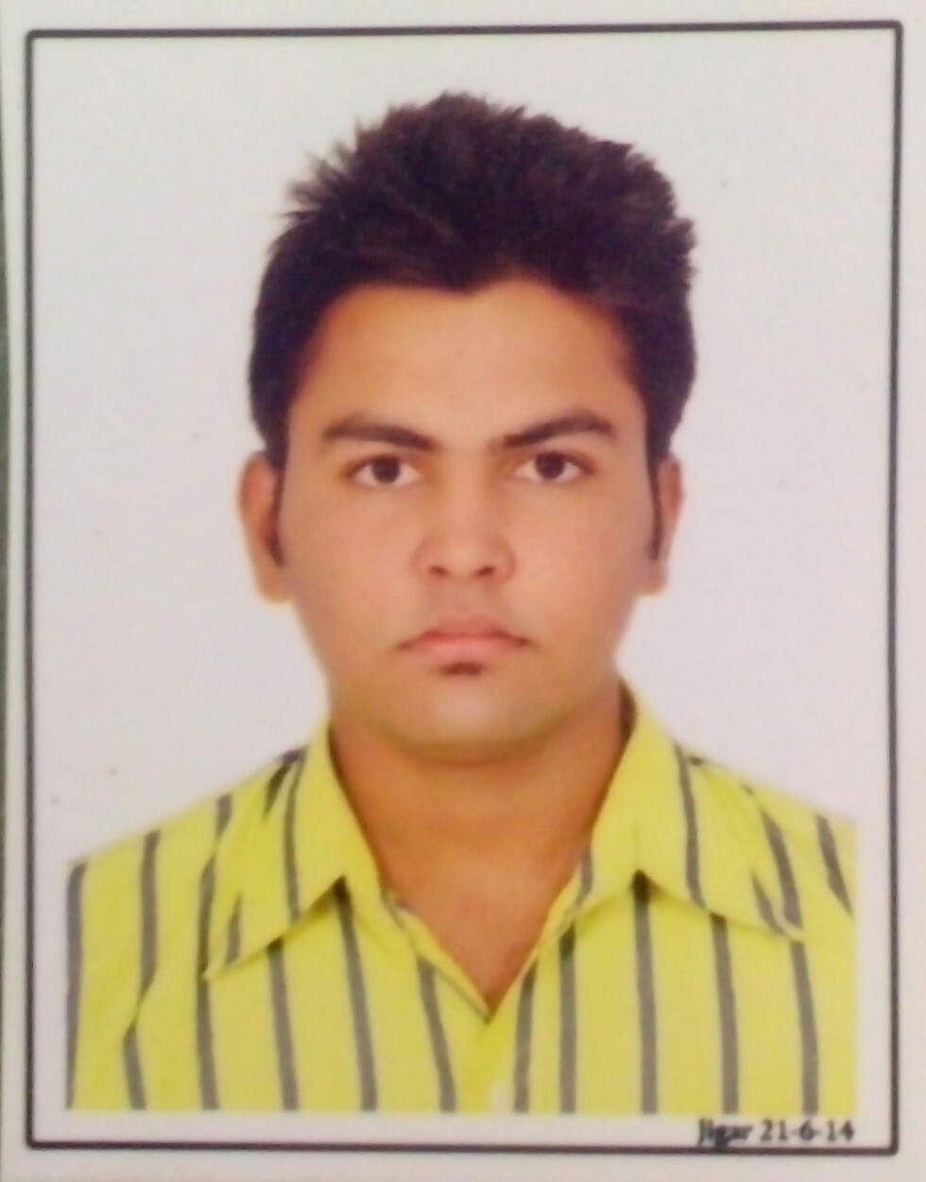
Present Address: - 48/ Kalpvrux Society,
NR . Golden Chokdi,
Patan-Chansma Highway,
Patan-384265

KISHAN PANCHANI
BE, Mechanical Engineering
Contact No. : - +91 95744 91444
E-mail:- kishanpanchani9@gmail.com

CAREER OBJECTIVE

I Want a highly Rewarding career where I can use my skills and knowledge to help the company or organization and I want to be part of The success in an environment and excellence.

BASIC ACADEMIC CREDENTIALS

Qualification | Board/University | Year | %/CGPA
BE (Mechanical) | Gujarat Technological University | 2012-2016 | 8.40/10
H.S.C. | GHSEB | 2012 | 55.20%
S.S.C. | GSEB | 2010 | 80.92%

FIELD TRAININGS

    - Company Name :- Mahalaxmi Industries , Chhatral.
Duration :- 15 Days (15th Nov’14 to 2nd Dec’14)
    - Company Name :- AVOCAB , Chhatral
Duration :- 15 Days (21st May’15 to 4th June’15)

PROJECT

- AUTOMATION OF BED FOR HOSPITAL PURPOSE

IT PROFICIENCY

- Auto CAD
- Pro/E
- Planner 5D
- Microsoft Office
- Internet Browsing

CO-/EXTRA –CURRICULAR ACTIVITIE

- In year 2013,15 – Participated in XITIJ-GTU Interzonal symposym.
- In year 2012,14 – Participated in SPIRIT-GTU level Sports Tournament.
- In year 2013,14 – Participated in many colleges & University in Technical Events like Robo Race, Robo war, Robo Soccer, Assembly, Junkyard War.
ACHIEVEMENTS

- Member of Space Society For Mechanical Engineering (SSME)
- In year 2013 – got 2nd Rank in Project presentation ( On line Traffic Contol) at Science City Ahemedabad
- In year 2008,09,10 – Got 3 Times 1st Rank in Taluka level Drawing Competition.
- In year 2012,13,14,15 – Took Part in some field like sports,cultural,quiz.
- In year 2016 – Got 1st Rank in On the Spot Painting,Cartooning & Best Out Of Waste.
- In year 2015 – Got 1st Rank in Mahatma Gandhi Swachhta Abhiyan Drawing Competition.
- In year 2016 – Got 1st Rank in Kabbadi In Funethinz.

ACADEMIC VISITS

- G.H.Engineering Works ,Vatva
- Amann Apollo , Linch
- GIPCL , Vadodara
- Gujarat Solar Park , Charanka
- Banas Dairy , Palanpur

INTERPERSONAL SKILL

  - Ability to rapidly build relationship and set up trust.
  - Confident and Determined
  - Ability to cope up with different situations.
  - Architecture & Design
  - Manufacturing & Production

PERSONAL DETAILS

- Father’s Name :- Navinkumar Devachandbhai Panchani
- Permanent Address :- 48/Kalpvrux Society,NR.Golden Chokdi ,Patan-384265
- Date of Birth :- 1stJune 1995
- Language Known :- English,Hindi,Gujarati
- Marital Status :- Single
- Nationality/Religion :- Indian / Hindu
- Interest & Hobbies :- Reading Books and Novels , Travelling , Music, Badminton

DECLARATION

I do hereby declare that the above information is true to the best of my knowledge.

Place: Patan Kishan Panchani
Date: 1st june 2016

