RESUM

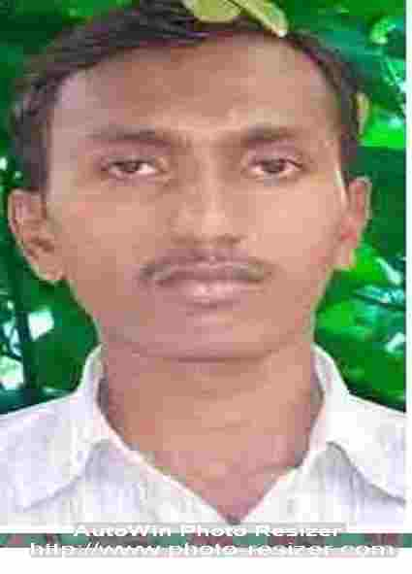
NAME :- MENIYA BALVANTBHAI LAXMANBHAI
FATHER’S NAME :- MENIYA LAXMANBHAI MOHANBHAI
ADD :- AT-Fedra, TA-Dhandhuka
DIST-Ahmedabad, PIN-382465
BIRTH DATE :- 01/06/1988
HEIGHT :- 167 cm
SEX :- MALE
MARRITAL STATUS :- MARRIED
NATIONALITY :- INDIAN
CAST :- HINDU TALPADA KOLI
LANGUAGE :- Gujarati,Hindi,English
MOBILE NO :- 9377232151
E-MAIL ID :- meniyabalvant2015@gmail.com
-:Education Qualification:-
EXAMINATION | MONTH/YEAR | BOARD/UNI | PER.OBT | CLASS
S.S.C | March-2005 | GSEB | 56.71 % | SECOND
H.S.C | March-2007 | GHSEB | 67.86% | FIRST
COPA (Computer Opretor Cum Programing Assistant) | July-2008 | N.C.V.T  I.T.I Sarkhej | 69.00% | FIRST
C.C.C (DOEACC) | Jun-2007 | DOEACC Society | 55.00% | SECOND
APPRENTIC  (1 Year) Pass  (PROG. & SYSTEM ADMIN.ASSISTENT) | May-2011  Period of Training  13/4/2010 To  12/4/2011 | S.T.DIVISION OFFICE-AHMEDABAD | 86.80% | FIRST

Technical Qualification: I have Successfully Completed Foxpro2.6 , C & C++ Computer
CourseFrom NICE Computer Education Dhandhuka.
- : Work Exeperiance :-
Post:- Taluka Level Executive (PDS & IPDS SYSTEM & OFFICE WORK) – 34 Month.
Place:-GSCSCL DHANDHUKA GOD...(Dhandhuka)

Work:- Lan/Wan – Network . Hardware . Programing Management in dhandhuka Taluka.
& computer ticheing of G.K.M. Vidhyalay -fedra

I hope that you will consider my personal resume and give me a interview call. I assure that I shall Work honestly and sincerely.

Yours faithfully.
_______________________________________
( Meniya Balvantbhai Laxmanbhai)

Login ID: | 1207738
 | Password: | LFP79ZCK

