CURRICULAM VITAE

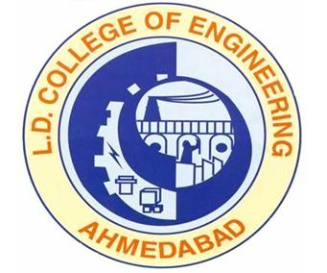
Kelaiya Paragkumar Bhikhubhai
21 years
Email: parag.kelaiya@gmail.com
Ph.no: +91-9909312300

Career Objectives:
Enthusiastic with sound technical knowledge, seeking a good platform in well organized company to implement ideas to enhance the growth of the company.

Educational Qualification:
Pursuing Mechanical engineering in 8th semester.

Examination | Year of passing | Percentage | Institution
7th Sem. | DEC-2009 | 61.17% | Gujarat University
6th Sem. | JUNE-2008 | 59.06% | Gujarat University
5th Sem. | DEC-JAN-2008 | 58.40% | Gujarat University
4th Sem. | MAY-JUNE 07 | 57.20 % | Gujarat University
3rd Sem. | DEC- 2006 | 54.26 % | Gujarat University
1st year | JUNE-2006 | 49.17 % | Gujarat University
H.S.C. | MARCH-2005 | 76.44 % | G.S.E.B.
S.S.C. | MARCH-2003 | 73.71 % | G.S.E.B.

Computer skills:
- MS Office, AutoCAD.

Seminar Presentations:
- I have presented a seminar on the topic of “Soldering” in 4th Sem. at L.D.College of Engineering.
- I have presented a seminar on the topic of “Earth Moving Machinary” in 7th Sem. at L.D.College of Engineering.

Co curricular Activity :
- I have participated in “Science Fair” in High School at Keshod.
- I have participated in “Robotics” event at V.V.P. Engineering College, Rajkot
- I have participated in “Robowar” event at V.V.P. Engineering College, Rajkot
- I have participated in project presentation at V.V.P.Engineering College, Rajkot.
My topic was “Locker Guard”.
- I had Coordinator in “Samannvay-09” at L.D. Engineering College, Ahmedabad.
- I had Coordinator in “Rang De-09” at L.D. Engineering College, Ahmedabad.

Work Experience:
- Worked as a supervisor in “International Test Cricket Match between India and South Africa” at president gallery, Sardar Patel cricket stadium, Motera, Ahmedabad.

Skill:
- Leadership
- Management

Hobbies:
- Listening Music
- Making New Friends
- Travelling.

Date of birth: 5th July, 1987.

Address:

Present: A-120, L.D.C.E. hostel,
Navarangpura,
Ahmedabad-380015.
Cell.-+91-9909312300

Permanent: 101-Aangan Apartments,
Jalaram Nagar,
B/H.Gayatri school,
Zanzarda road,
Junagadh-362001.
Ph.No.-0285-2632312

Parag B. Kelaiya

(B.E. Mechanical)

