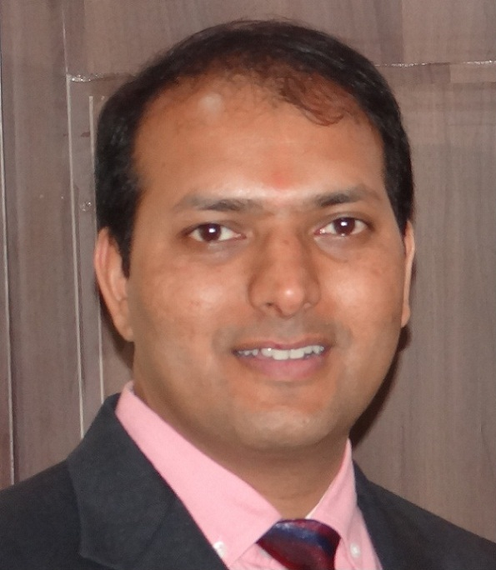 Pawan Nagla
E-Mail: pawannagla@rediffmail.com Mobile No: +91 9993595525, +91 9227665525

Senior managerial assignments in Sales & Credit and Collections / Business Development/ Channel Management /Key Account Management/ Team Management with organisations of repute

A BRIEF OVERVIEW

- A competent professional with 13+ years’ multi location, and multi product and multi Role experience in handling sales, credit and collections encompassing business development, and client servicing, channel management in financial service industry.
- Serving HDB Financial Services LTD as Branch Manager (Indore), Served Barclays Bank PLC as State Head (ACM and ASM)– Business Loans, Personal Loans and Credit Cards (Gujarat). Served ICICI Bank LTD as Area Sales Manager Personal Loans (ROM and Gujarat) and GMAC Financial Services India LTD as Branch Manager for Auto Loans.
- Experience in assigning sales targets, providing necessary assistance and ensuring achievement of the organizational revenue targets in budgeted parameters.
- Significant expertise in handling operations for driving business by effective relationship management and delivery of value added service.
- Demonstrated skills in Channel Development and team management coupled with excellent organizational ability.
ACADEMIC CREDENTIALS

2013 Pursued Chartered Financial Analyst (USA).
1999 Master of Business Administration in Marketing from Institute of Management Studies DAVV, Indore.
1996 B.Com. From P M B Gujarat Commerce College, Indore
1993 Higher Secondary from VHSS Madhya Pradesh Board with A+ Merit and Obtained Gold Medal.

PROFICIENCY FORTE

Sales and Marketing
- Driving sales strategies for attainment of periodical targets with a view to optimise revenue from primary as well as secondary markets.
- Forecasting monthly/ annual sales targets and executing them in a given time frame thereby enhancing existing clientele.
- Implementing sales & advertising program as specified and assigned for the specified routes & DSA areas.
- Setting-up the requisite infrastructure for brand development as well as undertaking in-depth competitor analysis and effecting plans to counter the same.

Key Account Management
- Identifying prospective institutional accounts from various sectors such as Software development companies, Manufacturing units, Telecom Companies, BPO etc for expansion of business horizons.
- Initiating / developing relations with key decision makers in target organizations for business development in pre-sales negotiation stages.
- Effective relationship Management with significant Corporate to ascertain rendering of quality service and business retention/enhancement.

Channel Management
- Identifying and networking with financially strong and reliable dealers/ distributors, channel partners, resulting in deeper market penetration and reach.
- Ensuring cost effective operations thru effective assignment of focus area of distribution channel.
- Establishing the distribution network thereby escalating the coverage of more number of Corporate at various Locations.

People Management
- Conducting manpower recruitment, training (Product knowledge / Selling skills) for Direct Sales Associates / Direct Sales Team / Loan Managers and updating them on competitor products, their weaknesses and techniques.
- Identifying and implementing strategies for building team effectiveness by promoting a spirit of cooperation between team members.

PROFESSIONAL EXPERIENCE

Growth Path with major accomplishments;

June’13 – till date HDB Financial Services LTD
Branch Manager-HL, Mortgage, Personal Loan, Business Loan, Gold Loan
- Handling Indore location with a team a team size of 35 sales, 3 credit, 2 Collections and 2 operations people.
- Responsible for Sales, Credit, Collections and Operations of the location.

April’08 – Nov’12 Barclays Bank PLC
Nov’08 – Nov’12 State Head-Personal Loans, Cards and Business Loans (Gujarat)
- Handling Gujarat with a team of 3 On-roll Managers.
- Started Sales & Collections operations in Surat and Baroda Location.
- Appointed Sales & Collection agencies across the locations.
- Lead the In-house Tele-calling Team for Business Loan and Credit Card sales for Gujarat

April’08 – Nov’ 08 Area Sales Manager-Personal Loans (Gujarat)
- Handled Gujarat (Ahmedabad, Surat, Baroda and Rajkot locations) for personal loan sales.
- Successfully launched personal loans in entire Gujarat for Barclays Bank PLC.
- Established the entire sales network including direct and indirect channels.
- Instrumental in achieving number 1 position in PL Market.
- Initiated Development of Direct and Indirect channel for Bank.
Major Accomplishments;
- Among the few manager in West Zone to be Rated “A” for appraisal year 2009 and 2010.
- Growth in Business of Gujarat from sketch to 42 Cr.
- Ahmedabad Location Emerged No. 1 Pan India in Cross Sell Products.
- Played key role in creation of Collection Network in entire Gujarat.
- Had the honour of winning collection contest for 3 times out of 4 month contest period Oct 09 to Jan 10.

Nov’05 – April’08 ICICI Bank Ltd
March ‘07 – April’08 Area Sales Manager-Personal Loans Corporate
- Handled Corporate Sales for Rest of Maharashtra and Gujarat with a team of 3 Sales Managers.
- Added Companies Like Reliance; IBM; Patni; TCS; Hutch; GM; Symantac, CapGemini, Persistant, Cognizant, Wipro, Infosys etc
- Instrumental in a dramatic increase in the business from 2.7 Cr to 11 Cr in 3 months.
- Initiated Development of DSA channel in Corporate Business.

Nov’05 – March ’07 Sales Manager Central Gujarat
- Distinction of increasing the business from 5.2 Cores to 16 Cores in Baroda in Vadodara, Bharuch, Ankleshwar, Anand, and Nadiad.
- Appointed 20 New DSA’s & 3 New DST

Major Accomplishments;
- Growth in Business of Central Gujarat from 5.2 Cr to 16 Cr.
- As an ASM instrumental in 300% growth in ROM and Gujarat business.
- Central Gujarat Emerged as Pan India No. 1 in Credit Card Sourcing thru Personal Loans.
- Second best region Pan India in Insurance Penetration.
- Won All safe Contest “ Go Malaysia” for highest business.

March’2000 – Nov’05 GMAC Financial Services India LTD (Sub: General Motors Corp)
Mar ‘00 – Jan’02 Junior Sales Officer Auto Loans Indore
- Worked in Indore location as Account Officer.
- Shown excellence in versatile job roles including Sales, Credit, Collection, Operations.
- Responsible for Retail Auto Loans sales thru direct as well indirect channels.
- Monitoring of key General Motor Dealer relationship for entire Madhya Pradesh for wholesale funding.
Major Accomplishments;
- Successful handling of Wholesale and Retail Business with General Motor Dealer Speed Automobiles (Biggest Dealer in MP).
- Indore was among the best Branches in Business, Credit, Collection, and Audit fronts.
- Disbursed highest number of GM car loans individually Pan India.

Jan’02 – Nov’05 Assistant Manager Auto Loans (Central Gujarat)
- Managed Key General Motor Dealer Shree Gopinathji Agencies in Vadodara, Bharuch, Ankleshwar, Anand, and Nadiad.
- Developed Indirect sales channel in surrounding areas of Baroda from Memdabad to Ankleshwar and till Dahod.
- Instrumental in implementing strong branch controls process.

Major Accomplishments;
- Rejuvenated business from sleeping Auto Loan DSAs in Vadodara.
- Appointed 10 New DSA’s in Vadodara and surrounding areas.
- Responsible for Wholesale, Retail and real estate loan business with General Motor Dealer Shree Gopinathji Agencies Vadodara.
- Vadodara was among the best Branches in Business, Credit, Collection, and Audit fronts.
- Central Gujarat moved from the worst to best Areas in controls during my stint.
- Was recognised multiple times for featuring in Top performer list Pan India in General Motor as well Non general Motor business.

Aug’99 – Mar’2000 Parks Webtech Ltd
Aug’99 ‘07 – Mar’00 Sales Executive – Internet Sales
- Responsible for Internet Sales thru Dealer and direct sales

Certification & Trainnings
- Attended residential training programs from ICICI Bank LTD on “Managerial Effectiveness”, Team Management”, “Stress Management”, and “Leadership Roles”.

PERSONAL DETAILS

Date of Birth : 18th February 1976
Address : E 82 Sachin Tower 100 Feet Road Satellite Ahmedabad India 380015

