
MARWADI POOJA
MBA (FINANCE)

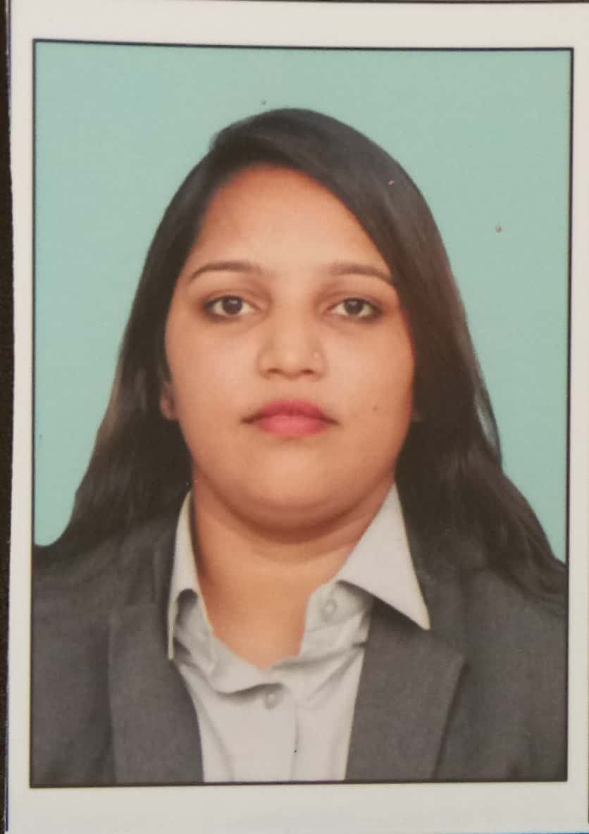
Email: poojamarwadi58@gmail.com
Mobile: 9737791590

Career Objective: To lead a responsible role in a challenging organization and like to put my best effort to help the organization to meets it goal.

Academic Qualifications:
Degree | Institute/School | Board/University | From/To |  | CGPA/%
M.B.A | Lj Institute of Management | GTU |  | 2017-2019 | 8.13
B.COM | S.v.vanijya Mahavidhyalaya | Gujarat University |  | 2014-2017 | 5.40
HSC | Shree Swaminarayan High School | G.S.H.S.E.B |  | 2014 | 40%
SSC | Shree Swaminarayan High School | G.S.E.B |  | 2012 | 55%

Work Experience: If Any

- Company:- IRSS (Indian Road safety services)
- Designation:- Insurance Executive
- Work Duration: -3 Month

Internships and Projects:

- Participated in Management Communication live project “TRAFFIC AWARENESS”.
- Internship with “plunes”.Technologies.
- Summer internship in “Religare broking Ltd”
- Cotton wicks machine market in a marketing project
- CP - A study on financial analysis of selected private and public sector banks
Co-Curricular Activities

- Skill Enhancement course
- Cambridge
- Coordinator in business baziger in college
- Volunteer in finance hakathon in college
Extra Curricular Activities:

Participated in College Sports Day :-Slow Activa,
Lemon Spoon,
Arm Wrestling.
Participated in School Sports Day :-kho-kho,
Rope Speaking.

Proficiencies:

Languages known: English, Hindi, Gujarati,Marwadi.
Computer Skills: Microsoft Office Excel.
Tally ERP 9.
D.T.P.
Hobbies / Interests:

- Interaction with people
- Listening music
- Reading
- Trawling.

Personal Details

Address:374/1 Jivabhai bharward’s chali danilimbada ahmedabad.
Date of Birth:07/08/1997
Gender:Female
Nationality:Indian
Marital Status: Single/Married:- Single

Signature Date:

