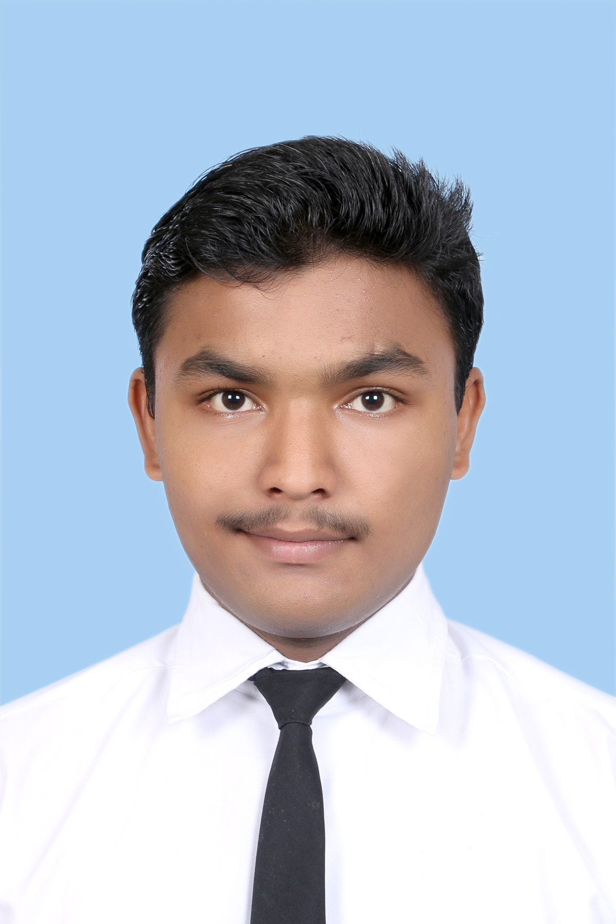

Pratik Jogawe
47/48 Sarvadhnya apartment
Sarvashree Nagar Near Navnath ITI
Nagpur, Maharashtra-440034
Mobile Number: +91-7203948340
Email ID: pratik12345jogawe@gmail.com

Personal Details

Date of Birth: 18/12/1996

Blood Group=O+

Father’s Name:
Mr.Sudhir Pandurang Jogawe

Father’s Occupation:
Govt. Servant (Defense)
Mother’s Name
Mrs. Archana Jogawe

Mother’s Occupation
Home maker

Languages Known:
English, Hindi, Marathi

Interests/ Hobbies.

- playing cricket
- Football
- Singing

Skills

1. Dedicated

2. Understanding and compatible nature

3. Good Listener

aking, Traveling etc
ster Making, Traveling etc

Communication Address

Manish Sharma
S/O R.K. Shama
House No – 554 / 6
Govind Puri, Kalkaji
New Delhi – 110019
India
Phone: +91(011)26448963,
+91 – 9873197367

CAREER OBJECTIVE

v To work with an organization wherein I get a good opportunity to learn and develop develop my skills and also acquire professional knowledge ,so that I can utilize utilize it for the interest of the organization

Academics

Serial no. |  | Degree/  course | Board/  university | Year of  passing | Result
1. |  | B.Sc.(Hospitality And Hotel Administration) | NCHMCT/IGNOU  (2nd Semester) | 2015-16 | 632
2. |  | BSc.(Hospitality And Hotel Administration) | NCHMCT/IGNOU  (1st Semester) | 2015-16 | 732
3. |  | XII (P.C.M) | S.S.C Board | 2014-15 | 57.85
4. |  | Xth | CBSE | 2012-13 | 8CGPA

Educational Achievements/Awards

Activity | Place | school | Year
1.Drawing Competition  2.Play | First  third | CIPS,Nagpur  CIPS,Nagpur | 2009  2009

Extra-curricular Achievements/Awards

Taken part in Symposium October 2015 (IHM Ahmedabad)

References

Mr.Vinay Namjoshi Mr. Salla Vijay Kumar
(. Lecturer & (Lecturer & Training Coordinator)
Astt. Placement Coordinator) Institute of Hotel Management
Institute of Hotel Management Ahmedabad,
Ahmedabad, Mob:- +91-9426356374.
Mob:-+91-9687606944 training@ihmahmedabad.com
Email: placement@ihmahmedabad.com

I hereby declare that above information is true to best of my knowledge.

Dated: 1. 08 .2016 Pratik Jogawe

