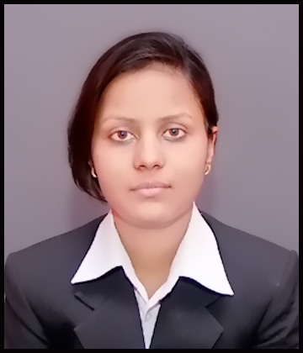  RAGINI SHARMA  (B.Tech-EC-2014)  Address for communication:  Village- Usaini, Post- Usaini, District –Firozabad (283104)  Agra, Uttar Pradesh.  Permanent Address:  Village-Usaini, Post-Usaini,  District- Firozabad (2831204)  Agra, Uttar Pradesh.  Personal Information:  Father's Name : Mr. Narendra Sharma  Mother’s Name : Mrs. Vimlesh Sharma  Date of Birth : Sep 10, 1992.  Sex : Female  Nationality : Indian  Marital Status : Single  Mobility : Global  Language : English & Hindi  Hobbies : Playing Chess | CURRICULAM VITAE  E-mail  Ragini.ecengineer@gmail.com  Ragini.usn@gmail.com  Mobile: +91-8488944118  CAREER OBJECTIVE:  Aiming to scale heights in an organization so that I can use my technical skills for fulfilling the goals of organization along with fulfilling my aim.  ACADEMIC QUALIFICATIONS:  - B.Tech.(Electronic & Communication) From MAHARANA INSTITUTE OF TECHNOLOGY & SCIENCES affiliated to UTTAR PRADESH TECHNICAL UNIVERSITY with 72.21% marks (aggregate) in year 2014.  - 10+2th from SHRI RAMANAND GARG INTER COLLEGE FIROZABAD affiliated to U.P. Board with 65% marks in year 2009.  - 10th from SHRI RAMANAND GARG INTER COLLEGE FIROZABAD affiliated to U.P. Board with 72.73% marks in year 2007.  TECHNICAL SKILLS:  - Software Language - PSPICE  - Operating System- Window XP Window 7  - MS office ( MS word, Excel, PowerPoint)  - Basic knowledge of Internet and its operations  Personal Qualities  - Target focused hard worker.  - Soft spoken.  - Quick learner, highly motivated and Enthusiastic.  - Enjoy working in Team environment.  INDUSTRIAL TRAINING:  - HAL Lucknow (2012-2013)-4 Weeks  - BSNL Agra (2011-2012)-2 Weeks  \  \\\  EXTRA ACTIVITIES & ACHIEVEMENT:  - Participated in ROBOTRYST-2014 Oragnised by the college.  - Certificate of Technical Training in HAL ( HINDUSTAN AERONAUTICS LIMITED) Lucknow.  - Knowledge of Embedded system .  - Training on PCB designing and simulation in PRECIOUS INFOSOFT.

EXTRA ACTIVITIES &ACHEIVEMENT

  - Participated in workshop of “ROBOTRYST-2013 organized by the college.

  - Knowledge of Embedded System.

  - Training on PCB designing and simulation in PRECIOUS INFOSOFT.

MAJOR PROJECT
- “Auto Metro Train to Shuttle between Stations”.
(Embedded System Base)

PROFESSIONAL SUMMERY

- Working in TAC Automation Pvt. Ltd. With Mitsubishi Electric.
- Knowledge of Sensors
- Knowledge of Industrial Automation Products

EXPERIENCE

I am working in TAC Automation Pvt. Ltd. with Mitsubishi Electric India from 7th July 2014 till now
Roles and Responsibilities:
- Handling with customer queries.
- Selling the product to the customer.
- Provide services to the customer like to provide information to the customer regarding product.
- Achieve day to day target and meet with the customer requirement.
- Maintaining good relationship with the customer.
- Analyze the need of the customer and provide services to them.

STRENGTH

- Self confidence
- Hardworking
- Result Oriented Preference

DECLARATION:

I hereby certify that all the information provided here is correct to the best of my Knowledge and belief.

Date………. (RAGINI SHARMA)

Place: ……….

