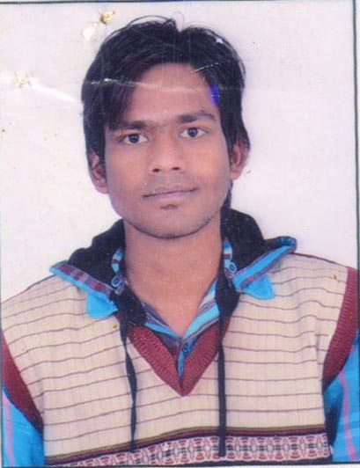
PRAVEEN NAGAR

Address : atru road khanpur, Jhalawar
Mobile : +91-9782864790
Email : praveennaga27@gmail.com

EDUCATION DETAIL

Course | College/School | Year | Aggregate
B. Tech  (electronics communication engg.) | vedant College of Engineering &tech. bundi | 2013 | 63.02%
XII | Fairyland Sr. Sec. School,Khanpur | 2009 | 47.08%
X | Govt sr.sec. School, khanpur | 2006 | 53.33%

COMPUTER SKILL

- I have good command on digital Electronics, Circuit Analysis, Data base management system, Data structure.
- In computer side, I have good command on programming languages like C and C++.
- Working Platforms : Windows XP, Windows 7,windows 8

HOBBIES/ INTEREST
- Reading stories and Spiritual books
- I take part in annual functions of school and college
- Participated in BADMINTON TOURNAMENT in college days
TRAINING

- Successfully completed 1 month training from DIVISION RAILWAY MANAGER (DRM) on
- Study of data logger/mis, Auto Exchange, IVRS,Overhead/OFC/Quad Cable communication,railnet and maintenance of various signaling gears and different types of communication using in Indian Railway on Kota Division of West Central Railway.

PROJECTS

- MINOER PROJECT-Study of LPG monitoring System.
- MAJOR PROJECT- LPG monitoring Sensor for home kitchen.

PERSONEL DETAIL

Date of Birth : 21 feb 1993

Nationality : Indian

Languages Known : English, Hindi, local languages

Permanent Address : Praveen nagar D/O Shiv Prasad nagar, Atru road khanpur
Th. –khanpur , Distt.- jhalawar ,Raj. ,PC.-326038

Hobbies : Reading social books, magazine, playing badminton

I am a hard working and always enthusiastic about the tasks that are given to me. The ability to prioritize the tasks has helped me in achieving best results and taste success in all my endeavors.

EXPERIENCE

I have no experience. I would like to have my job experience with your company.

I hereby declare that all the above-mentioned information is correct up to my knowledge and I bear the responsibility for the correctness of the above-mentioned particulars.

(Praveen nagar)

