CURRICULUM VITAE
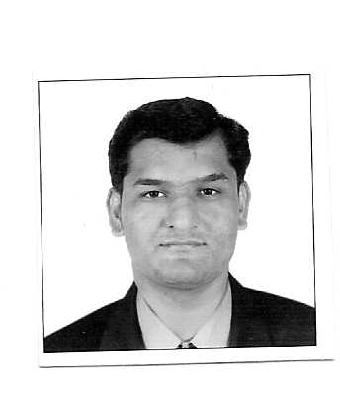
PATEL RINKESHKUMAR SURESHCHANDRA
42,Hariganga Society,
Opp.-C.M.C Nr, National Highway No-8
Odhav Road, Ahmedabad - 382415
State: Gujarat
Cell No. 09898898806
09979973633

Career Objective:
------------------------------------------------------------------------------------------------------------
To pursue a challenging career, which provides enough opportunity for growth and in the process, crate a symbolic relationship between the organization and my self. To have a consistent record of forging strong business relationship with prospects and clients by leveraging comprehensive product knowledge, to map out and fulfill client needs.
PERSONAL DETAILS
PERSONAL DETAILS

Date of Birth : 29th August 1987
Sex : Male
Languages Known : Gujarati, Hindi, and English
Marital Status : married
Nationality : Indian
E-mail Address patel.rinkesh@yahoo.co.in Patel.rinkesh1002@gmail.com
ACADEMIC QUALIFICATIONS

Qualification | School | Year of Passing | Percentage | Grade
SSC | Sahyog madhyamik shala | 2004 | 57% | 2nd Class
HSC | Pravinvidhya vihar | 2006 | 51% | 2nd Classs
Flyjac Logistic Pvt.Ltd(C & F Ajents)
C/o –The MobileStore Pvt.Ltd

Tenure ( 01st Aug-11 to Till Date )

Location : Ahmedabad

Designation : Warehouse In charge

Impact Retail Pvt. Ltd.(Essar Group)

Tenure ( 11st Nov-10 to 31st July-11)

Company Profile:

The Electronics Store is a part of Alghanim group of Industries based in Kuwait (Middle East) since 1932. This is Electronic Good’s Show-Room with 20,000 Carpet areas at here Ambawadi. The Electronic Store are a Brand Name.

Location : Ahmedabad

Designation : Warehouse In charge

Big Bazaar: (Pantaloon Retail India Ltd.)

Tenure : 18th Sept. 2006 to 10th Nov. 2010
(4 Years & 1 Month)

Company Profile:

Big Bazaar is a division of Pantaloon Retail India Ltd., a part of Kishore Biyani. There are One hundred One Big Bazaars spread / working in the country.
Big Bazaar merchandise includes the following good : Ladies, Dress materials, Western wear, Ethnic wear, Men’s garments like Shirts, Trousers, Shorts, Blazers, Kind wear, Suiting fabrics, Home furnishing , Plastic goods, Utensils, Food bazaar etc.

Designation : Team Leader (Cash Department)

Location : Ahmedabad

Job Description:

- Cash Flow & management – looking after daily business match with physical & deposited the same in bank.

- Team Management – Handle staff of 25 persons in cash team. Manage W/Off, shift & also manage counter on floor.

- Reporting - Prepare various reports & send it to Z.O. commercial.

- I have worked in Custer Service Desk as a Customer Representative in Big Bazaar since Two Months.

PERSONAL QUALITIES & MOTIVATION

I am smart working Young man capable of working individually as well as in-group. Able to mix with any type of community and maintain good relationship, furthermore I am very confident about one thing that whatever I do, do in the best possible way. I put in sincere efforts and try to fulfill the duties assigned to me.

I believe there is no short cut to success and the only way is through hard work and Sincerity. And I always like to be practical in all aspects of my life

Thanking you in anticipation of a prompt and positive response.

Rinkesh Patel

