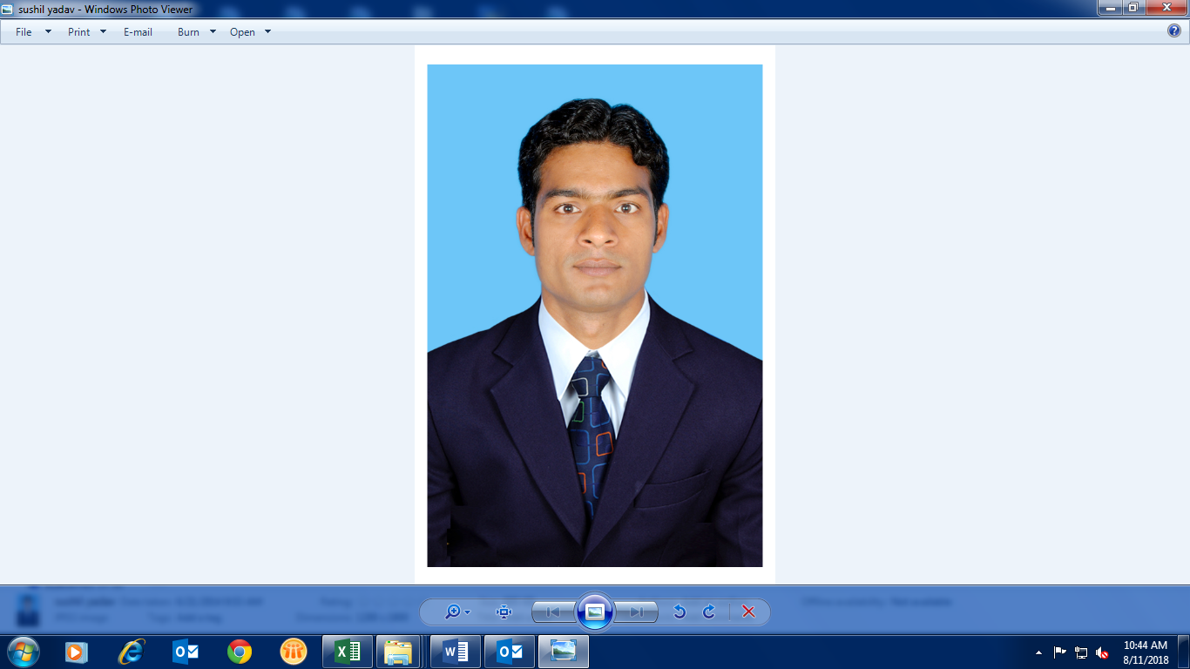
CURRICULUM VITE
SUSHIL YADAV
Address: B-195/A Kapra Colony Near
Air Force Road Main Gate NIT
Faridabad 121001.
Email: sushil21yadav@gmail.com
Mob No +91 9727020670,
9535303704,
Objective:

To pursue a challenging career in the domain of Quality Assurance, where I could make an impact by contributing my skills to the organization that I would work for. I wish to utilize my skills and knowledge in an organization that would foster my talents to get the best out of me.

Technical Qualifications:
- B-Tech (MECHANICAL) from B.S.A.I.T.M College affiliated to Maharishi Dayanand University Rohtak (HARYANA) in 2011
Educational Qualifications:
- Passed 12th from Haryana board in 2007
- Passed 10th from Haryana board in 2004
Organisational Scal:
FEB 2020 - Till Date M/S Indo Auto Tech Ltd. Daslana Ahmadabad. Asst. Manager
AUG 2016 –FEB 2020 M/S Neel Metal Products Ltd (NMPL-12) JBM GROUP Ahmadabad. Sr, Engineer
AUG 2015 - AUG 2016 M/S Indo Auto Tech Ltd. Bangalore Engineer
AUG 2013- AUG 2015 M/S Badve Engineering Ltd. Bangalore Engineer
JUN 2011 -JUL 2013 M/S Royal Auto Tech Ltd. Faridabad GET
Working Experience:

Total Work Exp: 10 yrs.
Presently working with M/S Indo Auto Tech Ltd. Daslana Ahmadabad. Provides fabricated metal products. The Company offers sheet metal, fine blanked, tubular components, and welding assemblies. Sheet Metal components; welded Frame Assy. Handle comp, Swing arm & Muffler for Honda Motor cycle and scooter India Pvt limited.
ROLES & RESPONSIBILITIES:-

- 100% SPR & Zero complaint from customer
- NVA elimination < chipping, retaping, hammering etc.>
- Manufacturing excellence activity for productivity improvement thru process merging, low cost automation, pick & place automation, cobot system etc.
- Experience in design/validation and use of jigs and fixtures, new sheet metal parts development, layout study and evaluation of die design and conduction trails.
- Good knowledge on welding concepts, design review, buy offs and skill to conduct trails and improve the sub assembly accuracy.
- Experience on understanding quality problems, carry out root cause analysis and countermeasure skills using QC tools. Experience on handling instruments and line set up i.e. Single piece flow line concept, fool proofing etc. Conducting supplier training and supplier audits (As per applicable Quality Standards).
- Preparation and updating the incoming inspection plans and train the team on methods and measurement of parts, communication of monthly supplier PPM and other performance matrix.
- Attending the weekly meeting with management and Develop training on parts quality to build quality awareness.
- Vendor Process improvement by conducting regular process audits.

M/s Neel Metal Product Limited
M/s Neel Metal Product Limited- Vithalapur (JBM Group). NMPL is an ISO/TS 16949: 2009, ISO 14001 and OHSAS 18001 certified Company, manufacturer of Sheet Metal components; welded Frame Assy. Handle comp & Muffler for Honda Motor cycle and scooter India Pvt limited is equipped with state of the art technology in metal forming & welding. The plant is equipped with MIG welding robots, Spot welding, Projection welding and Press shop with sophisticated Tool room.

ROLES & RESPONSIBILITIES:-

- Responsible for System Documentation for Quality dept.
- Responsible for in process & PDI Quality Assurance.
- Conducting Internal Audit (QMS )
- Conducting Process & Product Audit
- Preparing Weekly as well as Monthly Quality Presentation.
- Updating of documents like Control plan, FMEA, Work instruction, SPC.
- Attending the QAV Audit with customer & submitting the action Plan for NC Points.
- Review & Analysis daily Rejection and Rework for in process, PDI.
- Representing Quality dept. in CFT during New project Development.
- Daily basis Hmsi meeting attend.

M/S INDO AUTO TECH LTD.
By exceeding our customer requirements Indo has become a valued supplier of major Sheet Metal Components, Tubular components and assemblies and Sub-assemblies to leading OEM’s (HMSI) in the Indian as well as global automotive Industry.

ROLES & RESPONSIBILITIES:-

- Responsible for day to day customer interaction for complaints.
- Everyday Customer complaints review and monitoring by solving 7 QC techniques.
- For Customer Complaints updating the 5W1H Sheet as per HMSI Requirement.
- Coordinating with HMSI for Market Complaints & Providing 5W1H Sheet with all supporting Documents.
- For Customer Complaints Implementing the Poka yoke in Process to avoid the Issues.
- Educating the quality members through training & One point Lesson.
- Preparing the Quality presentation on weekly basis & Present to HMSI top management.
- Attending the QAV Audit with customer & submitting the action Plan for NC Points.
- As per the plan Conducting Internal QAV Audit

M/S BADVE ENGINEERING LTD.
A well known group of companies spread almost all over the India engaged in manufacturing frame body muffler and other sub assy/. For almost all leading OEM; .Bangalore plant is producing for HMSI
Working Area– Working in in- process quality and representing at customer end for all fame assy of Honda Aciva frame Parts and bike parts with down line support of 13nos. Of In- process and PDI quality supervisors.

ROLES & RESPONSIBILITIES:-

- Process defect analysis and elimination of same.
- Conduct daily meeting with sub-ordinates for customer complaint & necessary actions accordingly.
- On Job training to New Welders & Operators.
- Responsible for manpower deployment at right place.
- Conduct daily meeting with sub-ordinates for customer complaint & necessary actions accordingly.
- Adherence with Quality parameters.
- Work standard and Spot plan modification in area of improvement.
- Readiness for internal & external audit.
- Impart training to associates on Team Work, Positive attitude etc.
- Monitor hourly and daily product quantity.

M/S ROYAL AUTO TECH PVT LTD.
The Royal Group is among India's leading Manufacturer & Supplier of Sheet Metal Components,FabricatedComponents,Tubular Parts, M/c Components, for all Ranging 2Wheeler to 4 Wheeler. Royal Group is Major Supplier of Honda, Maruti, and Neel metal, Bextex, Escorts, & Cappro Maruti.

ROLES & RESPONSIBILITIES:-
- To handle the man power at PDI to insure 100 percent quality of EXPORT & OEM for customer satisfaction.
- Responsible for 100 % CKD Production, Quality and despatch with ensuring 100% quality.
- To make proper layout to insure smooth running for the material at pdi.
- Resolving customer complaints through customer quality as a part of daily activities in Quality Assurance.
- To insure the quality at predispatch shop by sample inspection method or cross checking.
- Coordination with the production department to avoid any production loss.
- To do the kaizen related activity for continuous improvement within the department.
- Responsible for Approval of newly Developed Component at Customer End.
- Responsible for Validation of Jig, Fixture & Rec. Gauge at Customer End & In- Process.
- To ensure timely Inspection of the quality assured components to assembly shop, maintaining the smooth fitments of component
Key Strengths:

- Process Improvement activity
- FMEA, Poke-Yoke, Kaizen, 7QC tools & 3M.
- Process capability study & equipment’s measurement system analysis.
- Quality problem solving <5W1H, 8D A3 etc.>
- Measuring Instruments <Micrometer, Height gauge, Vernier caliper, Air plug gauge, Bore gauge, Profile projector etc.>
- Process & Product Audit, PPAP, WI/SOP etc.
- Real time monitoring projects < Production & loss data, Asset tracking, Poke Yoke monitoring, Document management etc.>
- Knowledge of drawing, fabrication and automobile.
- Knowledge of APQP, Knowledge of manufacturing process.
- Extensive knowledge of QA best practices cause identification, and agile development methodologies
- Possess a learning attitude with a high degree of flexibility and adaptability.

Professional Strength:

- Disciplined, hardworking, smart working, Team building, Leadership
- Continuously seeking opportunities to learn.
- Always willing to take new responsibilities.

Software Skills:

- Operating System : Windows98/ XP/ 2000/ 7 / 8
- Basic Software : Ms-Office (Word, Excel, PowerPoint)
- Web Application : Internet

Hobbies:

- Listening soft Music.
- Playing and watching cricket.

Personal Details:
Father’s name : Sh. Shiv Jee Yadav
Date of Birth : 08 Oct 1987
Marital Status : Married
Nationality : Indian
Languages known : Hindi & English
Date: ……………
Place:- kadi (Sushil Yadav)

