
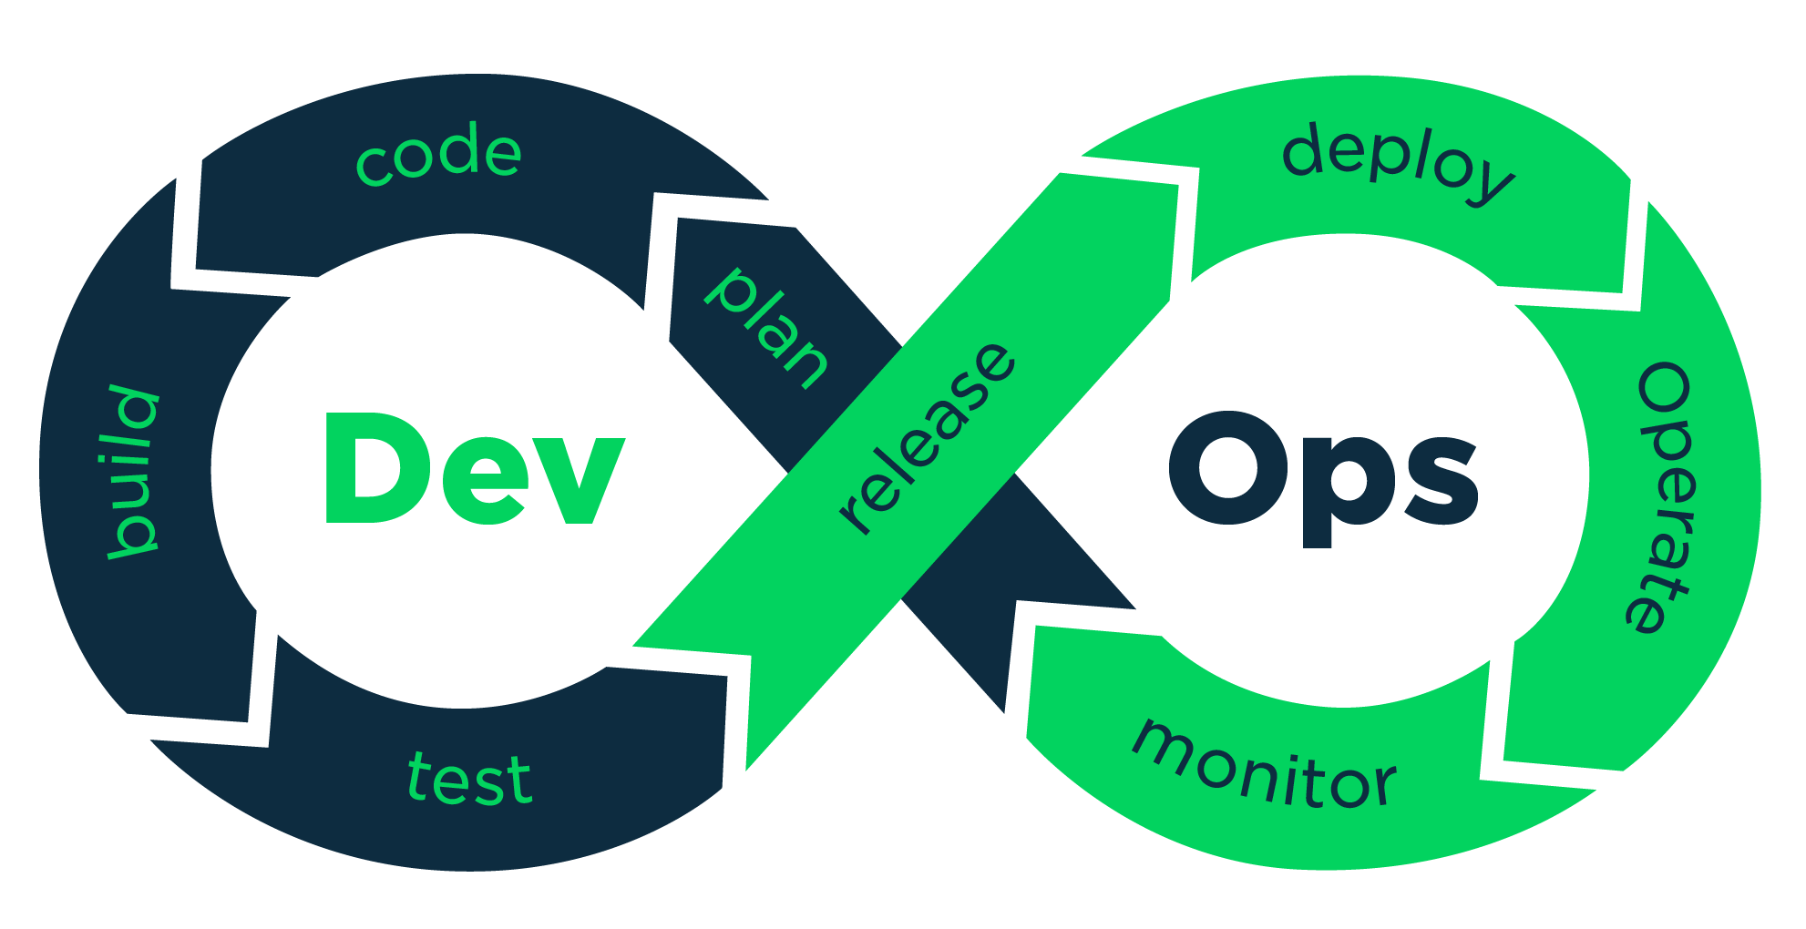
Vijayant Satapara

DevOps Lead Exp : 5 Year
On .Net Platform Exp: 8 Years,
Total IT experience: 13 Years Email: vijayant_satapara@yahoo.com
Mobile: +91 99255 84485

Professional Snapshot
- Working as DevOps and seeking further carrier growth in DevOps area.
- To work on business flow understanding and work on technology of business.
- Exposure in end-to-end Development life cycle.
- Development of software products from coding testing, DE- bugging, documentation and implementation.
- Azure Cloud and DevOps consultant with concentrations on Azure IAAS / PAAS.
- Strong experience on Azure Devops
- Strong expertise on DevOps concepts like Continuous Integration (CI), Continuous delivery (CD) and Infrastructure as Code (IaaS), Cloud Computing etc.
- Experience on Azure Kubernetes Service(AKS)
- Worked with different components of iPaaS solution Azure provides, Service Bus, Functions and Logic Apps to use connectors and create workflows.
- Experience on Jenkins and docker files
- Experience in dealing with Windows Azure IaaS-Virtual Networks, Virtual Machines, Cloud Services, Express Route, Traffic Manager, VPN, Load Balancing, and Auto-Scaling.
- Excellent working knowledge on Microsoft SQL Server 2005/2008/2014.
- Experience in working on source control tools like GitHub (GIT).
- Configured and Monitored CI CD pipelines using AZURE repo.
- Proficient in Deployment automation using Terraform scripting
- Experience in general Systems Administration and Change Management, Software Configuration Management.
- Worked with Docker on multiple cloud providers, from helping developers build and containerize their application (CI/CD) to deploying either on public or private clouds.

Technical Skill Summary: Experienced (E), Proficient (P), Foundation (F)
Operating Systems : Windows & Linux(UI) (F)
Languages : C(F), C++(F), Python(P), C#.NET(E)
RDBMS : MS-Access(P), ORACLE 8i(F), MS-SQL 2005(E), MS-SQL2008(P), LINQ(P)
Dev Tools : Visual Basic 6.0(P), VB.NET(E), Developer 2000 Report Builder(F),
Crystal Report 6 & 9(P)
Web Technologies : ASP.NET 2.0/ 3.5/4.0(E) ,WCF(P) Classic ASP(F), XARA Web Style 1.0(P),
Dreamweaver(F)
DevOps Tool : Jenkins(F), DataDog(E), Docker(F), Ranchar(F)
Kubernetes (F), Azure DevOps(E)
Cloud Services : Azure App insight(F), AWS(P)
Scripting : JavaScript(E), PowerShell(P), Logic App(F), Function App(F)
Version Control : GIT(P), SVN(E), TFS (F)
Messaging : Services Broker (P), Kafka (P)
Management Tool : JIRA, Confluence, Unfuddle, BaseCamp, Azure Board.
Experience Summary:
Organization Name | Designation | Period | Key Responsibilities
Stridely Solutions Pvt, Ltd.  (Ahmedabad) | Project Lead - DevOps | February 2020 - Till Date | - Setup Azure DevOps at client environment.  - Taking responsibility to manage GIT branching strategy.  - Responsible to manage work item to be sync with Azure Board to Visual Studio.  - Taking responsibility for Creating and presentation DevOps demo to Companies proposed client.  - Responsible for Entire monitoring team in company including support team as well.  - Research and implementation of Monitoring tool for suitable to company product and other tool.  - Member of Interview panel in company.
Excellence Infonet  (HHAeXchange)  At Ahmedabad center  (DevOps Dept) | Team Lead - DevOps | April 2017 – January 2020 | - Responsible for Entire monitoring team in company including support team as well.  - Research and implementation of Monitoring tool for suitable to company product and other tool.  - PowerShell script writing for various automation in monitoring.  - Creating POC for .Net code migration to .Net Core Technology.  - Handing Kafka Development and related management.  - Learning Docker and Ranchar tool accommodated by DevOps Dept.  - Using Jenkins for CI/CD for Testing environment and internal project.  - Handling DataDog monitoring tool for HHA portal.
Etech Inc,  At Gandhinagar center.  (ETS department) | Lead Developer  (Equivalent to Team Lead as per company hierarchy policy) | June 2013 – March 2017 | - As Team lead position, Taking care responsibility for Develop SDLC for project and Handles project and also handle team.  - Lead position in Designer chat project from ICE product.  - Taking responsibility of GIT repository for ICE project.  - Handling PowerShell project for auto deploy .Net code at web server.  - Code verification and helping team.  - Client communication responsibility for Designer chat project.
Gateway Technolabs pvt Ltd.  (Group of Gateway companies)  Location:  Ahmedabad  (Gujarat) | Analysts Programmer | Jan 2013 – May 2013 | - As senior developer responsible for coding and testing application, Develop SDLC for project, handles project and also handle team.  - Working as Team Member in RIM Scan Saas located at Norway.  - Taking care of Business object in RIM Scan Saas.  - Member of Interview panel in company.  - Communicate with client as per agile methodology and taking care of sprint.
Softweb Solutions Pvt Ltd.  (aka: Priyasoft)  Location:  Ahmedabad  (Gujarat) | Senior Software Developer | July 2011 – Jan 2013 | - Working as FTE (full time equivalent)for Innovative inspection LCC at Oklahoma USA.  - As senior developer responsible for coding and testing application, Develop SDLC for project, handles project and also handle team.  - Taking responsibilities for research new technologies and develop new logic for various projects.  - Working as Team Leader Murphy oil refinery project.  - Attain daily scrum meeting with Client using Go-To Meeting and Skype tools.  - Working as team member in Fujifilm project.  - Taking responsibilities for training company's trainee student.
VSquare System Pvt Ltd.  Location: Ahmedabad  (Gujarat) | Software  Developer | May 2008 – June 2011 | - As a software developer responsible for coding and testing application in VB.NET ,C#.NET and SQL-2005  - Taking reasonability to maintain the Share Registry System for the client of Corpserve Ptv Ltd from South Africa  - Designed and developed the web portal for Xbox and PS3 gamer called rivalspot (www.rivalspot.com). Client from Canada.  - Designed and developed the window application and Web application name as EnterMBA.
- S.R Doshi College/ Swami Vivekananda College at Surendranagar (Gujarat) As Lecturer. Nov 2005- May 2008.
- National Informatics Center(NIC) at Surendranagar (Gujarat) As Assistant Programmer. Oct 2004 – May 2005.

Educational Qualifications.

Bachelor of Science in Information Technology – Securing Second Class in M.P.Vora Commerce & Science College from Saurashtra University in 2004.
I have achieved First Class my school studies. I have studied up to H.S.C. at N.T.M High School Surendranagar.
I have also completed course of IELTS(International English language testing system) Exam held by British council , at Ahmedabad in 2005.

Successful completed Microsoft conduct exam (70-515), and earned Microsoft certified technologies specialist (MCTS) certificate.

Achievement:

- Certificate award from department of post (Govt of India) for successfully developing software for post office agents

Major Trainings Attended:

- 2 months training in .NET from National Informatics Center

Personal Information:
Name: Vijayant J. Satapara  Birth Date: 28/12/1982  Nationality: Indian,  Passport No: Z-4508134  Pan Card: BSMPS7046H  Marital Status: Married | Contact No: +91 99255 84485  Correspondence Address: Vijayant Satapara,  A-701, Satyamev Vista, Gota Circle, SG Highway, Gota, Ahmedabad – 382481.  Gujarat.(INDIA)

