RESUME

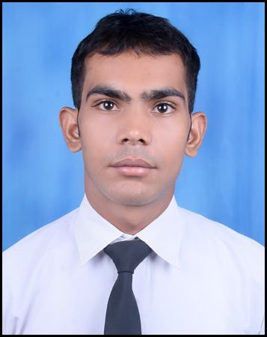
ANKIT WARIA
B.TECH – TEXTILE TECHNOLOGY
TIT&S COLLEGE, BHIWANI ( HARYANA )
COLLEGE ID – 14TT009
CONTACT NO. – 8950459928
Email ID – ankitbeserwal3595@gmail.com

Present Address:

CAREER OBJECTIVE

To work in a firm with a professional work driven environment where I can utilize and apply my knowledge, skills which would enable me as a experienced graduate to grow while fulfilling organizational goals.

BASIC ACADEMIC CREDENTIALS
Qualification | Board/University | Year | Percentage
B.Tech (Textile technology) | TIT&S College, M.D.U. ROHTAK | 2018 | 61.58 %
Intermediate | TIT SENIOR SECONDARY SCHOOL, STATE BOARD (H.B.S.E.) | 2013-2014 | 68.8 %
High School | V.P.O. DHANA LADANPUR  GOVT. HIGH SCHOOL  STATE BOARD (H.B.S.E.) | 2011 | 81.4 %

EXPERIENTIAL LEARNING

- Present work in bmd pvt ltd (technical textile )hathrol Gujarat

- Company name = BMD PVT LTD BANSWARA 6 months in weaving dept.

- I conduct the Picanol Rapier Jacquard machine all Erecting program at hathrol Gujarat in same company
- To maintain the maximum Production & efficiency of Looms in weaving departments.
- Also knowledge of section warping machine errection and to check daily programme of warping machine .

IT PROFICIENCY

- Microsoft Office Word, Microsoft Office Excel, Microsoft Office Power Point
- Internet Browsing
- CAD,CAM and Coral Draw

INDUSTRIAL VISIT

GRASIM LIMITED BHIWANI

RSWM , KHARIGRAM UNIT

BMD PVT LTD ,BANSWARA

BMD PVT LTD ,HATHROL GUJARAT

ACHIEVEMENTS

- Sustain the 2nd position 6 to 10 class at school level
- Get AIR 2003 in UPES 2014 exam

INTERPERSONAL SKILL

  - Sincere & Serious to work
  - Confident and Determined
  - Ability to cope up with different situations.
  - Self motivated
  - Team player

PERSONAL DETAILS

- Father’s Name :- Mr. Suresh
- Permanent Address :- H.NO. 467 ,V.P.O. DHANA LADANPUR ,BHIWANI 127021, INDIA
- Date of Birth :- 3 Nov. 1995
- Language Known :- English & Hindi
- Interest & Hobbies :- Listen music, Playing cricket & chess game

DECLARATION

I do hereby declare that the above information is true to the best of my knowledge.

DATE - ANKIT WARIA
(Signature)

