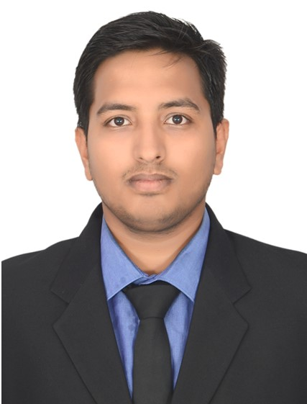 ROHIT KUMAR SHAH
+91-7873060016
rohitshah12319@gmail.com
CAREER OBJECTIVE
Seeking a career to utilize my knowledge, personal skills to gain comprehensive understanding of an organization so as to take responsibility and contribute significantly.

PROFESSIONAL QUALIFICATIONS:

EXAMINATION PASSED | NAME OF BOARD / UNIVERSITY | YEAR | Score
MBA | Amity University  ( Rajasthan) | 2016-18 | 8.2

EDUCATIONAL QUALIFICATIONS:

EXAMINATION PASSED | NAME OF BOARD / UNIVERSITY | YEAR | % AGE/CGPA
B.Com (Hons.) | Sambalpur University , Odisha | 2013-2016 | 57.6
Senior Secondary | C.B.S.E, Chhattisgarh | 2011-2013 | 70
Secondary | C.B.S.E, Odisha | 2011 | 6.0

SUMMER INTRENSHIP:

S. No. | Nature of Training / Summer Project | Organization | Duration | Location
1 | Finance | Birla Sun life insurance | June – July 2017 | New Delhi
Brief of the Summer Internship:

On Job Training I Work on:-
- Trading.
- Analysis.
- Asset class investments.
- Insurance products sales.
- Outdoor cold selling.

WORK EXPERIANCE:

S. No. | Department | Organization | Duration | Location
1 | Corporate Data (People Data) | S&P Global | June 2018 – Present | Ahmedabad
Brief of the work experience:
On Job I Work on:-
- Big documents analysis
- Backlogs Projects
- US proxy Research and analysis
- International Annual Reports analysis
- Working with Compensation Department as a Smart Source

Achievements & Suggestion during Job:
- More then 4 times performer of the day and week.
- Nominated and Win rising star of the quarter for Best Performance.
- Give various suggestion about software improvement and policy updates.
- ACE bronze performance Award for best performance in peer group.
- Get promotion as Approver within 6 month as per the performance.

CERTIFICATES AND PROJECTS
- Contributing to the live project “Multi-Level Campus Ambassador Program.
- BSI certified Green Belt in 6Sigma
- National seminar of Contemporary Management Practices.
- Participate in Youth Money Olympiad 2k17

ACHIVEMENTS AND ACCOLADES
- Winner of Corporate Roadies in IIS University 2k17 ·
- Second in Buzz Quiz in IIS University 2k17
- LCPL Rank in N.C.C

COMPUTER PROFICIENCY
- MS. Office.
- Minitab (basic)
- Tally ERP.9

PERSONAL INFORMATION

Father’s Name: Mr. S.K.Shah
Date of Birth: 31/10/1994
Communication Address: B/L 219 B .Colony Rourkela Odisha 769012
Languages Known: HINDI, ENGLISH
LinkedIn Id: https://www.linkedin.com/in/rohit-kumar-shah-404116139/

DECLARATION
I hereby declare that the information provided above is true to the best of my knowledge and belief.

Place: ODISHA Signature:
(Rohit Kumar shah)
Date:

