***Curriculum vitae***

**Name**: - KevalGhanshyambhaiThakor.

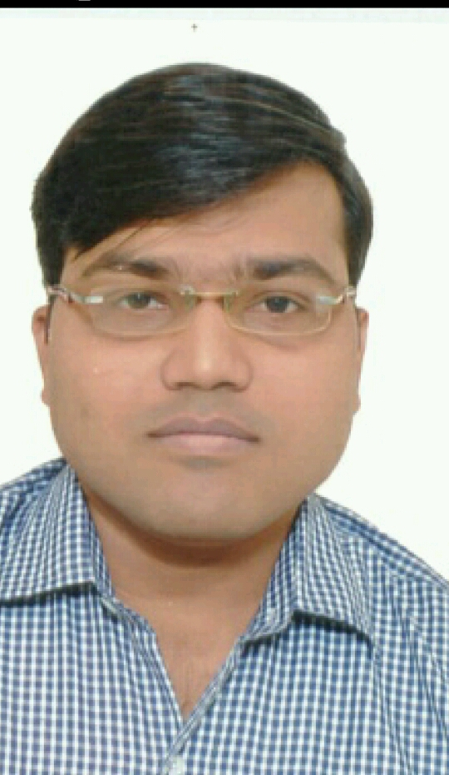

Ph oto

**Address**: - 23/3,Chandraprakash Society,

Old Pilot Dairy Road,

Kankaria, Ahmedabad,

Gujarat.

**Date of Birth**: - 23th December 1985.

**Nationality**: - Indian.

**LanguageKnown**: - Gujarati, Hindi, English.

**Contactno**.: - 7405635963/079-25452521

**EmailId**: - [kevalthakor85@yahoo.com](mailto:kevalthakor85@yahoo.com).

Academic **Qualification:-**

|  |  |  |  |  |  |
| --- | --- | --- | --- | --- | --- |
| Degree | Board/University | | Year passing | Percentage | |
| HSC | GSHEB | | MARCH 2001 | 78 | |
| BCOM | Gujarat | | April 2007 | 65.11 | |
| MCOM | Gujarat | | April 2010 | 50 | |
| CS Executive | ICSI | | PURSUING |  | |
| CA ( Final ) | ICAI | PURSUING | | |  |
| LLB | GUJRAT UNIVERSITY | April-2018 | | | 58% |
| DTP | GUJRAT UNIVERSITY | April-2019 | | | 60% |

To pursue a dynamic and challenging career with an organization of repute and integrating my own goals with the organization so as to become a catalyst in each other growth.

**Technical Qualification**: -

* Completed 250 hours I.T training from ICAI.

**Job Profile**: -

* **Worked as Tax Auditor & Accountant from 03-01-2008 to 30-4-2012 at, B.N Patni& co. at Navarangpura, Ahmedabad.**
* **Worked as Tax Auditor at,PrakashSheth& co. (1YRS)**
* **Worked as Tax Auditor at Kamlesh shah & co. (6 Month) (S.S.N.N.L (Govt.).)**
* **Work as senior Accountant (2yr) at Star energy systems (proprietorship) , Star safety systems Pvt ltd& Star renewable pvt ltd**
* **worked as Senior Account Executive in MOTONOVASUPER BIKES PVT LTD (1 yrs)**
* **Chitra Publicity company &Chitra insultech PVT LTD (2yrs) (manufacturing company) as a Senior Accounts Executive**
* **Currently Working in KATIRA CONSTRUCTION PVT LTD as senior Accounts Executive**

**Work Experience of: -**

* Preparation of Financial Statements.
* Preparation GST Returns
* Preparation Of TDS Statements
* TDS Returns
* Income tax and Other Taxes knowledge
* Scrutiny of various Ledgers.
* Cash & bank Vouching.
* Checking of Fixed Assets registers and depreciation thereon.
* Checking compliance of TDS & Preparing TDS return.
* Physical Verification of cash, security items, stock & related records.
* Export Documents
* Import Documents
* Checking the internal control procedures.

**References**: -

1. Jay D Parikh (M:9824139505)
2. CA.B.N Patni (M:9898068740)