**PATHAN AEHMAD A**

**Address**

28/c, Ramjan park-2, opp: Super Park,

Near: Sama primary school, Fatehvadi, Sarkhej rod

Dist: Ahmadabad, 380055

**Contact Details**

Contact No. : 9825543460

E-Mail: a.a.pathan6@gmail.com

**Career Objectives:**

To work with an organization, where to keep up with cutting edge of technologies and serve for the betterment of the organization in the best way...

**Education:**

I have completed my Diploma (CIVIL) from D.A. Diploma engineering & technology Mahemdavad (GUJARAT).With 7.65 CGPA

|  |  |  |  |  |  |  |
| --- | --- | --- | --- | --- | --- | --- |
| **Sem** | **1st** | **2nd** | **3rd** | **4th** | **5th** | **6th** |
| **Spi** | 6.13 | 4.0 | 6.57 | 7.87 | 7.61 | 8.57 |

|  |  |  |  |
| --- | --- | --- | --- |
| **Passing Exams** | **Board** | **Year** | **Percentage** |
| **S.S.C.** | G.S.E.B. | 2011 | 78.80% |
| **Engineering** | G.T.U. | 2014 | 7.65CGPA |

**Computer skill:**

* AutoCAD , Revit Architecture completed

**Strength: -** Self-motivated, Reliable, Flexible in learning, and Confident in nature.

**Personal Information:**

* Name : PATHAN AEHMAD ABDUL BHAI
* Date of Birth : 9th NOV 1995
* Gender : Male
* Nationality. : Indian
* Languages Known : Gujarati, English and Hindi
* Marital Status : Single
* Religion : Muslim
* Native Place : Goblej , Dist.: kheda

**Experience:** One Year (At: - Swati gardenia, makarba , And Seth corporate tower , Gujarat college)

**Declaration:**

I hereby declare that the information furnished above is true to the best of my knowledge.

**Your Sincerely**

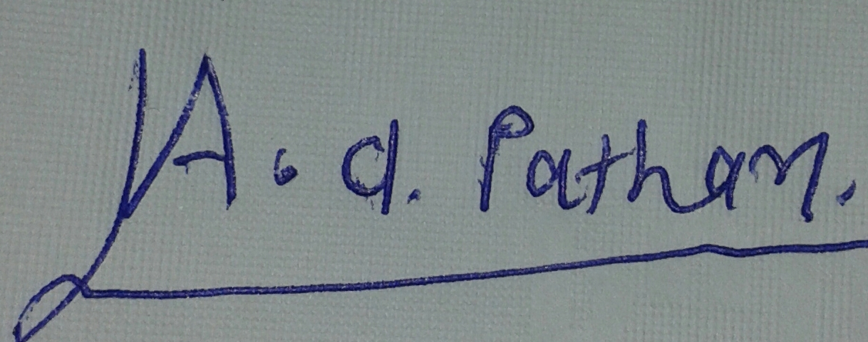

**Aehmad pathan**