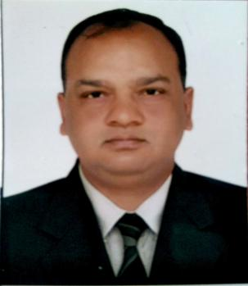 **ARVIND KUMAR**

House No.28, Hare Krishna Tenement Society,

Near Vivekanand School

Kolawada, Gandhinagar, Gujarat

PIN-382028

Mobile: +91-9409124974

E-mail: arvindkumar713012@gmail.com

OBJECTIVE

To manage and organize staff activities of an organization and leads negotiation between employees. Effectively organize recruitment, selection,training and compensation activities. To look after overall activities, functions of the company and to manage proper coordination between employer and the employee.

PROFESSIONAL SUMMARY

I had a work experience of 29 years as HR and in administration at different locations of Indian Air Force. I managed full range of human resource activities in Indian Air Force at different locations of India. Assisted the organization in recruitment and selection of personnel, imparted on job training, maintained personnel up-to-date information including Appraisal Reports. Effectively maintained attendance records completed all responsibilities and duties as assigned. Proficient in recruiting, organizational skill, effective communication, team work, computer operation and record management.

EDUCATION DETAILS

1988 10th – CBSE (KV SRINAGAR, J&K)

1991 12th – Board of Intermediate Education (Hyderabad, Andhra Pradesh)

1995 BA - Osmania University (Hyderabad, Andhra Pradesh)

1998 PG Diploma in Industrial Relations and Personnel Management (Bhartiya Vidya Bhawan’s Rajendra Prasad Institute of Communication and Management, Kanpur, Uttar Pradesh)

CERTIFICATE COURSE

2003 Management Course for Junior Warrant Officer Promotion (Air Force Station Suratgarh, Rajasthan)

2011 Methods of Instruction Course (Airmen) (Ground Instructors’ School, Tambaram Chennai, Tamil Nadu)

2013 Security Course (Airmen) & Intelligence Security (Air Force Intelligence School, Pune, Maharashtra)

2017 Diploma in Marketing and Sales Management (Udaybhansinhji Regional Institute of Cooperative Management, Sector-30, Gandhinagar, Gujarat)

TECHNICAL KNOWLEDGE

2005 MS OFFICE (APTECH Computer Education, Gandhinagar, Gujarat)

PERSONAL INFORMATION

Date of Birth : 30th Dec 1971

Gender : MALE

Father Name : BISHWANATH PRASAD

Mother Name : CHANDRAVATI DEVI

Mother tongue : HINDI

Nationality : INDIAN

Marital status : MARRIED

Languages : English, Hindi, Gujarati

Address : 28, Harikrushna Tenements Society,

Kolawada, gandhinagar.

DECLARATION

I do hereby that the particulars of information and facts stated here in above are true, correct and complete to the best of my knowledge and belief.

ARVIND KUMAR