**Abhishek Banerjee**

**Personal Data**

Name : Abhishek Banerjee

Mailing Address : Banerjee Bhawan, Banerjee Colony, Pachmari Road Pipariya.Madhya Pradesh.

Phone : +917574890655

Email : abhishek.banerje1984@gmail.com

Date of Birth : 16th November 1983

Marital Status : Married

Passport No : G2725109

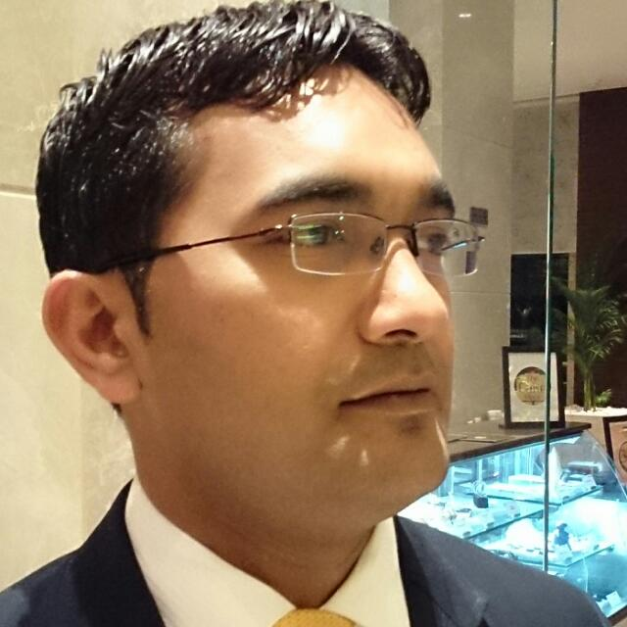

**Functional Competencies**

**Summary**

* Over all twelve years of experience in hospitality industry in areas such as
* Food and Beverage Administration and Outlet Operation
* Performance management, budget preparation, general office management in coordination with other Departments
* Planning and implementing quality control programs
* Possess well-developed, conceptual, communication and creative skills.
* Maintain good customer relationships
* Skill in exercising initiative, judgment, and decision making in solving problems and meeting organizational objectives
* Communicate openly with management and staff.
* Languages: Fluent in English, Hindi & Bengali

**Education**

● **Diploma in Hotel Management** ORIENTAL SCHOOL OF HOTEL MANAGEMENT WAYNNAD KERALA (2002-2005)

* **Higher Secondary** ST.JOSEPH’S HIGHER SECONDRY SCHOOL PIPARIYA (M.P) 2002.

* **Secondary** ST.JOSEPH’S HIGHER SECONDRY SCHOOL PIPARIYA (M.P) 2000.

**Professional Training Attended**

* Commitment to excellence ● Supervisory Skills
* Food & Beverage Up-Selling
* Material Management System ● Managerial Skills
* Fire Fighting

**Computer skills**

Windows 98, 2000, Xp, 2003Proficient in MS office, Hospitality Software (MMS, Micros, Triton, Opera)

**Professional Experience**

* Reporting To MD & Directors Of Sanghi Industries Ltd
* Taking care of in & out operations of the bungalow
* Managing each & every departments
* Taking charge of whole bungalow in terms of operations
* The property is build up in 12 acres of land which includes 15 rooms fully operational,2 swimming pools, one aquarium, one discotheque, two bars, one gazebo, one gymnasium, one Jacuzzi & banqueting space of 700 pax with parking facility available.
* Conducting in-house training for the staff
* Managing the budget in co-ordination with Asst.Food & Beverage. Manager
* In charge of speciality Pan-asian Restaurant (Tides)

**Sanghi Industries ltd**.

Ahmadabad, Gujarat

**Estate Manager**

From October 2015

Till date

**Responsibilities**

* Reporting to the Asst.Food & Beverage Manager

**Radisson Blu Hotel.**Ahmedabad,Gujrat.

**Restaurant Manager**

From August 2012 To

October 2015 Maintaining excellent service quality and on time delivery

* Anticipating and fulfilling the needs of in-house guests& Non-Resident guests
* Assisting in planning and executing quality control programs
* Actively participating in customer feedback

Coordinating and communicating with other departments

* Motivating the staff and improving cohesiveness as a team
* Handling queries and assisting in quick service recovery

Assisting Asst.FNB for budgeting & profit & loss of whole FNB.

Responsible for 3 FNB outlets Coffee Shop, In Room Dining & Speciality restaurant (The Great Kabab Factory).

**Thunderbird Resorts**

Daman,Diu-Daman, India

**Asst.Manager Food& Beverage**

From, January 2012 to July 2012

**Responsibilities**

* Reporting to Restaurant Manager
* Took charge of Specialty Restaurant as a Pre-Opening Team
* Maintaining a training process on day to day operations
* Maintaining excellent service quality and on time delivery
* Actively participating in customer feedback
* Coordinating and communicating with other departments
* Motivating the staff and improving cohesiveness as a team
* Handling queries and assisting in quick service recovery
* Took charge of ordering of cutlery, crockeries, glassware & linenfor whole Food & Beverage operations.
* Handling the minibar

**Responsibilities**

* Reporting to Asst.Restaurant Manager
* Anticipating and fulfilling the needs of restaurant guests
* Maintaining excellent service quality and on time delivery
* Actively participating in customer feedback
* Coordinating and communicating with other departments
* Handling queries and assisting in quick service recovery
* Maintaining inventories of the day to day operations for cutlery, crockeries, glassware& linen.

**The Grand Maratha(Luxury Collection)**Mumbai, India

**Executive**

From Feb 2008 to December 2011

**Grand Hyatt**

Mumbai, India

**Guest service Associate**

From Jan 2005 to September 2007

**Responsibilities**

* Reporting to captains
* Delivering orders
* Serving the orders as per Hyatt SOP’S
* Maintaing excellent service quality
* Attending all the FNB trainings held in & out of the departments
* Preparing for each & every shifts for their smooth operations.

**Industrial exposure training**

**Responsibilities**

Le Meridian Kochi

* Reporting to the captains
* Anticipating and fulfilling the needs of the guests
* Maintaining excellent service quality
* Attending the training programs

**References**

**Mr.Saurabh Srivastava**

Director Food & Beverage

Gift City, Ahmadabad, India

Mob: +91 9998237938.

**Mr.Purshottam Walavalkar,**

FnB Manager, Banyan Tree Resorts,Bangalore,

Mob:-+91 9591923228.

**DECLARATION**

I hereby declare that all the particulars furnished above are true to the best of my knowledge and I assure you that if given a chance, would fulfill all the responsibilities entrusted to me from time to time giving you complete satisfaction.

Yours Faithfully,

Abhishek Banerjee.