**Electronics and Communication Engineer**

**Akansha Khanduri**

**Mob** : +918780337082

**E-mail**  : akankshakhanduri.8@gmail.com

**DOB** : 25th Aug 1995

**Gender** : Female

**Languages Known**: English, Hindi, Sanskrit

**Correspondence Address** : B-74, Samruddhi Park, Kamlanagar, Vadodara, Gujarat-390019

cvcv

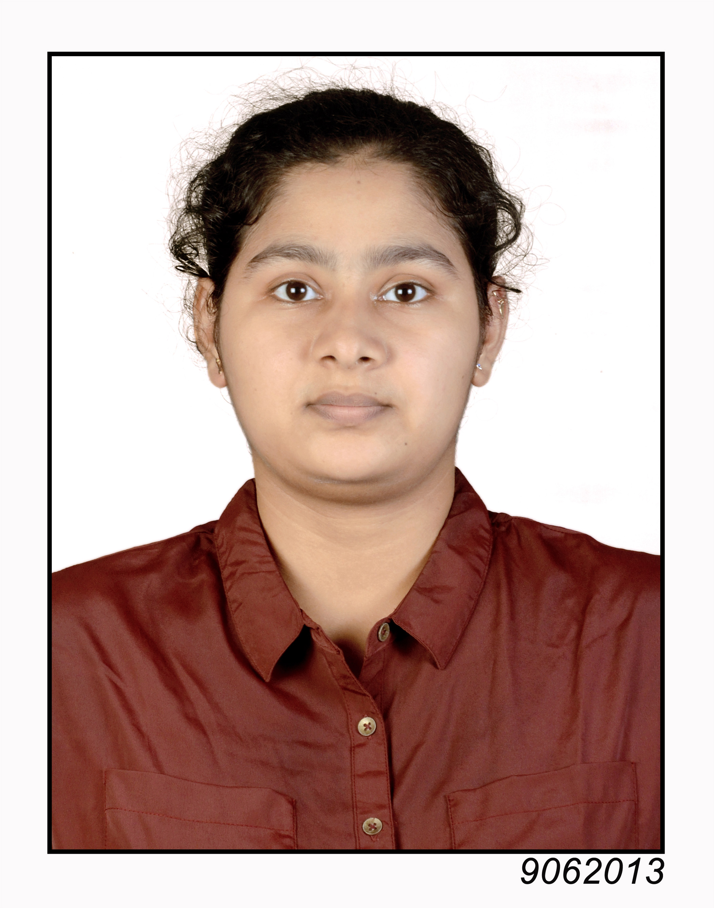

**CARRIER OBJECTIVE**

To be an aspiring professional in a recognized manufacturing Industry to drive the business dynamics towards overall growth of the organization by putting all my best efforts and get the best practices in place for a mutual rewarding career.

**ACADEMIC QUALIFICATION**

|  |  |  |  |  |
| --- | --- | --- | --- | --- |
| **S.NO** | **Name of the university/ board** | **Year of**  **passing** | **Board/Institute/ University** | **Percentage/ CPA** |
| 1 | BE( Electronics  and  Communication) | 2017 | Gujarat Technological university | 6.11/10 |
| 2 | 12th (Higher secondary) | 2013 | CBSE | 74.6% |
| 3 | 10th (Secondary) | 2011 | CBSE | 8.6 |

**CORE SKILLS:**

* C language
* Python language
* Microsoft Office
* MATLAB (2019B)

**INTERPERSONEL SKILLS:**

* Good communication skills
* A good leader as well as team player
* Adaptable
* Amiable
* Self-Reliant

**PROJECT DETAILS:**

* 5G resource allocation, studying the division of allocation based on economical constrains
* Four circular disk Antenna fabrication- getting an micro-patch resonant antenna fabricated to study the difference between the ideal gain of the antenna and the actual gain of the antenna
* GPS tracking System and alarm

**STELLER ACHIEVEMENTS:**

* Internship in M/s Thermax India Limited
* Certified in industrial automation conducted by Apollo technical education foundation
* Completed 1st Level of A2 SCOPE with association with UNIVERSITY OF CAMBRIDGE ESOL Examinations.
* Certificate Holder in Swarnim Gujarat Sanskrit Sambhashan Yojnayam Conducted by SHREE SOMNATH SANSKRIT UNIVERITY, VERAVAL, GUJARAT.
* Certified Holder in International Master Mathematics Olympiad.
* 9 CGPA in mathematics, science and English subject in secondary education.

**HOBBIES:**

* Reading Web-novels
* Singing
* Art and Craft (Origami and Crochet)
* Gardening

I hereby declare that all the information furnished above is true to the best of my knowledge & nothing has been concealed.