|  |
| --- |
| **AkshatDoshi**  B 403, Kalatirth.  Near Prernatirth Jain Temple,  Jodhpur Satellite.  Ahmedabad-380 015.  Mobile no. **9824333295**  Email:**doshiakshat19@gmail.com** |

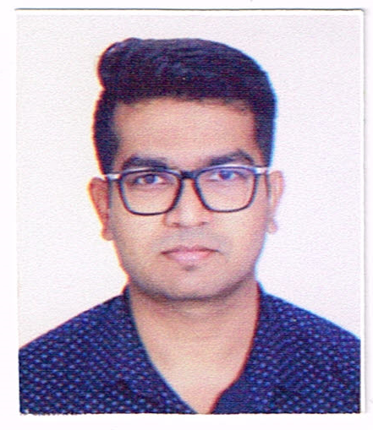

|  |  |
| --- | --- |
| Objective | Look for a challenging position as an Executive / Assistant in a leading company, where I can utilize and refine my current skills and knowledge; avail an opportunity to learn new skills for further development in career. |
| Education Qualification | **S.S.C**   * March 2005 G S E Board Ahmedabad – Gujarat   **H S C**   * March 2007 G S H S E Board Ahmedabad – Gujarat   **Bachelor of Commerce** ( B.Com )   * April 2010 Gujarat University - Ahmedabad.   **Master of Commerce** ( M.Com 1stSemester)   * November 2011. Gujarat University - Ahmedabad.   Passed 1st semester of Master of Commerce.( M.Com) |
| Professional Qualification | Certificate course in Tally accounting program from **Tally academy** in July 2010  Passed “Tally certified Accountant “with”**A”**grade from **“ACCA London”** In December 2010.  I have practical knowledge of computer i.e. MS office, Internet and emailing. |
| Work Experience | 1. Worked as an Executive in **M/s** **Karma Enterprise** (Exporter of Imitation Jewellery) from 2011 to 2013.   **Job profile**   * Export Sales Invoicing * Export Packing List * GSP Certificate of Origin * Other Export Related Documentation * Maintain sales and Purchase Register With **Busywin** Accounting Software * Material Receipt/ Issue * Maintain Stock Register * Tagging of Jewellery Items  1. Worked as an Assistant Export/Import Executive & Assistant Accountant in **M/s** **Laxmi Jewellery Export Pvt. Ltd** from July 2013 to November 2021   **Job profile**  **Export / Import Related**   * Export Sales Invoicing, Packing List * Export / Import Custom Clearing * Communication With CHA For shipping Bill and Bill of Entry File & Other Documents * Communication with bank for Export & Import Related documents as well as BRC. * Invoice Checking for Import and Give Confirmation to Party. * Prepare Documents for Foreign Exhibition. * Prepare EPCG Documentation For Import Duty Benefits. * Prepare Payment Documents of Import. * Maintain Export Gold Stock & Export Performance Margin for Custom Duty Benefits. * Prepare Port Registration Documents and New / Update IEC application in DGFT.   **Accounting Related**   * Maintain Export Sales, Import Purchase, and all Export / Import related Expenses In **ORNATE** Jewelers Software. * Maintain All banking Transactions online as well as manually and its entry with Daily Bank Reconciliation. * Accounting Related Work with Ornate Jewellery Software. * Bullion Gold Purchase & Sales Details * Maintain Loan Details, Working and its Entry i.e. Gold Loan, EPC, PCFC, WCDL * Prepare DP Statement and Receivable and Payable. * Guide / Help Auditors for Query & audit.  1. Working as a Sr. Assistant in **M/s Nirma Limited** from November 2021.   **Job profile**   * Handling all Kind of Import Payments and Maintain Its Data. * Prepare Letter Of Credit for Import of Goods. * Co-Ordinate with Bank for Import Payments and LC Transmission * Retirement of Documents From bank * Rates Booking for import Payments (Under Higher Authority Observations) * Submit relevant documents to accounts for accounting * Co-Ordinate with account department for Bank Reconciliation |
| Personal Details | Date of Birth : June 19, 1990  Birth Place : Ahmedabad  Gender : Male  Religion : Jain  Nationality : Indian  Languages Known : English Gujarati, Hindi |
| Strength | * Dedication, Devotion, Hardworking. * Positive attitude with sense of responsibility, Confident. * Quick learner & Result Oriented * Optimistic Person having good behavior * Team Player who believes in team work |
| Declaration | ”I hereby declare that all the information given is true to the best of my knowledge and believe. If I am given the chance would give you every satisfactory.” |

Date : / /2022.

Place : Ahmedabad

------------------------------------------

Akshat Doshi