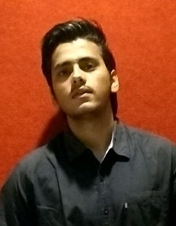**Aman Singh**

**saman8019@gmail.com 9574577640**

# CAREER OBJECTIVE

To succeed in an environment of growth and excellence and earn a job which provides me satisfaction and self development and help me to achieve organizational goal.

# PERSONAL DETAILS

|  |  |
| --- | --- |
| Address | B-202 Suryakiran society near modest hotel 9g.i.d.c kadi Distt-  Mehsena |
| Date of birth | 04/12/1996 |
| Gender | Male |
| City | Kadi |
| State | Gujarat |
| Pin Code | 382715 |
| Nationality | India |
| Marital Status | Unmarried |
| Religion | Hindu |
| Languages known | Hindi, English |
| Hobby | Outdoor Sports, Interested In Machines |

# WORK EXPERIENCE

**I was engaged in the Bricks Manufacturing**

Neptune

Jun 2017 - Jul 2017

Manufacturing of the actual shape and size of the bricks.

# PROJECTS

**Footstep Power Generator**

Group leader

2 Month

Team member(s): 4

To generate electricity by non conventional method or by renewable energy source

# EDUCATION DETAILS

|  |  |  |  |  |
| --- | --- | --- | --- | --- |
| Degree/Course | Institution | University/Board | CGPA/Percenta ge | Year of Passing |
| B.E Mechanical | Kalol Institute Of  Technology | Gujarat Board | 6.60 | 2018 |

# SKILLS

AutoCAD and The application which allows to develop designs of machines Solidworks

# ACHIEVEMENTS

State level State level basketball player

certificate

# DECLARATION

I hereby declare that the above cited information is true to the best of my knowledge and belief, if given a chance, I can prove myself.

Aman Singh Date: 25/05/2018

Place: Ahmedabad

[Powered by TCPDF (www.tcpdf.org)](http://www.tcpdf.org/)