**CURRICULUM VITAE**

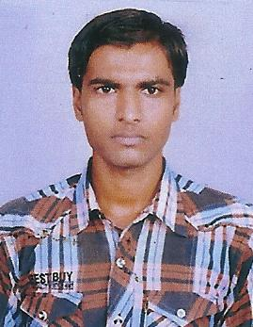

**Name : ANKIT KUMAR**

**Permanent Address :** DR. Tripurari Road,,

Marwari Mohalla

Ward No. 11, Jaynagar,

Dist. – Madhubani (Bihar)

Pin – 847226

**Present Address :** H. NO. 560, Nehru Nagar,

Near - Boring Canal Road, Rajapur,

Patna - 800 001

**E-mail :** ketpatel999@gmail.com

**Mob.** **: 8292011442,8936869996**

**Personal Profile**

|  |  |  |
| --- | --- | --- |
| Date of Birth | : | 11.01.1996 |
| Gender | : | Male |
| Category | : | OBC |
| Nationality | : | Indian |
| Father 's Name | : | Pravin Bhai Patel |

**Academic Qualification :**

|  |  |  |  |
| --- | --- | --- | --- |
| **Qualification** | **Percentage (Exact to**  **two decimal places)** | **Institute/Board/University** | **Year of Passing** |
| **10**th | 60.43% | B.S.S.B, Patna | 2015 |
| **12**th | 65.60% | B.B.O.S.E., Patna | 2019 |
| **Graduation**  **(B.A.)** |  | Magadh University | 1st year |

**Vocational Skills : D.F.A from NCETS, Jainagar Madhubani (Bihar)**

**ITI (NCVT/ SCVT) . ELECTRICIAN year 2017 patna.**

**Work Experience : (i)** I have worked as a Computer operator in Aditya   
 Computers, Jaipur for 1 year.

**(ii)** I have been working as a Assistant Manager in Oasis   
 Tuition Beuro Patna for 1 year

**(iii)** I have 1 Year Working Experience in Manager

Amit Preet Training & Service Pvt. Ltd. (Patna)

**Professional Strength/Skills :**

* Effective Communication
* Problem solving/Creativity
* Interpersonal ability
* Team work skill
* Leadership & Management.
* Adaptability & Flexibility
* Positive Attitude & Energy

**Language (Read, Write & Speak)**

* Hindi & English

**Interest**

* Social work

**Brief Medical History**

* As far as no major illness is concerned.

|  |  |
| --- | --- |
| Whether you have ever been arrested for  any reason or convicted or committed to  prison or subjected to preventive  detention subjected to any penalties by  any previous employer or adjudicated  insolvent: | No |

Place :

Date : (Signature)