Annapurna Pandey

M.Sc Organic Chemistry



Experience

Invitro Speciality Laboratory Pvt Ltd

05/03/2021 - 08/21/2022

Lab Technician

Lab Technician working on • Molecular Diagnostics Techniques such as RT-PCR, Isolation of RNA & DNA, Gel electrophoresis, Routine pathology

Education

Jawahar Navodaya Vidyalaya, Kutch 2014

SSC

Grades - CGPA:8.0

Jawahar Navodaya Vidyalaya, Kutch 2016



HSC Science (Biology)

Grades -



Percentage: 80%

M.G. Science Institute, Ahmedabad 2019



B.Sc. Chemistry (botany and Zoology as secondary subjects)

Grades - Overall CGPA: 7.1

M.G. Science Institute Gujarat University, Ahmedabad

2021

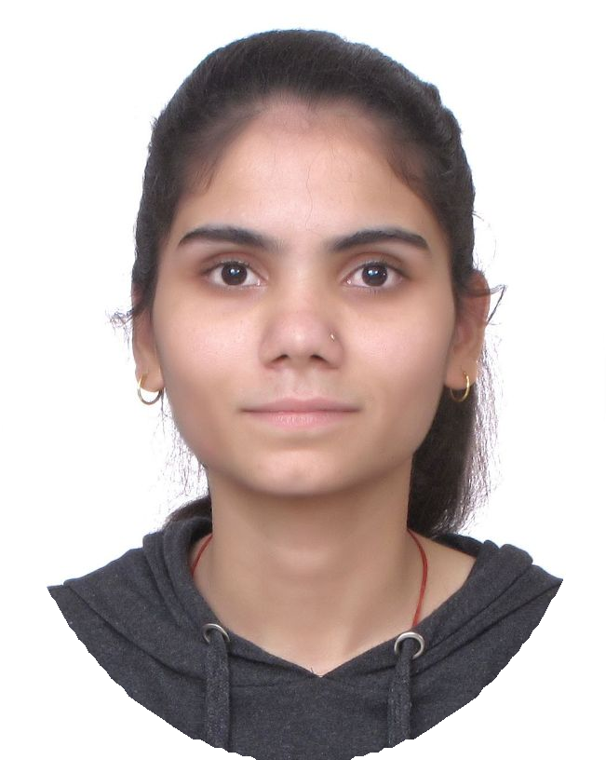

Contact

→

[annpurnapande14@gmail.com](mailto:annpurnapande14@gmail.com)

 8320912437

 C/O Santkumar Pandey A.S.R. Multimetal Pvt Ltd Samakhiali Kutch Gujarat 370150

✶

Objective

Enthusiastic, ethical, honest and

resourceful graduate who possesses academic knowledge of chemical laboratory techniques in Chemical science with the ability to establish priorities and meet challenges head- on.

Skills

Intermediate practical

knowledge of laboratory instruments like TLC, GC, LC, Mass spectrometry.

* Theoretical knowledge of laboratory instruments like GC, LC, IR, RAMAN, MS.
* Theoretical and practical knowledge of chemical laboratory techniques.

. Knowledge Of Organic Synthesis.

* Molecular Diagnostics



Course: M.SC Organic Chemistry

Grades - Overall CGPA: 7.01

Activities

Dissertation topic/ Industrial Training (Sem 4)M.Sc : Akash Dyes & Intermediate where I had worked on Salt Of Sulpho Tobias Acid & learned TLC, LC/MS/MS, UV.

Techniques such as RT-PCR,

Isolation of RNA & DNA, Gel electrophoresis, Routine pathology

* Outstanding analytical and critical thinking skills.
* Skilled in verbal and written communication.

-------Level: Skillfull