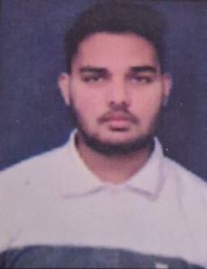**RESUME**

**AVANISH NAYI**

117/Silver Duplex,

Kansa N.A. Area,

Visnagar-384315

**Email Id:-** avanishnayi1771@gmail.com

**Mo:-** +91 9510441207

**CAREER OBJECTIVE**

To get an opportunity where I can make the best of my potential and contribute to the organization's growth.

**EDUCATIONAL QUALIFICATION**

* Passed out **B.Sc.(Chemistry)** from **HNGU** in 2022.

**CGPA- 6.9**

* Passed out **12th** from **GSHSEB** in 2019.

Percentage- 47.16%

* Passed out **10th** from **GSHSEB** in 2017.
* Percentage- 71.16%

**TECHNICAL SKILLS**

* Basic knowledge of computer.
* Technical writing
* Data Analysis

**STRENGTH & HOBBIES**

* Decision making.
* Leadership
* Good communication skill
* Novel reading, cricket and watch movies.

**PERSONAL DETAILS**

* Full Name : Mr. Nayi Avanish Prakashbhai
* Date of Birth : 22/01/2002
* Gender : Male
* Marital Status : Unmarried
* Languages Known : Gujarati, Hindi, English, Marathi

**DECLARATION**

I hereby declare that every information is true and I am solely responsible for its authenticity.

Date: / /

Place: **( AVANISH NAYI )**