# **Curriculum Vitae of Chetan M Dixit**

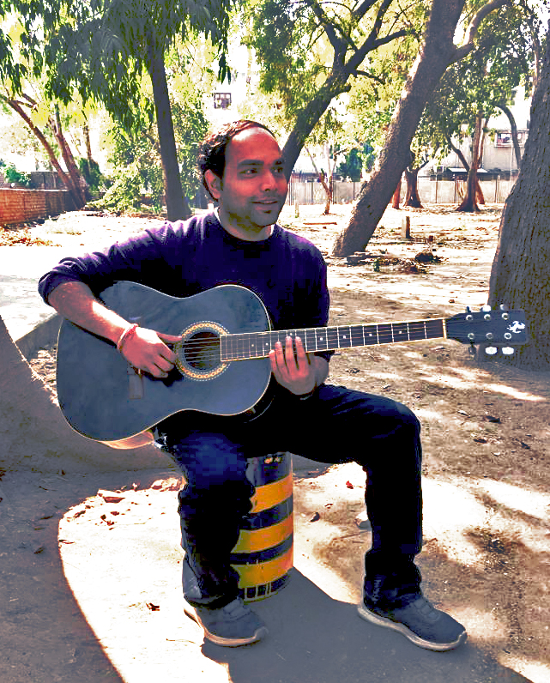

**Name:** Chetan M. Dixit

## Address for Correspondence:

## Chetan M. Dixit

501, Renesa Apartments,

B/h Gujarat Polytechnic, Panjrapol,

# Ahmedabad -380015

Tel: +919924951007

**E mail:**

1. [chetan16061989@gmail.com](mailto:chetan16061989@gmail.com)

**Date of Birth:** June 16, 1989

**Qualification:**

* Completed Bachelors Program in Performing Arts (B.P.A.) with distinction and gold medal, specializing in Carnatic Classical Music (2018).
* Completed 3 Semesters in Masters in Management Studies - Heritage Management, from Ahmedabad University after BPA. Taken a break.
* Completed ‘Design Thinking’, certificate course, from Iversity, Berlin.
* Completed Summer Workshop, from KNUCH Seoul, South Korea, as a part of Exchange program in the Heritage Management Programme of Ahmedabad University, for 3 weeks in 2019.
* Prior to B.P.A., studied Interior Design for 2 years from CEPT University. Have also completed a certificate course in Auto CAD.

**Experiences:**

* Worked with Ms Amala Shah, a leading interior architect, as an intern for six months.
* Designed sets, lighting, backdrops, costumes and make-ups for music shows, theatre, and dance, along with the direction of 2 Plays.
* Taught Guitar as a tutor in a music institute
* Completed one month Summer Project with Saptak, Ahmedabad in 2019.

**Competencies:**

* Creativity and Imaginative Thinking
* Design and composition Skills
* Communication and Analytical Skills.
* Problem solving and Organizational Skills.
* Conceptualization Skills
* Fluency in English, Hindi and Gujarati Languages.

**Interest Areas:**

* Performing Arts
* Design Thinking
* Western and Indian Classical Music
* Heritage sustenance

**Exposure**:

* Have travelled in various parts of North and South India
* Have visited France, Greece, Italy, Poland, Singapore, Malaysia, United Kingdom, United States of America, Turkey and Hong Kong.