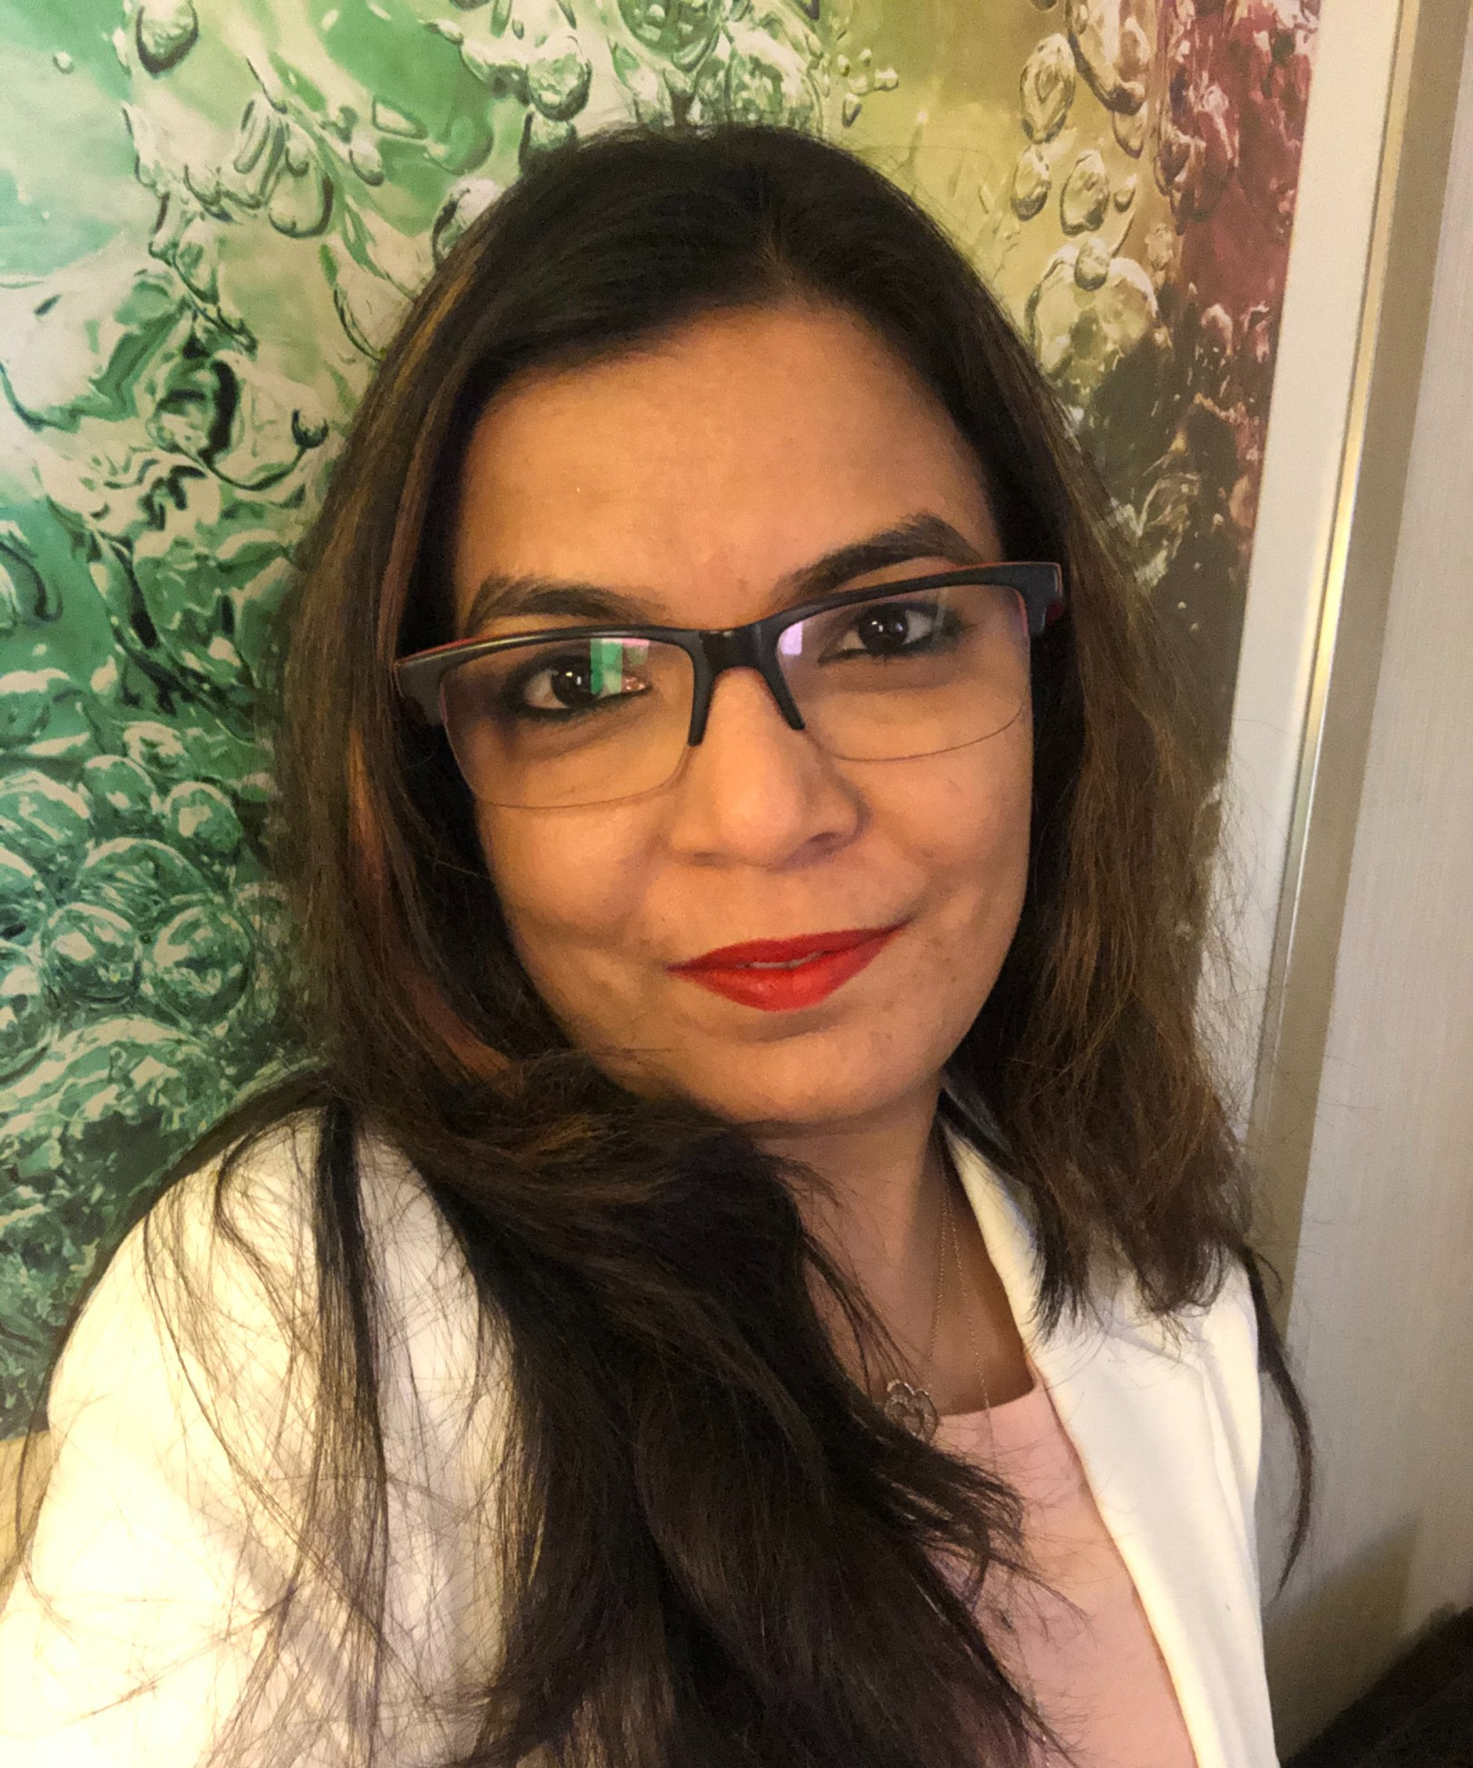Chetna Patel

 Ahmedabad, Gujarat.  patelchetana2018@gmail.com +91-9537379529  in/chetna13011981

SUMMARY

Result-oriented HR professional with 18 years' experience in various HR functions, including Generalist HR, Learning & Development, Talent Acquisition, and Performance Management. Skilled in workforce management, motivating personnel, and maintaining harmonious employee relations. Proficient in managing modern HR systems and providing comprehensive talent attraction and resourcing services. Committed to delivering HR solutions aligned with business goals, driving organizational excellence. With a track record of success in delivering HR solutions that align with business goals, I am committed to driving organizational excellence through effective human resources management practices.

EXPERIENCE

Sr VP Human Resources

Amnex Infotechnologies January 2023 - Present, Ahmedabad

• Work as a strategic partner to multiple business units, integrating HR strategy with unit strategy.  
• Provide guidance and support to HR team, adding value to business performance.  
• Work with Center of excellence team on succession planning and redefining and building organizational capabilities and bands.  
• Primary contact for all HR Organization development initiatives, leveraging HR specialists for talent management, compensation, and other HR areas.  
• Drive employee performance through goal setting, feedback mechanism and development opportunities  
• Analyze attrition rate, employee trends and root causes, design proactive programs to address them  
• Ensure legal compliance, conduct HR Audit, and HR Innovations through human capability, organization capability, talent.   
• Manage employee transactions, maintain accurate HRIS data, and compile reports

Head HR/ Head of Employee Success

Mediscribe/Shaip/Raapid/DataOrb June 2021 - January 2023, Ahmedabad

• Key role in Merger & Acquisition, Key Leadership hiring, OKRs and Policy & benefit management and high potential leaders’ development. Bought Attrition from 30% to 18%, Head count increased 60%, Introduced a new HRMS system (Qandle).  
• Human capital management, talent acquisition and retention, and operations leadership for 4 different companies. Design, develop, and deploy innovative, win-win HR, operational, and employee solutions.  
• Total Enterprise Leadership i.e., talent acquisition, talent management, training, learning and development (L&D), business administration, leadership development, OKR, and goal formulation, organizational restructuring, mergers and acquisitions (M&As), etc.  
• Best People practices for enabling right Culture, High performance, Rewarding through Emotional intelligence, HR Excellence model.

Head HR

Analytix Business Solutions Pvt Ltd June 2011 - May 2021, Ahmedabad

• Effective work force planning and talent acquisition for US and UK clients at organizational level  
• Create and implement organizational development strategy to drive people management and development initiatives to support business growth objectives.  
• Work closely with senior management team and business heads to establish and strengthen a performance driven work culture. Align individual, departmental and BU goals with organization’s growth objectives.   
• Closely work with management and HODs to identify HIPO’s & Program management for all critical roles, positions across all business units and ensure availability of back up roles.  
• NextGen Leadership programs & their career progression.  
• Plan and implement an effective performance driven compensation and benefits philosophy and policy at organization level.  
• Guide HR Team, Functional / departmental heads on Employee Development needs and establish effective learning and development process in the organization.  
• Lead LMs/HODs education sessions to establish rewards and recognition base organization culture.   
• Reviewing HR & Admin policies and practices to ensure they are in compliance with the legal and regulatory framework and in alignment with best industry practices.

Manager - HR & Operations

Contech BPO Pvt Ltd March 2007 - September 2010, Ahmedabad

• Forecasting & fulfilling Manpower Requirements in accordance with the business plan.  
• Management of the complete recruitment life-cycle for sourcing the best talent from diverse sources after identification of manpower requirements.  
• Conducting specially designed Induction program for new recruits under Business Familiarization Process.  
• Designing a conducive performance appraisal system.  
• Coaching & Counselling for self-development & performance improvement.  
• Ascertaining the specific training needs of employees across all levels through mapping of skills required for particular positions and analysis of the existing level of competencies.  
• Reviewing and implementing HR policies for manpower planning, recruitment, selection, induction, orientation and development of employees in the organization.  
• Handling wage and salary administration and other compensation and remuneration issues, including settlement of all financial accounts at the time of exit of an employee from the organization.  
• Creating harmony between organizational and personnel goals with a view to ensure achievement of organizational mission.

HR Executive/Coordinator

Saral Software Solutions Pvt Ltd February 2006 - March 2007, Ahmedabad

• To take care of employment details such as recruitment, selection, training & development, Employee welfare & motivation etc.  
• To prepare salaries for the employees.  
• To take care of leave details   
• To take care of Attrition level & Performance evaluation.   
• To take care of Employee coordination.  
• To take care of PF details. Etc.

Associate for Satisfaction Department

Ocwen Financial Solutions Pvt Ltd February 2005 - October 2005, Bengaluru

• Ensure that the team meets or exceeds the client standards in production & accuracy on a consistent basis.  
• Monitoring workflow & delegate work in order to meet the compliance & requirements of the client.  
• Pitch in the team’s production as per the situational demand.  
• Ensure the weekly quality audits are revived and discussed with the team to ensure the errors are not repeated.  
• Formulate & implement plans/practices that enable the team to maximize their output in terms of productivity & accuracy.

EDUCATION

MBA (Finance & HR)

Minor in Finance • A.I.T (VTU) • Bangalore, Karnataka. • 2004

B.Com

SSRG Women’s Collage • Gulbarga University, Karnataka. • 2002

Pre-University Course

SSRG Women’s Collage • Gulbarga University, Karnataka. • 1999

CERTIFICATIONS & OTHER ACCOMPLISHMENTS

Founder of Chetnas Divine Healing and Enlightenment

Advance Lama Fera and Shamanism Practitioner

Ahmedabad • 2021

Reiki Grand Master

Ahmedabad • 2019

HR Analytics Professional

Middle Earth • 2018

Thomas Profiling

UK • 2016

COURSEWORK

C, C++, Oracle, VB, MS Office

SKILLS

Talent Acquisition, Talent Engagement, Talent Development, HR Transition, HR Transformation, Succession Planning, Performance Management, End-2-End HR Life Cycle, HRIS & e-HR, Recruitment & Resourcing, General Management, Employee Relations, HR Subject Matter Expert (SME), Transition Management, Team Management, OD & change champion, Leadership hiring, Strategic HR Management

STRENGTHS

* **Pragmatic and positive attitude** coupled with a lead-by-example management style**.**
* **Adaptability** to meet organization dynamics and effectively navigate constraints.
* **Ability to live up to commitments** with sense of urgency.
* **Organised, Customer focused, flair for learning,** fast learner and hands-on person
* Experience to **perform** under demanding expectations.
* Demonstrable problem solving and conflict resolution skills.
* Ability to **interact** with customers and to manage multiple assignments & priorities.
* Excellent stake holder and ability to **mentor, motivate & drive teams to success.**
* Quality & cost consciousness through decision making ability & resource management skills.
* Believe in making everybody a **winner** and in providing equal employment opportunity atmosphere.

ACHIEVEMENTS

* Best **Women Leadership in the year 2021**, Listed in Passion Vista magazine globally.
* Training Program on **“Recruitment Process”** by Hiren Vakil at Ahmedabad Management Association **(AMA)** in September’2002.
* **Best Employee of the year** at Analytix Business Solutions Pvt Ltd.
* Certified **Thomas Profiling** from UK.
* Certified **HR Analytics Professional** from Middle Earth.
* **Leadership Training** – From external Training facilitator at Analytix Business Solutions Pvt Ltd.
* Participated in get together of **NASSCOM HR** forum for all IT & ITES companies in Ahmedabad.

PERSONAL SNIPPETS

**Date of Birth:** 13th January, 1981

**Address:** Dev-181, F-201, Nr. Tulip School, Sterling City, Bopal, Ahmedabad 380058, Gujarat

**Linguistics:** English, Hindi, Gujarati, Kannada, Telugu

**Marital Status:** Married

Note: References may be provided upon request.