**RESUME**

## Chirayu D. Shah

D-34, Parshwa Nagar,

Near Kalyan Party Plot,

Vasna Road, Vadodara-390007.

(M) 9725026945

Email**:** [**shahchirayu111@gmail.com**](mailto:shahchirayu111@gmail.com)

**Objective:**

To work in a challenging atmosphere by exhibiting my skills with utmost sincerity and dedicated smart work for the growth of your esteemed organization along with mine.

**Education:**

* Gujarat Technological University

Degree: Bachelor of Engineering

Branch: Electrical

Name of College: Government Engineering College, Bharuch

CGPA: 6.40

Year of Passing: 2013

* Gujarat Higher Secondary Education Board

Degree: 12th Science

Percentage: 64.65%

Year of Passing: 2009

Experience:

* Works at Khushbu Vinyl Pvt. Ltd. Since October 2013 till continue as an engineer.

**Technical Skills:**

* Software: MATLAB Simulation
* Computer Basic Knowledge

**Achievements:**

* I got 71% in NIIT aptitude test which was held in our college.

**Project:**

* “Improve power factor of Induction motor using capacitor” on MATLAB simulation and hardware.

**Extra-Curricular Activities:**

* I have worked as one of the organizer for the seminar of GEDA on “Save Energy” in my college.

**Personal strengths:**

* Quick Lerner
* Elegant team player
* Smart Worker

**Personal profile:**

Date of Birth : 17/11/1991

Father’s Name : Mr. Dineshchandra J. Shah

Sex : Male

Marital Status : Single

Nationality : Indian

Languages known : English, Hindi, Gujarati

Hobbies : Reading books, photography, travelling

**Declaration:**

I hereby declare that the above mentioned details are true to the best of my knowledge.

Date : / / 2014

Place : Vadodara

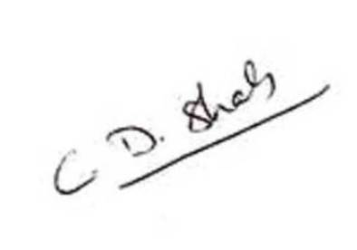

(CHIRAYU D. SHAH)