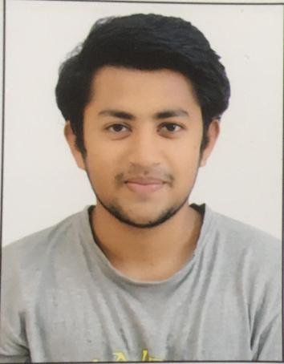252525252525

**DECLARATION :- I do hereby declare that the above information is true to the best of my knowledge.**

ENGLISH :- To speak, read & write

HINDI : - To speak, read & write

GUJARATI :- To speak,read & write

MALAYALAM :- To speak

**Linguistic power**

Collaborative

Pioneer

Efficient

Managed

Adaptability

Aggregate

**Personal Qualities**

**ADANI PORT & SPECIAL ECONOMIC ZONE (MUNDRA)**

Engineering services at Container Terminal-4

Project: - 5s & 7s (Kaizen) Red Tagging

**Internship**

**CRIST SILJAN**

**LDRP-ITR (KSV University)**

Bachelor of Engineering, 2023

Branch :- Mechanical

**ST XAVIER’S High School**

High school (SSC) , Class of 2016

Higher secondary (HSC), Class of 2018

**Education**

**Email:-**cristsiljan@gmail.com

**Phone:-** +91 7433834451

**Address:-** C-15 Kaveri bunglows, Nava Naroda, Ahmedabad, Gujarat, 382330

**DOB :-**22/12/2000

**Marital status:-** bachelor

Football

Aautomobile Eenthusiast

Music

Movies

Travel & Explore

**Personal Information**

**Hobbies**