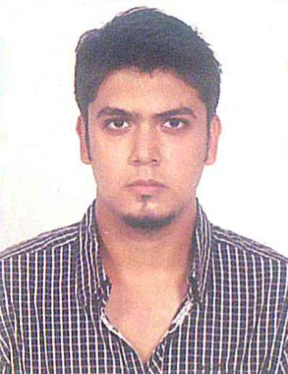

Digvijay Singh Rathore

Bungalow A-19, Karmacharinagar,

Part -1,Ghatlodiya, Ahmedabad (Guj.) PIN- 380061

**Contact**- +91- 9725686219; **Email**-[maildigvijay4@gmail.com](mailto:maildigvijay4@gmail.com)

**Objective:**

Focused mechanical engineering graduate with solid proficiency in software and mechanical design. Seeks a challenging and varied position that will capitalize on my education and training, expand my knowledge and offer opportunities for personal and professional growth.

**Professional Summary:**

* Able to write technical and detailed reports learnt during my training period at University.
* Good command over Auto CAD designing software.
* Able to encourage and motivate team members.
* Able to develop components and products from concept to finished product, strong planning skills with the ability to conceptualize and analyze complex designs.
* Good communication Skills

**Education:**

* Mechanical Engineering from Geetanjali Institute of Technical Studies affiliated to RTU University
* Auto CAD (2d & 3d)
* SSC – (62%) Som Lalit Higher Secondary School, Ahmedabad
* HSC – (47%) Som Lalit Higher Secondary School, Ahmedabad

**Training(s) undergone:**

* Training undergone at ONGC’s Mechanical Workshops.
* Training undergone at ONGC’s oil field installations

**Languages known:**

* English, Hindi and Gujarati

**Hobbies:**

* Rock Climbing, Water Polo, Road trips

**Key Achievements**

* Participation in a seminar on Sterling engine and an explanation on Wind tunnel testing, Stealth flying machines, Warloff Geometry (BMW) and various automobile workshops.
* Team Leader of BAJA SAE (Society of Automotive Engineers) 2013.
* Have been the body double of Oscar winning celebrity Dev Patel for the Hollywood movie: ‘The Second Best Exotic Marigold Hotel’.
* Lead several projects during my studies.
* Also an associate member of AIESEC (International Student Network and Council).

**Personal Strengths**

* Quick learner
* Hard worker
* Team player
* Innovative thinking
* Analytical mindset
* Avid researcher
* Updated information about the sector

**PERSONAL DETAIL**

|  |
| --- |
| **Name:**  Digvijay Singh Rathore **Date of Birth:** 4th December 1992 |
| **Father’s Name:** Shobhag Singh Rathore **Marital Status:** Unmarried |