**CURRICULAM VITAE**

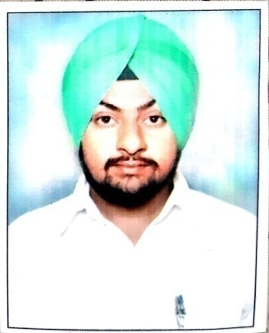

**GURJAIPAL SINGH**

**Department of Petroleum Engg.**

**Guru kashi University**

**Talwandi sabo.(Bathinda , Punjab- 151302)**

**Email :** [**gurjaipalsingh91@gmail.com**](mailto:gurjaipalsingh91@gmail.com)

**Cell No : +91 9530697912**

**OBJECTIVE**

To be a part of a reputed organization to utilize and improve my skills and abilities in a challenging environment of growth and excellence for the progress of the organization which will help me to achieve personal as well as organization skills.

**EDUCATION**

* **B.**Tech **in PETROLEUM ENGG.**
* Guru Kashi University, Talwandi sabo.(Bathinda)
* Percentage/SGPA- 60%
* **Diploma in PCPRE (petro chemicals and petroleum refining engg.)**

Guru kashi University, Punjab, India

Percentage/ SGPA - **60%**

**INPLANT TRAINING**

* 2 months in NFL, Bathinda June- August 2016
* 45 days in NFL, Bathinda -June 2015
* 6 weeks in NFL, Bathinda
* 15 Days in Rigtech in Kerala 2017
* 43 Days in HPCL –Mittal Energy Limited .Phulokhari(Bathinda)

**PROJECTS**

* ***EXPLORATION AND PRODUCTION OF CRUDE OIL.***

**MODULES**

* Crude Distillation
* Fluid Catalytic Cracking
* Effluent Treatment System
* Explosion Control

**SKILLS AND STRENGTHS**

* Handled equipments like valves, pumps, compressors, pressure and temperature measuring devices
* Efficient
* Problem solving attitude
* Adaptable

**AWARDS AND ACHIEVEMENTS**

* Volunteered a seminar on the topic Exploration and production of crude oil*“*

**EXTRA CURRICULAR ACTIVITIES**

* MS Office ( Word, Excel, Powerpoint)
* Bhangra Performer
* Sufi Singer

**PERSONNEL PROFILE**

**Name** : Gurjaipal Singh

**Father's Name** : Balbir Singh

**Permanent address** : Police Colony, Quarter No: 13, Talwandi Sabo, Bathinda -151302

**Date of birth** : 23/08/1991 **Gender** : Male

**E mail ID** : [**gurjaipalsingh91@gmail.com**](mailto:gurjaipalsingh91@gmail.com) **Cell No** : +91 9530697912

**DECLARATION**

I hereby declare that all the above furnished details are correct to the best of my knowledge and belief.

Date : 01/ 12/2016 Yours faithfully,

Place : Talwandi sabo Gurjaipal Singh

Bathinda, India

**REFERENCES**

Atul Goyal

HOD Petroleum Engineering

Guru kashi University

Talwandi sabo

Bathinda, Punjab -151302

[goyal.atulchem@gmail.com](mailto:goyal.atulchem@gmail.com)