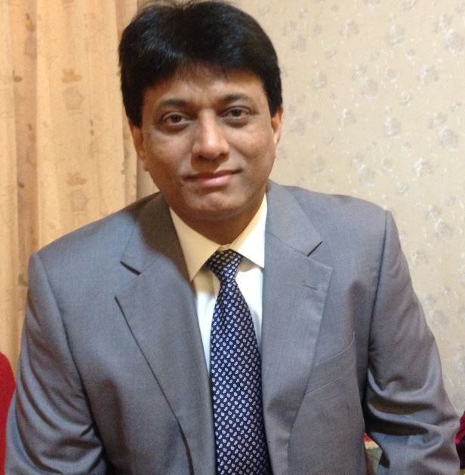 **HARESH m sAVITA**

**Senior Human Resource Professional**

Ahmedabad, India | hsavita2810@gmail.com | +91 9714992021/7600857310

<https://www.linkedin.com/in/haresh-savita2810>

**Domain Proficiency**

An enriched and experienced Human Resource domain expert, international exposure with MNC Oil & Gas and Indian giants in Chemical, Textile & Tyre manufacturing industries. Technical background has given a niche skill to understand plant processes quickly and hence able to deliver from day one in the organization.

**Qualification**

**Professional**

1992-1993 Post Graduate Diploma in Industrial Relation & Personnel Management - Faculty of Social Work, M.S. University, Baroda, India

1996-1997 Post Graduate Diploma in Human Resources Development- Faculty of Psychology, M.S. University, Baroda, India

1997-1998 Diploma in Labor Laws - Faculty of Law, M.S. UNIVERSITY, Baroda, India

**Academic**

1988-1991 Masters in Applied Physics (MSc.)

Faculty of Engineering & Technology, M.S University, Baroda, India

**Certificate**

a) ISO – 9001 Qualified Lead Assessor”, Portsmouth Business School, University of Portsmouth – UK b) ISO - 14001 EMS Lead Auditor Course, Det Norske Veritas, Netherland

**Professional Courses**

1) Xp Hiring, Shell India; 2) HR Business Partnering, Shell Malaysia; 3) Data Analytics, Shell Dubai; 4) Talent Management, Shell Singapore; 5) Coaching for HR, Shell Malaysia; 6) HR On-boarding Process, Shell Netherland

**Experience**  Over 26+ years of experience, 12+ years with Royal Dutch Shell at managerial & leadership position with progressive added responsibilities in India and abroad. Have exposure to work with more than 200+ nationalities to understand their cultures and work as one team to achieve common goal. Delivered more than defined responsibilities in a complex multicultural and challenging environment within budget and time-line. Enriched experience of 13 years with diverse industries like Agro-Chemicals, Textile and Tire in different capacities with respective industries. Professional career has led to specialize increasingly in the field of HR Management. The cosmopolitan background and consistent interest in other cultures, together with an experience of managing diverse teams has given boost to self-confidence to work internationally including difficult locations.

**Employment Details**

**Association Organization/Position Work Force/location**

2016- Till date Working with Corporates for HR Outsourcing assignments Ahmedabad, India

2015-2016 **Royal Dutch Shell JV (Hazira LNG Private Limited)** Ahmedabad, India

India, HR Manager, Integrated Gas & Functions (Workforce ~650)

2013-2015 **Shell International Petroleum Development (SIPD)** Dubai, Basra

HR Operations Manager (Workforce ~400 + Expats & 500 LN’s + 1500 contract labor)

2009-2013 **Royal Dutch Shell JV (Hazira LNG Private Limited)** Ahmedabad, India

General Manager- HR (Upstream International & Functions, India) (Workforce ~600+)

2007–2009 **Qatar Shell GTL** Doha, Qatar

HR Advisor (Workforce ~2000+ Shell Staff + 80,000 construction workers)

2004- 2007 **Royal Dutch Shell Gas & Power**  Surat, India

Site Manager- HR/SP & Facilities (Workforce ~100 Shell Expats + 3000 Const. workers)

2002- 2004 **Bayer CropScience Limited** Ankleshwar, India

Head- HR/ERIR (Workforce ~500+)

2000-2002 **The Arvind Mills** Ahmedabad, India

Head HR/IR, Shirting Business (Workforce ~2800)

1991-2000 **The Apollo Tires Limited** Baroda, India

Asst. Manager – HR (Workforce ~1700+)

**Comprehensive Responsibilities handled during assignments**

HR Generalist, HR Operations, HR Business Partner, Corporate HR , MIS & HRIS, Resource Utilization & Budget Control, HR Strategy Aligning with Business Needs, Talent Management & Acquisition, Implementing Discipline, HR Processes and Systems, Succession Planning, Retention, Employee Engagement, Industrial Relations, Motivation through recognition & rewards, Counseling, Negotiation Management & Settlements, Exit Interviews, Organization Employee Satisfaction Survey & Implementation Plan as per outcome of the Survey, Performance Management, Compensation/Benefits & HR Policies, Grievance Management & Stakeholder Management.

**Core Competency**

Natural instinct to Manage, Counselling, Relate and Engage individuals across hierarchy, Collaboration, Performance, Growth & Change Management, HR Polices, Project Management, Employee Relations, Grievance Management, Contract Labor Management, HR Compliances, managing non-performers, Negotiation, Talent Management & Resourcing, interact & manage with different Communities.

**Strategic Planning**

Development of Human Resources in the organization based on the competence gaps, Formulating strategies and plans focusing HR alignment with core business requirement, People Polices focusing needs and managing expectations.

**HR Management**

Systems and Processes, Payroll Management, Employee Life-Cycle, Succession Planning, Competency Mapping, Performance Management Talent Management, Organization Structures, Work-Life-Balance, HR Information Management System, Budgeting & HR Generalist.

**Employee Engagement/Industrial Relations**

Negotiation & Settlement with Unions, Statutory Compliances, Agreements, Disciplinary procedure, Standing order & Implementation, Labor laws, Community & Employees Engagement.

**Learning & Development**

Learning needs based on the Skill mapping, Competency mapping & analysis, Structured On-boarding process, Building Capability & Quality Enhancement for new joiners, Skill Development based on Skill GAP Analysis.

**Corporate Social Responsibility**

Working with diverse communities & Supporting for Education, Medical, Employability, Sanitation & Hygiene.

**Facility Management**

Communication, Hospitality Management, Transportation, office administration, Security, horticulture, managing schools & Govt. Compliance.

**Projects**

* Resourced permanent organization for LNG project in India & Qatar Shell GTL Project
* Establish HR set up in green-field project in war-zone location & Payroll Management Implementation
* Employee Development Need Identification
* Undertook comprehensive study and benchmarking of contract labor ratio, salaries and benefits for contract labor
* Settlement with Unions to sign agreement in a given time-frame
* Competence development for Local Nationals and implement sharp learning curve to individuals, Ensured 100% IDP (Individual development Plan) for 750 staff.
* HR Online implementation in remote and sensitive country (SAP Modules)

**Few Key Achievements**

* Strategy to migrate staff to centralize services under the project ‘One Finance’ delivered without affecting motivation of impacted staff & employee relations.
* Experienced hiring for first LNG Terminal in India
* Resourced 800+ staff from 11 countries with 28 nationalities in given time frame & budget, On-boarding
* Union negotiation with multiple Unions within budget & singed agreements
* ‘Quality Circle’ movement across the Organization for optimal utilization of workforce potential and growth.
* Succession planning for localization for Iraq project
* Mega event management for the business
* Zero HSE incident in HR & Admin function in 12 years duration

**Professional Membership**

**QCFI, Baroda Chapter** - Life Member and holding voluntary position of Secretary for three (3) years

**HRD Network, Baroda Chapter** - Joint Secretary for HRD Network for three (3) years

**Baroda Management Association** - Chairman for small scale industries during my association in 1998- 1999

**Ahmedabad Management Association** – Life Member

**Personal** Proficient in MS Office Tools, Data Analytics, professional fluent in English, Hindi, Gujarati & can understand Marathi. Engaging & networking with people, games & sports, and supporting underprivileged kids for Schooling.

**Great Vision without Great Talent is Impossible**

**End-Of-Resume**