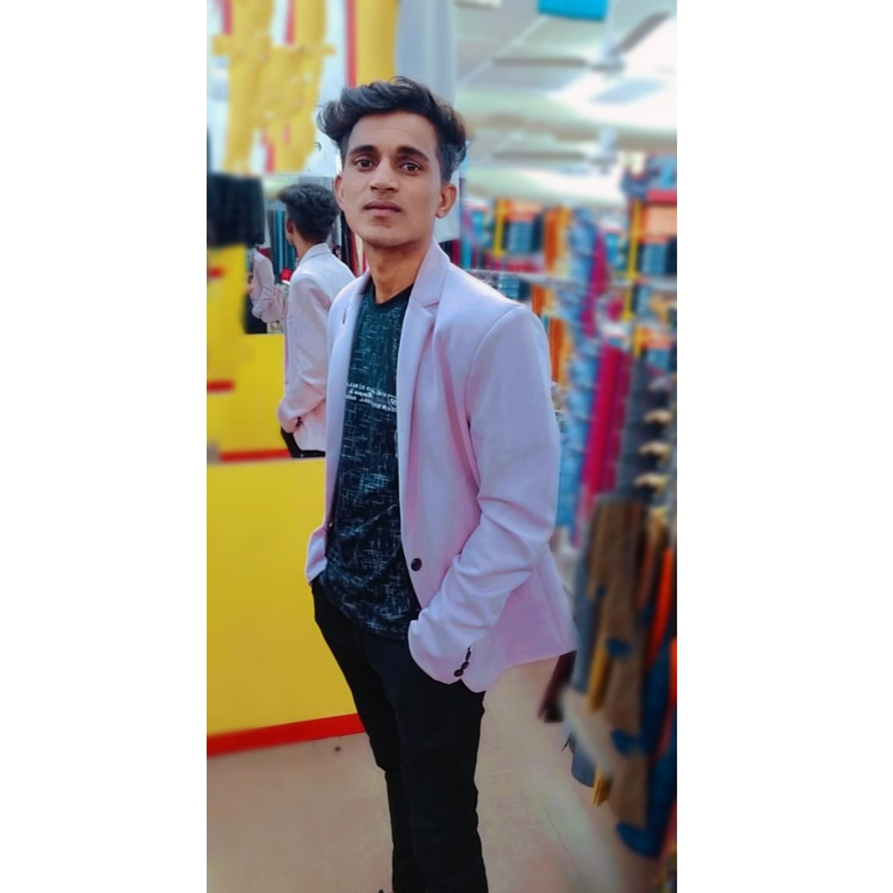**HAREESH PATLIYA**

BLOCK NO. 3, GURUSMRUTI SOCIETY,

OPP. DEVI MULTIPLEX, NARODA,

AHMEDABAD – 382330

EMAIL: [harishpatliya78@gmail.com](mailto:harishpatliya78@gmail.com)

Mob. No. 9783809461

**Objective**

* My goal is to become associated with a company where I can utilize my skill and gain further experience while enhancing the company's productivity and reputation.

**Skills**

* Excellent Mathematics and Knowledge of accounting concept and Skills.
* Strong Communication and Good sense of humor.
* Decision Making, Positive Team player, Journal Entry Preparation.
* Technological native familiar with Tally Erp-9 & Tally Prime and also good knowledge of MS Office, Microsoft excels (with Pivot table, H-lookup, V-lookup & further formula’s.)
* Excellent Internet, Outlook E-Mail knowledge.
* I achieved Tally Erp-9 certificate.

**Academic & Professional Qualification**

|  |  |  |  |  |
| --- | --- | --- | --- | --- |
| **No.** | **Qualification** | **Board/University** | **Passing Year** | **Percentage** |
| **1.** | S.S.C. | R.B.S.E. AJMER | 2014 | 65.33% |
| **2.** | H.S.C. (Commerce) | R.B.S.E. AJMER | 2016 | 67.80% |
| **3.** | B.COM. | JNVU JODHPUR | 2019 | 54.11 % |

**Experience**

* I Worked in Forex ltd. & Jewels as an office assistant for 13 Months (Mumbai). (Selling, calculation & bills making.)
* I also worked in Samrat Nankeen Pvt. Ltd. Company as an Account Assistant from 15 Feb.-2020 to till date continue (Naroda Ahmbd.).

(Making Tax invoice in tally Erp.9 & tally prime {Purchase entry, Stock Entry, Debit & Credit note} Data entry, data analysis with WPS office.)

* Currently I am working with Green Earth Trans logistics Pvt. ltd. Company as an Account Executive (Jamnagar).

(Here I am totally involved in accounting work from

1. Making Truck port operation fund req. report and utilize 3 branches as required and prepared daily petro report.
2. Daily payments through Happay transaction and prepared daily Happay exp. Report.
3. Managed driver and vehicle Monthly exp. cost report and coordinate with branch manager.
4. Caring bills and Bill wise details.
5. Daily trip entry through ERP Software.
6. Day to day reconciliation of Happay & petro amount transaction.
7. Vouching.)

**Interest & Hobbies**

* I enjoy travelling, Listening Song and learning about different cultures and I love to read a book & magazines also.
* I also like to sing a song & Photo-shoot.

**Interesting Subject**

* Account, Audit, Maths.

|  |  |
| --- | --- |
| **Personal Details** |  |
| Father's Name - | Mr.Bagdaram Patliya |
| Gender - | Male |
| Maritial Status - | Unmarried |
| Language Known - | Hindi,Besic English,& Gujrati |
| **Pro. Address :** |  |
| Pooran |  |
| Jalore-343039 |  |
| Rajashtan |  |
|  |  |

**YOURS FAITHFULLY,**

**HAREESH PATLIYA**