**HIMANI SHAILESHBHAI SATHWARA**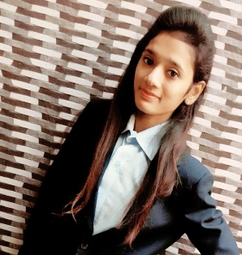

**Address: -** 2/A Sagar raw house opp. vishamo flat near Ghodasar, Ahmedabad: 380050

**Mobile No**: 9054207714

**E-Mail Id: -** himani2102lh@gmail.com

|  |
| --- |
| **CAREER OBJECTIVES:** |

* To ensue a highly profitable career, seeking for a challenging job and healthy work environment where I can utilize my skills, experience and knowledge efficiently for organizational goal.

|  |
| --- |
| **EDUCATION QUALIFICATION:** |

|  |  |  |  |  |
| --- | --- | --- | --- | --- |
| QUALIFICATION | INSTITUTE/COLLAGE | YEAR | BOARD/UNIVESITY | PERCENTAGE |
| S.S.C | SHREE MUKTAJIVAN HIGHER SECONDARY SCHOOL A’BAD | 2012-13 | G.S.H.S.E.B | 75% |
| H.S.C | SHREE MUKTAJIVAN HIGHER SECONDARY SCHOOL A’BAD | 2014-15 | G.S.H.S.E.B | 76% |
| B.COM | P.D.PANDYA MAHILA COMMERCE COLLAGE A’BAD | 2017-18 | GUJRAT UNIVERSITY | 79% |
| M.B.A | CHIMANBHAI PATEL INSTITUTE OF MANAGEMENT AND RESEARCH A’BAD | 2017-19 | GUJRAT TECHNOLOGICAL UNIVERSITY | SEM-1 SPI:7.33  CPI:7.33  SEM-2 SPI:7.38  CPI:7.35  SEM-3 SPI:7.82  CPI:7.54 |

|  |
| --- |
| **SPECIALIZATION** |

* Finance in MBA

|  |
| --- |
| **PROJECT** |

|  |  |
| --- | --- |
| SIP | “A STUDY ON NEED OF FINANCIAL ADVISOR FOR MUTUAL FUND INVESTOR” |
| MAP | “ANALYSE & RECOMMEND BRANDING STRATEGIES FOR MINERAL WATER INDUSTRY FOR ENHANCED CUSTOMER ACQUISTION” |
| CPR | “A STUDY ON FINANCIAL LIETRACY AMONG WOMEN IN AHMEDABAD” |

|  |
| --- |
| **VISIT** |

* SHYAM PLASTIC INDUSTRY
* HALLMARK

|  |
| --- |
| **PERSONAL PROFILE** |

DATE OF BIRTH: 21st February, 1997

NATIONALITY**:** Indian

LANGUAGES KNOWN:Gujrati**,** English, Hindi

MARITAL STATUS: Single

GENDER: Female

HOBBIES:Dancing, Music

|  |
| --- |
| **DECLARATION:** |

I hereby declare that the above-mentioned information is true to the best of my knowledge.

**Yours Faithfully.**

Himani Sathwara