* 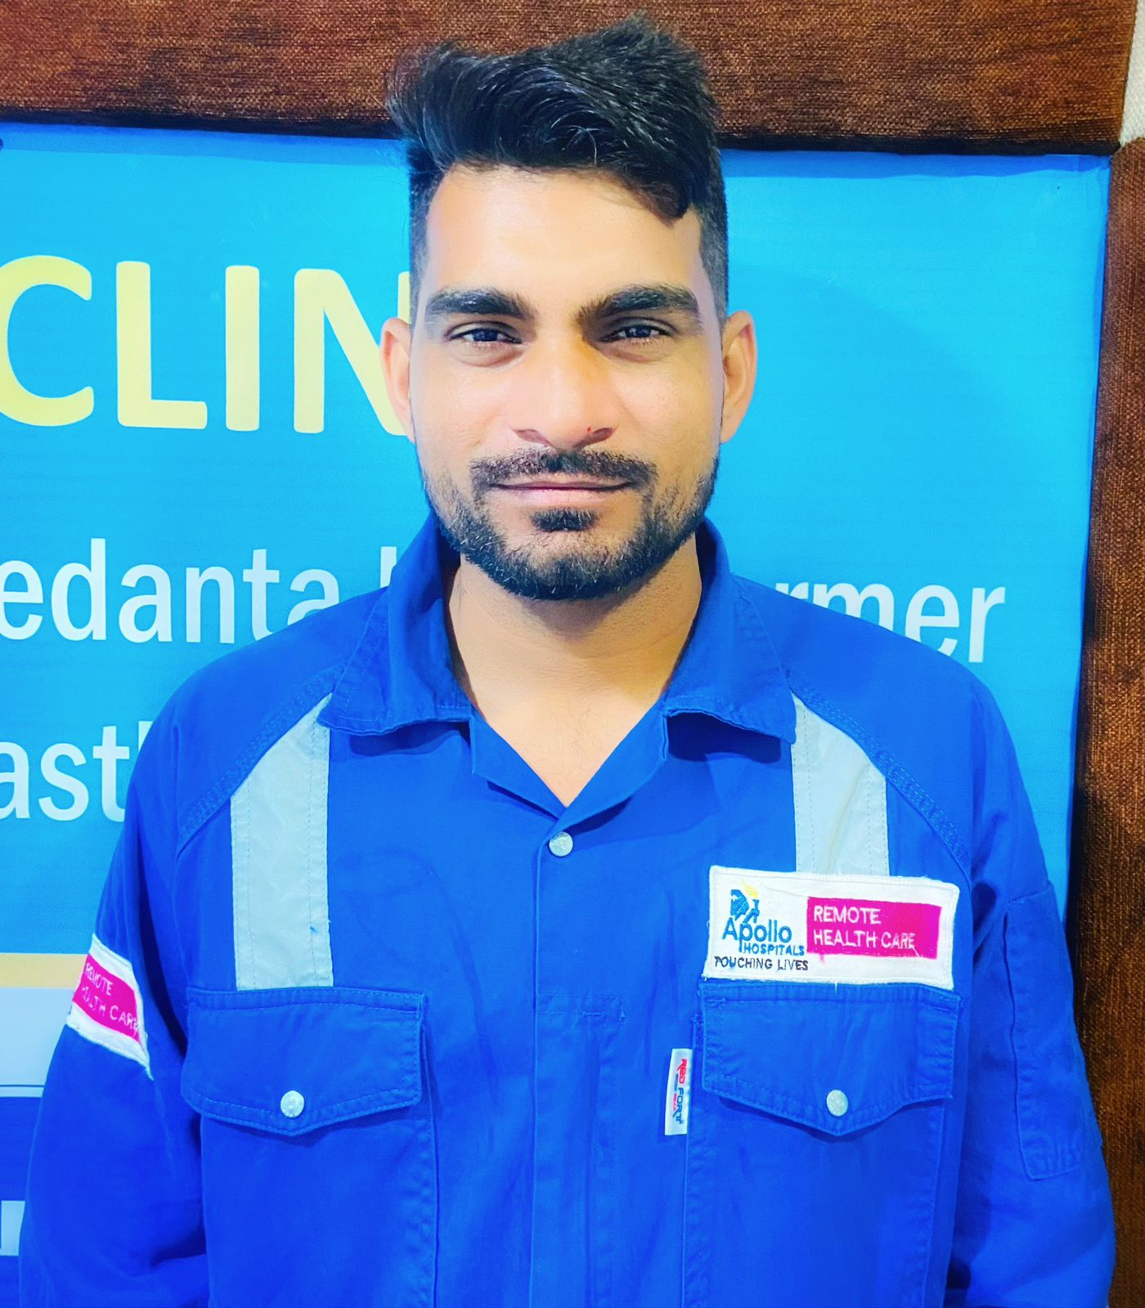CURRICIULUM VITAE
* **FROM:**

## **Mr Jagdish Dhorawat S/o Shri lakharam dhorawat**

## **vill- dedwa post-jakhal teh.-sanchore**

## **dist- jalore rajasthan 343041**

## **MOB.9001887770,9660957350**

## **Email [id-aryan9660@gmail.com](mailto:id-aryan9660@gmail.com)**

* ABOUT MYSELF
* **A YOUNG ENERGETIC INDIVIDUAL WITH IMMENSE CAPCITY AND DEDICATED TOWARD LONG WORKING HOURS AND ENTHUSIASM SEEKS A POSITION THAT UTILIZE MY SIKLLS OF ENSURING BETTER SERVICE TO INDIVIDUAL FAMILY COMMUNITY AND SOCIETY AT LARGE.**
* **PERSONAL DETAIL**
* **NAME : JAGDISH DHORAWAT**
* **AGE/SEX : 31 YEAR MALE**
* **FATHER NAME : SHREE LAKHARAM DHORAWAT**
* **DOB : 7 AUG. 1991**
* **LANGUAGE KNOWN : HINDI, ENGLIDH, LOCAL LANGUAGES**
* **MARITAL STATUS : MARRIED**
* ***GRNERAL QUALIFICATION***
* PASSED 10TH CLASS FROM BSER AJMER (RAJ.) IN YEAR 2008 WITH 2ND DIVISION
* PASSED 12TH CLASS FROM BSER AJMER (RAJ.) IN YEAR 2010 WITH 1ST DIVISION
* ***PROFESSIONAL QUALIFICATION***

|  |  |  |  |  |  |  |
| --- | --- | --- | --- | --- | --- | --- |
| DEGREE | DURETION | COLLAGE NAME | UNIVERSTY | YEAR | YEAR OF PASSING | PERCENTAGE |
| GENERAL  NURSING  MIDWIFERY | THREE  YEAR  AND  SIX  MONTHS | RAJASTHAN  INSTITUTE  OF NURSING  ABUROAD  SIROHI (RAJ.) | RNC JAIPUR  RAJASTHAN | 1ST YEAR  2ND YEAR  3RD YEAR  INTERSHIP | 2011  2012  2013  2014 | 80%  74%  74%  77% |
| * OVER ALL PERCENTAGE | | | | | | 76% |

* ***ACHIVEMENTS TO DATES***
* **PARTICEPATED IN INMMINIZATION PROGRAM CONDUCT IN AUG. 2012**
* **PARTICEPATED IN MEASELS PROGRAM IN 2014**
* **PARTICEPATEDIN HIV/AIDS AWERNESS CAMPAIGON AND HEARTBEAT.**
* ***CLINCAL PARCTICE EXPERIRNCE***
* **ONE YEAR EXPERIENCE IN CHOUDHARY BHUPENDRA HOSPITAL BHINMAL (JALORE) AS STAFF NURSE (15 June 2014 To 30 August 2015)**
* **ONE AND HALF YEAR EXPERIENCE IN SAGAR HOSPITAL SANCHORE (JALORE) AS STAFF NURSE**

**(10 Sep. 2015 To 20 Jan.2017)**

* **ONE YEAR EXPERIENCE IN KIRAN HOSPITAL SURAT (GUJRAT) (16 June 2017 To 18 July 2018)**
* **ONE AND HALF YEAR EXPERIENCE IN SUZUKI MOTOR PVT. LTD. AS A OCCUPATION HEALTH NURSE MAHASANA (GUJRAT) (29 Oct.2018 To 25 July 2020)**
* **CURRENTY WORKS IN CAIRN VEDANTA PVT. LTD. AS A OCCUPATION HEALTH NURSE BARMER RAJASTHAN (UNDER APOLLO HOSPITALS ) (3rd Sep 2020 To Present Date)**

**DECLARATION**:

**I HEREBY DECLARE THATS THE INFROMATION FURNIS HED ABOVE IS TRUE TO THE BEST OF MY KNOELEDGE AND CAN PRODUCE TESTIMONIA IS WHENEVER ASKED FOR**

**PLACE: YOUR SINCERLY**

**DATE: JAGDISH DHORAWAT**