

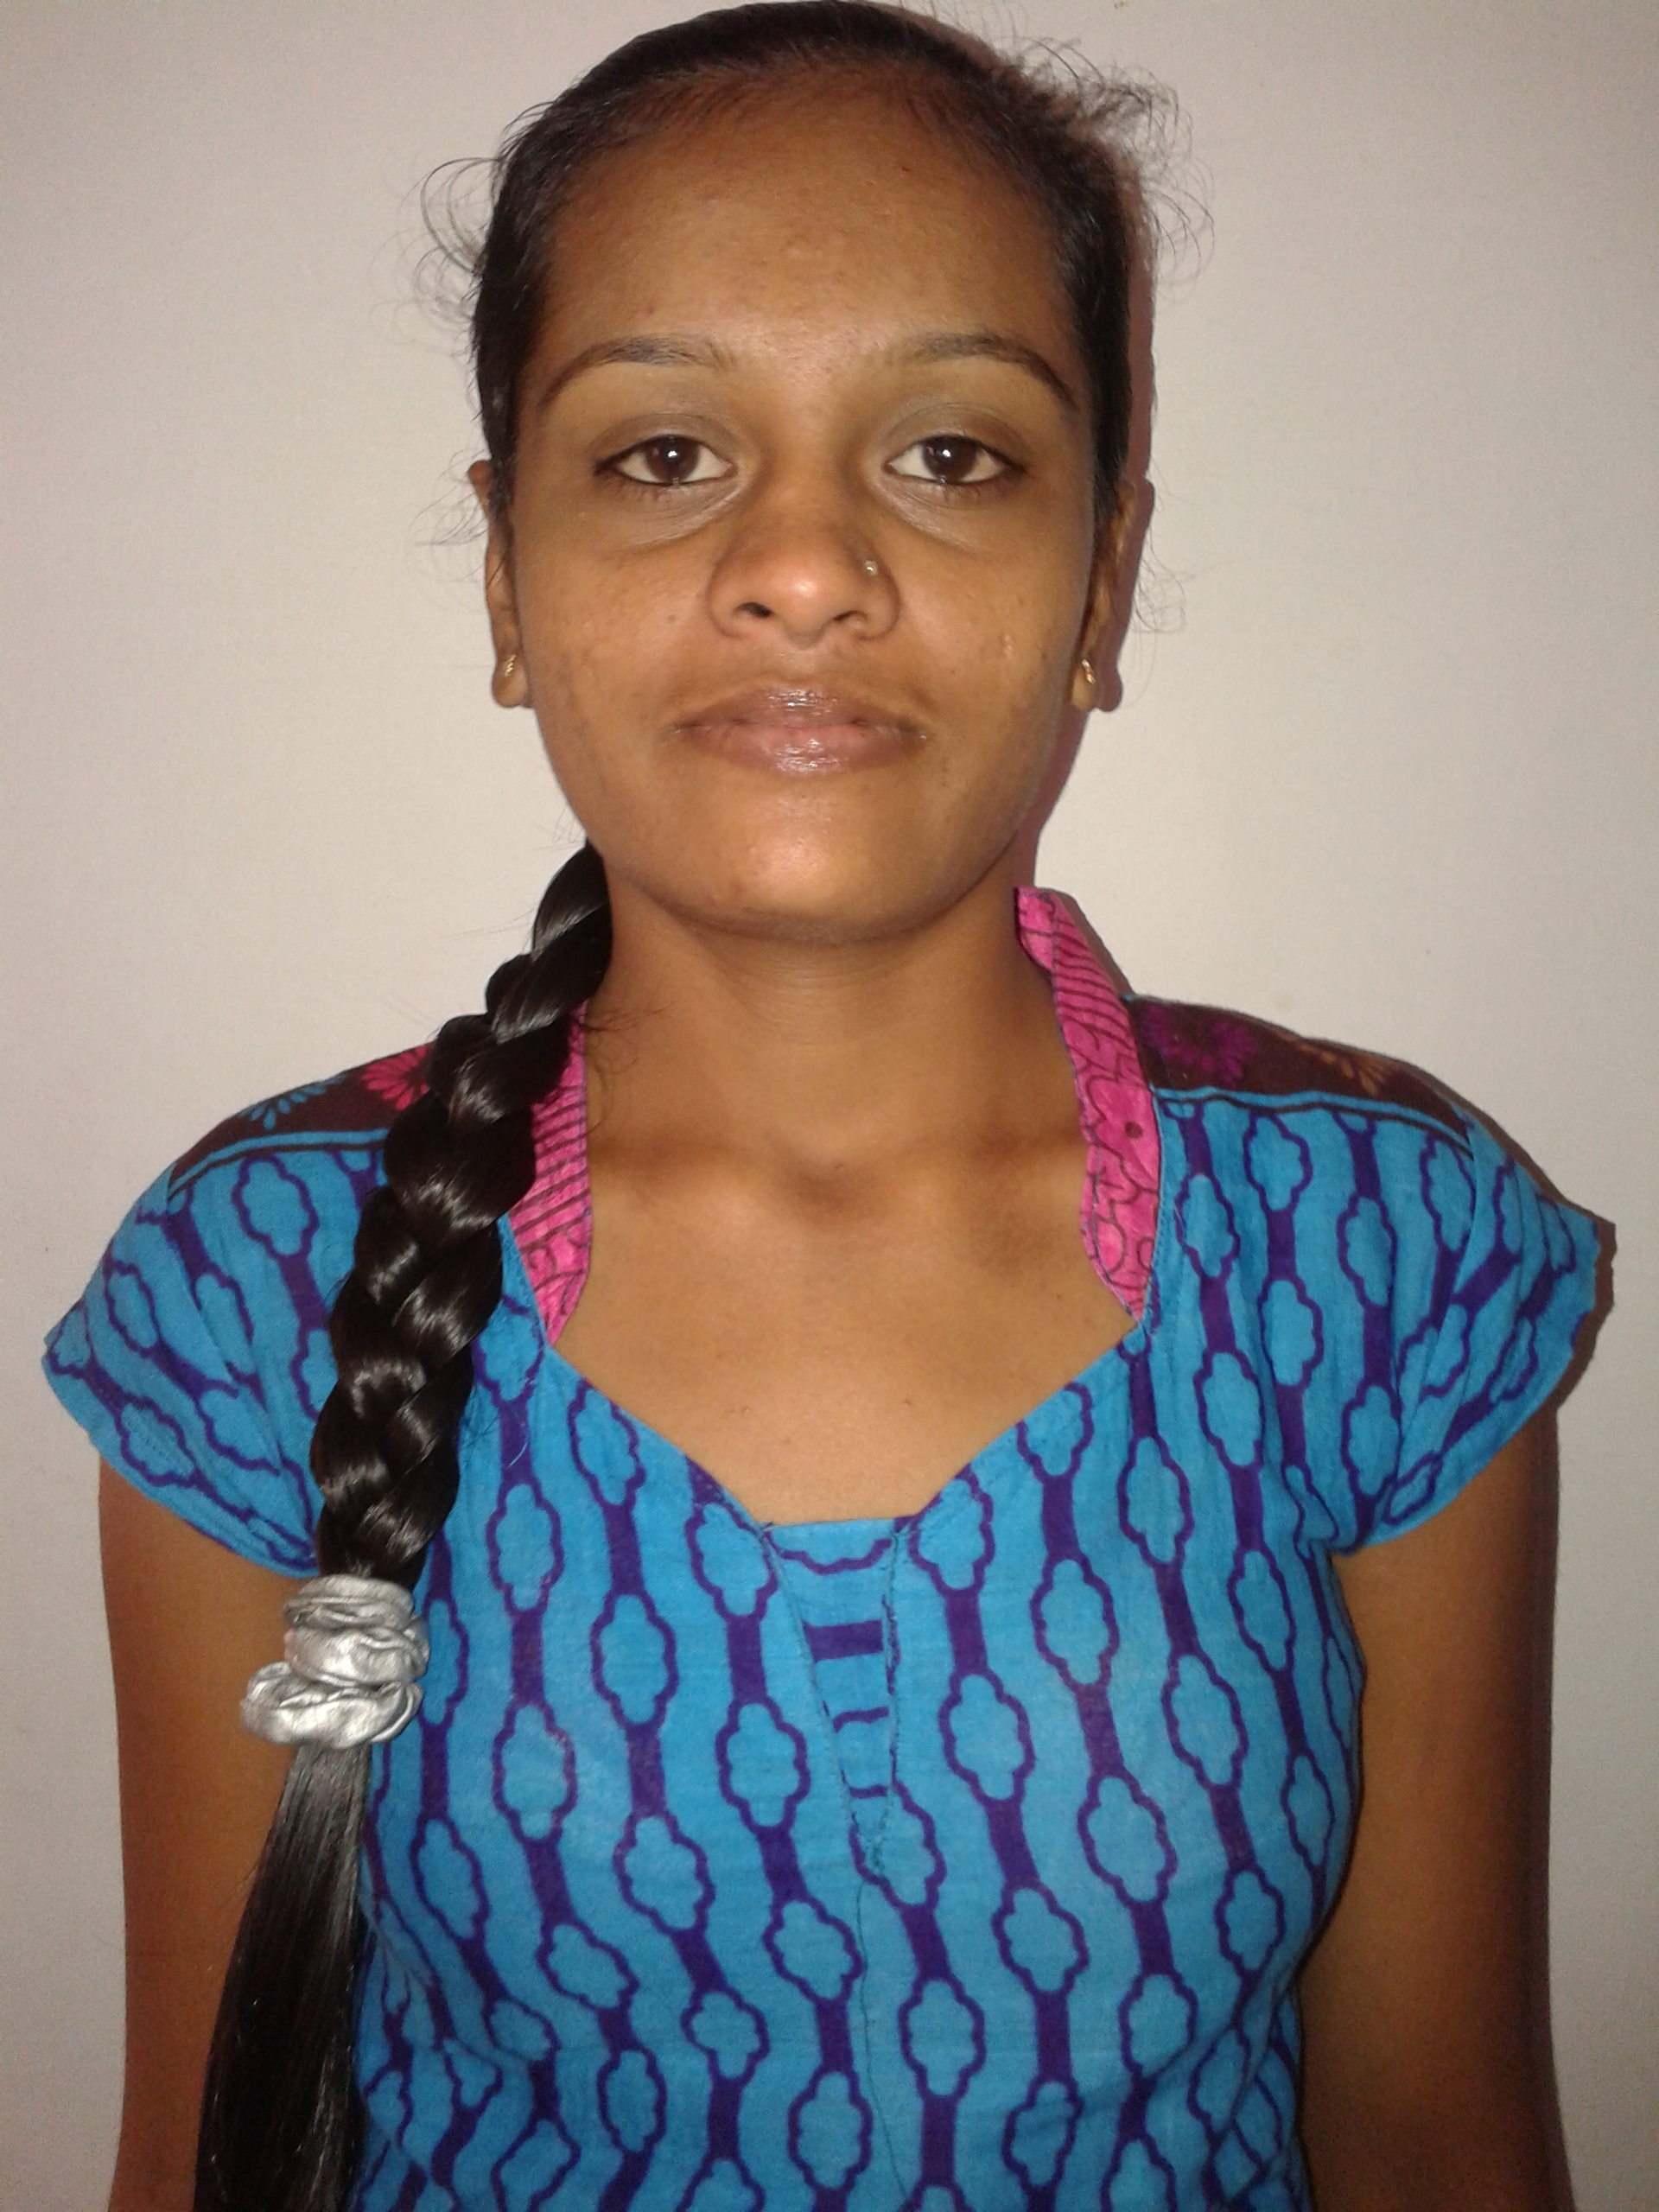

Paste your Passport Size Photo Here

**JALPA VANPARIYA**

**(MBA FINANCE)**

**Email:jalmava93@gmail.com**

**Mobile:8000962448**

**Career Objective:**

I wish to embark in a successful career as a management professional, I want to be associated with an organization that provides me with ample opportunities to broaden my skills and develop my self into a successful professional.

|  |  |  |  |  |  |
| --- | --- | --- | --- | --- | --- |
| **Degree** | **Institute** | **Board/University** | **From/To** | | **CGPA/%** |
| MBA(finance) | L.J Institutes of Management studies-Ahmedabad | Gujarat Technological University | | 2013-15 | CPI 7.54 |
| B. Com | M. M. G, Mahila Arts & Commerce College-Junagadh | Saurashtra University | | April-2013 | 77.42% |
| XII | G. D. Vachhani Kanya Vidhyalay-Keshod | GHSEB | | March-2010 | 68.00% |
| X | Govt. Girls High school-Keshod | GHSEB | | March-2008 | 64.46% |

**Internship Project:**

My Internship Project was “A comparative study between Bharti-Axa life Insurance & Reliance life Insurance Co. from customer prospective” worked in Bharti-Axa life insurance at Junagadh for 2 months.

**Global country study report**

Prepared a GCSR report on “Automobile Industry of Portugal and Chandigarh”.

**Comprehensive Report**

Prepared a CP Proposal on “ A Study on Financial Policies of State Bank of India”.

**Project as a part of PRASHIKSHAN:**

PRASHIKSHAN is an intiative taken by L.J.M.B.A where students are involved in short term live project so that students can get exposure to real life experiences.

1. **Rang de.!**
   * + I did project work for Tropical Flavors Pvt.Ltd.
     + Project was about marketing and selling colours for Holi,Rang de
     + We were in a group of two and total 11 groups participated.
     + We were allocated an area of Ahmedabad where we had to do market research to find opportunity for Rang de colours.
     + Four days before Holi we had to sell the colours the project was two months long and actual selling was for 4 days.

**Co-Curricular Activities:**

Participated in **“MARKETING EXCELLENCE SERIES (MAX)”, FINANCIAL EXCELLENCE SERIES (FINEX)”,** at L.J. Institute of Management .

Participated in **“National seminar on Enterpreneurship-2014”**

Got third prize in **“BUSINESS ARCHETYPE MODEL COMPETITION** (Management model competition) held at L.J. Institute of management-2014.

**Proficiencies:**

**Languages known:** English, Hindi, Gujarati

**Computer Skills:** Telly 9.0 and 7.2, MS Office, Excel

**Hobbies / Interests:**

Reading

Drawing

**Personal Details:**

**Address:** O 302,Parishkaar 2 co op h society,

Opp hanumanji temple

Khokhra circle,

Khokhra,

380023.

**Nationality:** Indian

**Date of Birth:** 11th May 1993

**Marital Status:** married

**Date:**