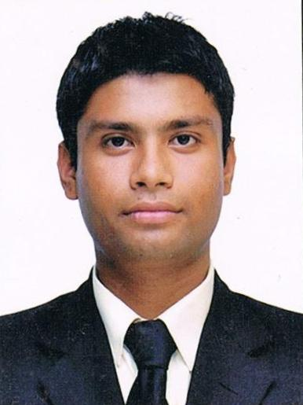

**RESUME**

**Name :Jaydeep singh chundawat**

**Email :** Chundawat.jay007@gmail.com

**Mobile:** +919784468509/08460880789

**Area Of Specialization:** Food and beverage production.

**Career Objective:**

To perform, develop and enhance my skills and knowledge with positive attitude and hard work to reach the topmost level of an organization. **Professional Qualification:**

Pursuing 3rd year of **BA IN INTERNATIONAL HOSPITALITY ADMINISTRATION**  From Anand Institute of Management Science (AIMS), affiliated with IGNOU & AH&LEI.

**Academic Qualification:**

|  |  |  |
| --- | --- | --- |
| **QUALIFICATION** | **YEAR** | **PERCENTAGE** |
| **HSS**[R.B.S.E] | 2008 | 56% |
| **SSS**[R.B.S.E] | 2006 | 54% |

**Training Exposure:**

I have successfully completed 22 weeks Industrial Exposure Training in all the four major departments from **“THE RAMBAGH PALACE, JAIPUR “**

**Continued…**

**Working Experience:**

Frequently attended various ‘ ODC’s (Out Door Catering) ’ at, TAJ GATEWAY-SURAT,ITC FORTUNE LANDMARK-AHMEDABAD,COUNTRY INN & SUITES, ITC WELCOME-VADODARA and

**DLF IPL CRICKET TOURNAMEMT** AT **MOTERA STADIUM AHMEDABAD.**

**Awards and achievement:**

I have represented Gujarat at national level in roller skating

I have done non-stop skating for 6 hours and received trainee of the month in front office department.

**Computer Skill:**

Basic computer skills.

**Hobbies:**

Playing cricket , make food

**Personal Data:**

**Date of Birth :** 1st oct 1989

**Martial Status :** Single

**Father’s name :** Mr. Himmat singh chundawat

**Strength :** calm and polite nature and good communication.

**Languages Known :** English, Hindi

**Permanent Address :** Village:Senala post:Ajana Tehsil:Ghari

Dist:Banswara

**Reference:**

**On request available**

**Declaration:**

I hereby declare that all information furnished above is true to the best of my knowledge.

**Date: 18th April 2012 Jaydeep singh chundawat**

**Place: Gujarat**